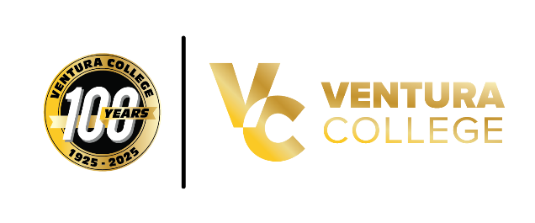
Ventura College to Host “Decolonized: The Matriarchs,” a Powerful Black History Month Performance
VENTURA, Calif. (February 17, 2026) — Ventura College invites students, employees, and the broader campus community to attend Decolonized: The Matriarchs, a moving and culturally significant performance taking place on Wednesday, February 25, 2026, at Noon in the Performing Arts Center (PAC). The event is presented in honor of Black History Month and is free and open to all Ventura County Community College District (VCCCD) students and employees.
Created and directed by acclaimed choreographer and artistic leader Karen Parks, CEO and Artistic Director of Stagebound, Inc., Decolonized: The Matriarchs is a multidisciplinary performance that reclaims and elevates the Black female narrative through expressive movement, voice, and storytelling. Parks is widely recognized for her work exploring themes of identity, culture, and healing through the performing arts. Her work has been featured throughout California and beyond, engaging audiences in meaningful dialogue around history, resilience, and empowerment.
This special presentation reflects Ventura College’s ongoing commitment to honoring diverse voices, fostering cultural understanding, and creating spaces where students and employees can engage in transformative educational experiences beyond the classroom.
This event is part of Ventura College’s Black History Month programming and Centennial year celebration, highlighting the college’s continued dedication to equity, inclusion, and student engagement.
Event Details:
Decolonized: The Matriarchs
Wednesday, February 25, 2026
Noon
Performing Arts Center (PAC), Ventura College
Free and open to all VCCCD students and employees
For more information, please contact Oscar Rivera oscar_rivera4@vcccd.edu or visit venturacollege.edu.

