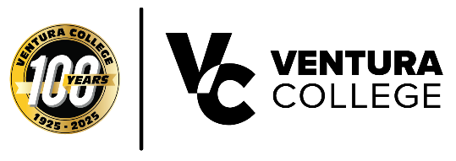
FOR IMMEDIATE RELEASE
Ventura College Closes Centennial Year With 2026 Commencement Ceremony
Two-Time Paralympian Anastasia Pagonis and Ventura College alumnus and journalist Desmond Shaw to participate in milestone ceremony
Ventura, Calif. — Marking 100 years of transforming student lives in Ventura County, Ventura College is preparing to close its centennial year with a ceremony befitting the milestone. This ceremony, taking place Friday, May 22 on the Ventura College campus, will feature distinguished guests, a historic musical performance, and a keynote address from a world-class athlete and advocate. Media representatives are encouraged to attend and cover the event.
Ventura College alumnus and journalist Desmond Shaw will deliver opening remarks at 9:30 a.m. Shaw went on from VC to build a career in broadcast journalism, and his return to campus is a testament to the pathways Ventura College creates for its students.
Gold medalist, two-time Paralympic swimmer and advocate Anastasia Pagonis will deliver the commencement address. Diagnosed with a visual impairment at age 11, Pagonis transformed adversity into a platform for resilience and advocacy. A Team USA representative and passionate advocate for inclusivity and individuality, she has inspired others not to be defined by a single label.
As Ventura College closes its Centennial year, the VC Singers will perform the original Alma Mater, a tribute to a century of Pirate pride. The program will open with a Chumash land acknowledgement honoring the Indigenous heritage of the land on which the College stands.
Note to Media:
Commencement is a ticketed, invitation-only event reserved for graduates and their guests. Media credentialed for coverage are welcome and encouraged to attend. Please contact Andrea Rambo for more information.
Media Contact:
Andrea Rambo
Executive Assistant
(805) 289-6102
arambo@vcccd.edu
About Ventura College
Ventura College is a two-year community college serving Ventura County since 1925. As part of the Ventura County Community College District, the college offers associate degrees, certificates, and transfer pathways to thousands of students each year.

