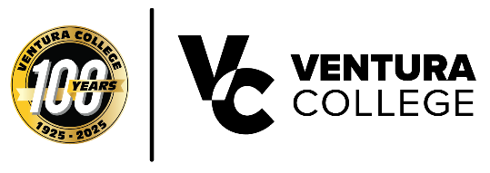
FOR IMMEDIATE RELEASE
Ventura College Students Complete Landmark Study Abroad Program in Loreto, Mexico
First-Ever Cross-Disciplinary International Trip Unites Sociology and Biology Students in Historic Baja California Sister City
Ventura, Calif. (May 12, 2026) — Ventura College made history this spring break when eleven students participated in the college’s inaugural study abroad program, traveling to Loreto, Mexico — Ventura’s sister city — for a week-long immersive, cross-disciplinary experience. Led by Professor of Sociology Daniella Graves and Professor of Biology Kammy Algiers, the program marked a milestone year in the making.
“This trip has been such an enriching experience. There couldn’t have been a better fit for our Ventura College students,” said Professor Graves. The program originated three years ago when Ventura Sister City Association board member Mark Urwick connected with Ventura College faculty about a potential collaboration. Ventura, California, and Loreto, Mexico, have been sister cities since 2015, sharing a rich mission heritage that gave students the opportunity to explore historical landmarks and reflect on their lasting cultural impact. Ventura College officially approved the program this year, bringing the vision to life.
A Week of Discovery: Culture, Nature, and Community
Students from Introduction to Sociology and Field Biology (Natural History of California) engaged in a rich variety of activities throughout the week-long trip. They visited the historic Mission Nuestra Señora de Loreto (est. 1697) and Mission San Javier (est. 1699), exploring the history that illuminates the intersection of religious institutionalization, cultural transformation, and colonization. They snorkeled in the marine sanctuary, hiked in the Sierra de la Giganta desert range, explored Coronado and Carmen Islands in Loreto’s Parque Nacional Bahía de Loreto — a sister park to Ventura’s Channel Islands National Park — and recorded species biodiversity across land and sea.
Students gave back to the Loreto community by participating in a beach cleanup at Estero Las Garzas, visiting foster children, learning watercolor painting at Casa Cultura from local artist Lizette Inzunza, and supporting local businesses.
“In the quiet of the sand, discovering new species and environments, I found more than knowledge—I found curiosity. Loreto, Mexico, will always be the beginning of that journey.” — Julie de Jesus, Ventura College Student
“The trip stuck with me in the way that I got to experience this vast difference in so many themes of life, alongside other students who were also navigating the same experience.” — Javier Razo, Ventura College Student
Key Partners: Eco-Alianza de Loreto and Conserva Loreto
The trip was made possible through a partnership with Eco-Alianza de Loreto, a non-profit founded in 2007 to address the overuse of Loreto’s natural resources. Eco-Alianza organized excursions, island trips, transportation, and student housing, while also educating participants on local environmental challenges. Students also spent a day with Conserva Loreto, receiving a guided desert tour from biologist Dr. Sula Vanderplank, who introduced them to the region’s unique flora and fauna.
“Our vision is to bring students yearly to Loreto to study the social and environmental aspects of Ventura’s sister city,” said Professor Algiers. “We hope to continue this program and build upon what we all learned in this first trip.”
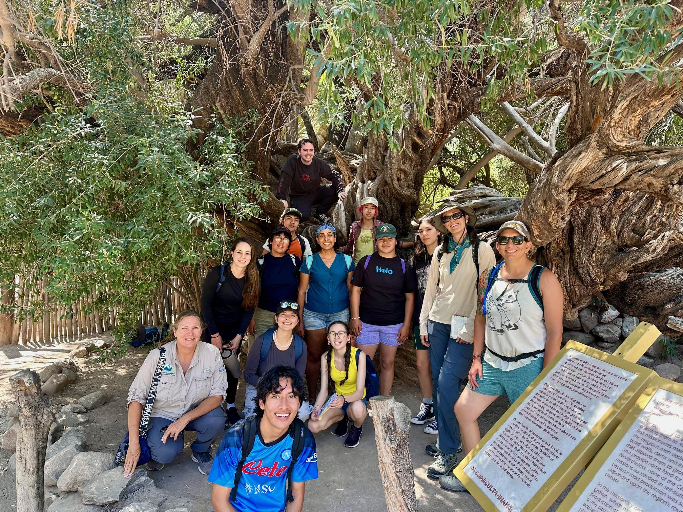
Ventura College students with Conserva Loreto Program Director Dr. Sula Vanderplank. The Olive Tree behind the students is one of the oldest living trees in Baja California. Students visited Mission San Francisco Javier and the desert in the Sierra de la Giganta mountain range.
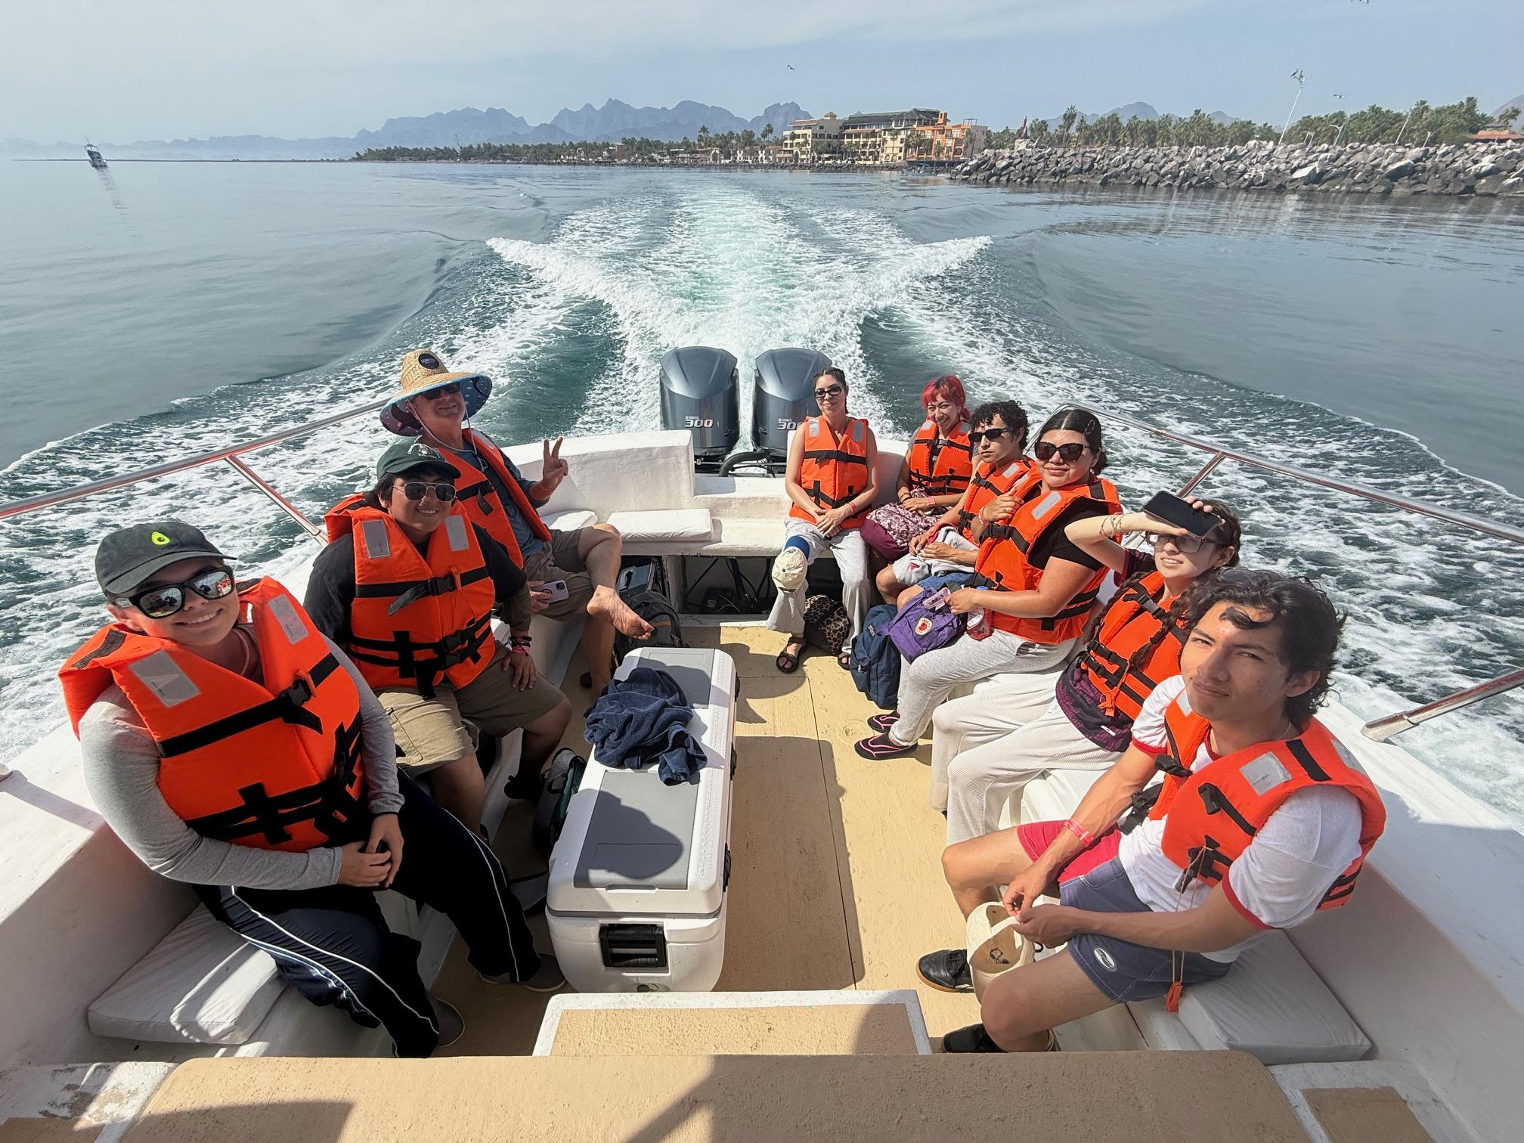
Ventura College Students visiting Coronado Island in Loreto, Mexico, after visiting Santa Cruz Island in Ventura.
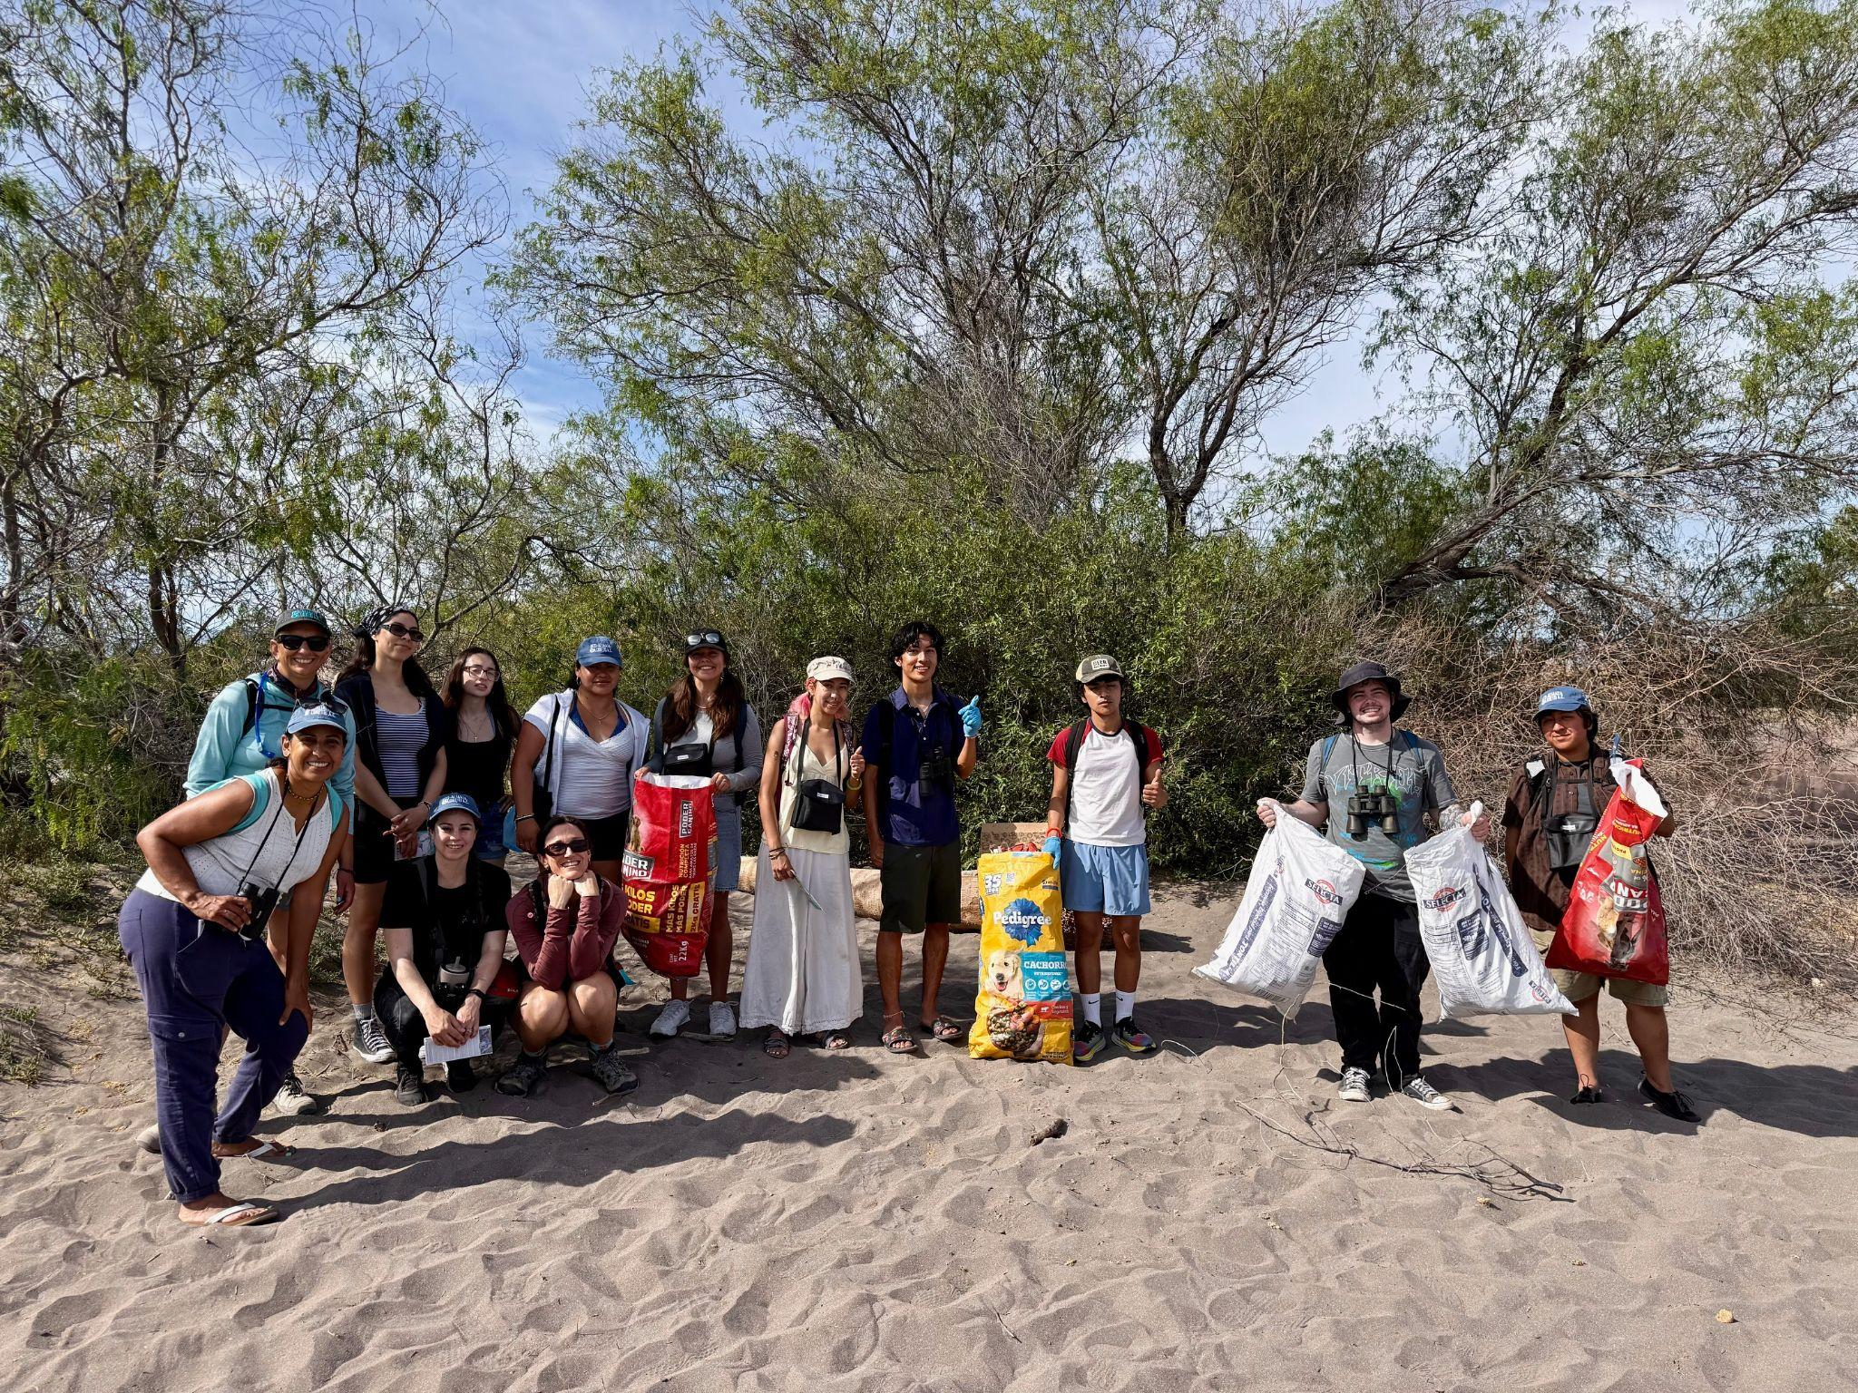
Beach Clean-up at Estero Las Garzas, a coastal estuary in the city of Loreto. Freshwater mixes with saltwater from the Sea of Cortez to create an area very popular for bird watchers.
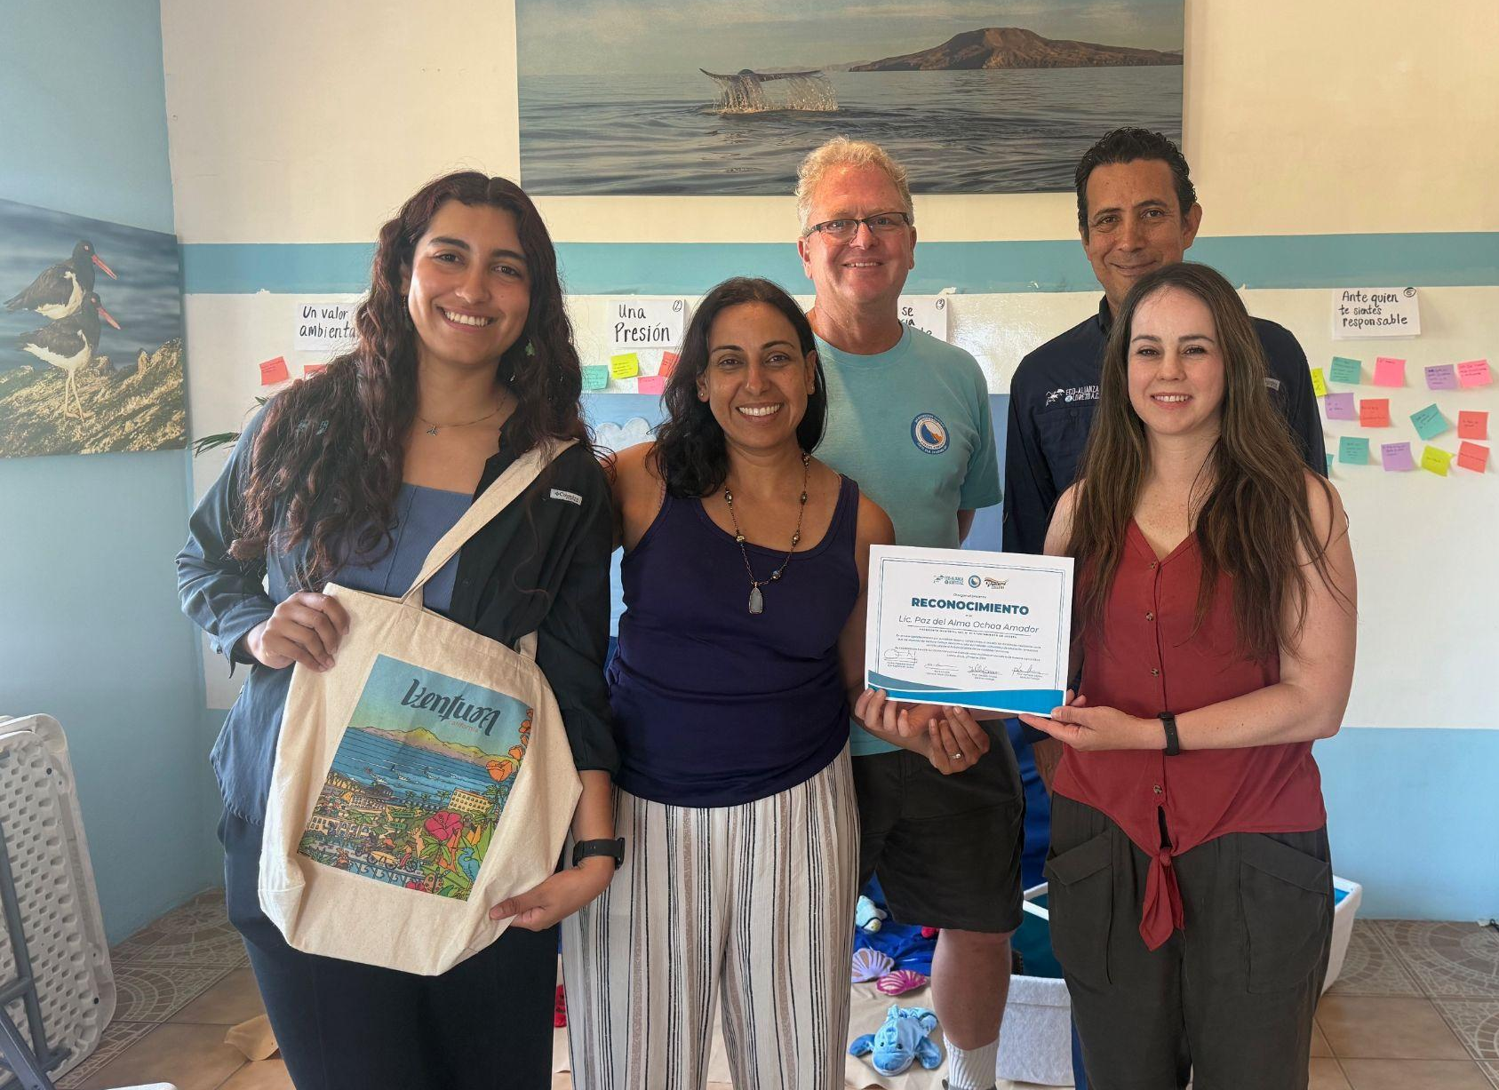
Left to right: Michelle Marily Higuera Amador (program assistant of Eco-Alianza), Kammy Algiers (Biology Professor at Ventura College), Mark Urwick (Ventura Sister City Board Member), Carlos Posadas (Director of Eco-Alianza), Daniella Graves (Sociology Professor at Ventura College), receiving a recognition for their work together.
###
About Ventura College
Ventura College, the first institution of higher education in Ventura County, has provided quality education to the community since 1925. A designated Hispanic-Serving Institution, the college enrolls over 12,000 students each semester at two campuses. VC offers over 70 disciplines of study in STEM fields, business, the arts, education, social/behavioral sciences, liberal arts, and health sciences. Named one of the nation’s top 150 community colleges by the Aspen Institute College Excellence Program, it is the largest provider of workforce participants in the county in manufacturing, automotive technology, and nursing. To learn more, visit VenturaCollege.edu.
Media Contact:
Outreach and Marketing
Ventura College
vcmarketing@vcccd.edu

