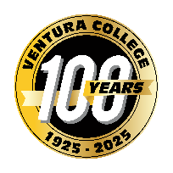

FOR IMMEDIATE RELEASE
Ventura College Tutoring Center Earns National Certification for Tutor Training Excellence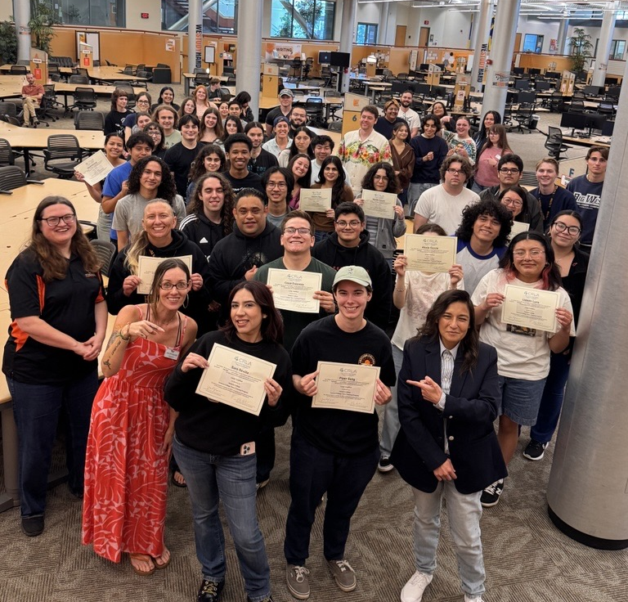
Ventura, Calif. (March 31, 2026) — Ventura College is proud to announce that the Ventura College Stan Weisel Tutoring Center has been awarded Level One Certification as a tutor training program by the internationally recognized College Reading and Learning Association (CRLA).
The Tutoring Center has worked hard to develop a tutor training program that meets CRLA’s rigorous standards and has successfully completed the International Tutor Training Program Certification (ITTPC) peer review process. Achieving certification means that the Tutoring Center has met CRLA’s high standards for tutor selection, training, direct service, and evaluation as an integral part of their overall tutoring program.
For more than 30 years, CRLA has been a leader in learning assistance, reading, and academic support programs with almost 1,300 members and over 2,000 certified training programs worldwide.
The Tutoring Center plays a vital role in supporting Ventura College students by providing accessible, effective tutoring services that enhance learning and promote academic persistence.
Congratulations to the Tutoring Center team on this important accomplishment and their continued impact on student success.
Newly Certified CRLA Level One Tutors
Ahmed, Aamina • Ahmed, Fatima • Allen, Makayla • Arquilevich, Isaac • Barrios, Viola • Beg, Ramsha • Contreras, Charlie • De Los Santos, Ray • Diaz, Rosalyn • Espinoza, Cesar • Espinoza, Christian • Ferrier, Lucy • Freeman, Helena • Garcia, Alexia • Garcia, Monique • Giron, Lorenzo • Glancy, Grayson • Gomez, Alec • Hanone, Marella • Hester, Ezra • Hester, Noah • Huovinen, Emilie • Jesson, Kyle • Johnsen Kelmar, Ryan • Lo Piano, Charles • Luna, Lizbeth • Maass, Lisa • Martinez, Nayeli • Meyers, Alanna • Meza, Erick • Nguyen, Andrew • Penzel, Jules • Pettit, Eowyn • Phillips, Sophia • Puga, Dowson • Sahar Khiz Langroody, Sonya • Selig, Piper • Sevilla, Sara • Solorio, Armando • Tam, Ethan • Tang, Yun • Wedeking, Ana • Wolf, Nathan

About Ventura College
Ventura College, the first institution of higher education in Ventura County, has provided quality education to the community since 1925. A designated Hispanic-Serving Institution, the college enrolls over 13,000 students each semester at two campuses. VC offers over 70 disciplines of study in STEM fields, business, the arts, education, social/behavioral sciences, liberal arts, and the health sciences. Named one of the nation’s top 150 community colleges by the Aspen Institute College Excellence Program, it is the largest provider of workforce participants in the county in manufacturing, automotive technology, and nursing. To learn more, visit VenturaCollege.edu.

Media Contact:
Vanessa Stotler, Director of Outreach and Marketing
Ventura College
805-289-6410
vstotler@vcccd.edu
For More Information:
Brook Masters
Dean of Learning, Equity, Achievement, and Persistence
805-289-6064

