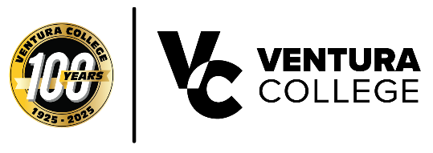
FOR IMMEDIATE RELEASE
Ventura College Celebrates With "Onward!" Event This Thursday — Honoring Legendary Comic Artists The Brothers Hernandez
Ventura, Calif. (April 28, 2026) — Ventura College invites the community to Onward! A Legacy of Heritage and Hope, a centennial celebration on Thursday, April 30, from 5:30 to 8:30 p.m. at the Wright Event Center at Ventura College.
The evening will launch a printed anthology featuring creative work from alumni, students, and community members — and will honor five outstanding Ventura College alumni with the inaugural VC Heritage & Hope Award.
Among this year's honorees is legendary cartoonist Jaime Hernandez, co-creator of the groundbreaking Love and Rockets series, which was recently awarded the Los Angeles Times Book Prize for Graphic Novel/Comics for Life Drawing: A Love and Rockets Collection.
The book was also named a New York Times Best Graphic Novel of 2025. Jaime will be honored with his brother Gilbert Hernandez. The siblings along with their brother Mario, co-created Love and Rockets in 1981, a series that has become one of the great bodies of American literary fiction.
Jaime and Gilbert were born and raised in Oxnard, California, making their recognition by their hometown college especially meaningful as Ventura College marks its 100th year.
The evening celebration will feature creative presentations from anthology contributors, live music, food, and community celebration. All are welcome and admission is free.
What: Onward! A Legacy of Heritage and Hope — Centennial Celebration & Anthology Launch
When: Thursday, April 30, 2026, 5:30 – 8:30 p.m.
Where: Wright Event Center, Ventura College, 4667 Telegraph Road, Ventura, CA 93003
Admission: Free and open to the public
About Ventura College
Ventura College, the first institution of higher education in Ventura County, has provided quality education to the community since 1925. A designated Hispanic-Serving Institution, the college enrolls over 12,000 students each semester at two campuses. VC offers over 70 disciplines of study in STEM fields, business, the arts, education, social/behavioral sciences, liberal arts, and health sciences. Named one of the nation’s top 150 community colleges by the Aspen Institute College Excellence Program, it is the largest provider of workforce participants in the county in manufacturing, automotive technology, and nursing. To learn more, visit VenturaCollege.edu.

Media Contact:
Vanessa Stotler
Director of Marketing and Outreach
(805) 289-6410
vstotler@vcccd.edu

