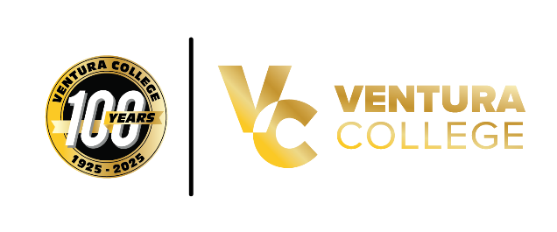
FOR IMMEDIATE RELEASE
Ventura College Celebrates 10th Annual Diversity in Culture Festival During Centennial Year
Featuring New York Times Bestselling Author Marjan Kamali

Ventura, Calif. (April 2, 2026) — Ventura College will host its 10th annual Diversity in Culture Festival on April 8 and 9, 2026, marking a decade of celebrating cultural diversity, inclusion, and community during the College’s historic 100-year anniversary year.
This free, two-day festival will feature a dynamic lineup of live performances, interactive workshops, and thought-provoking discussions that highlight global cultures and shared experiences across the Ventura County community.
A highlight of this year’s festival is a virtual presentation by New York Times bestselling author Marjan Kamali, known for The Lion Women of Tehran and The Stationery Shop. Kamali will share insights from her work exploring identity, resilience, and cross-cultural experiences. Register for the Marjan Kamali Zoom webinar.

Festival programming will include:
- Cultural performances such as Danza Azteca Xochipilli, VC Jazz Ensemble, and VC Folklorico Club, Afro-Fusion dance, Japanese Taiko drumming, and live music from local soul band Los So-Lows and Josephoenix
- Student-centered events, including a Poetry Slam competition centered on legacy, heritage, and hope with leadership from professor Fernando Salinas
- Lectures and workshops on topics such as Indigenous knowledge, mental health, social work, global conflict, and storytelling
- Interactive experiences including zine-making, wellness sessions, and cultural demonstrations
- A Centennial-themed evening celebration and night market, honoring 100 years of student life and community at Ventura College
The festival will open with a land acknowledgment led by Ethnic Studies and Native American Studies faculty and will continue with programming designed to foster dialogue, creativity, and connection.
The Diversity in Culture Festival is free and open to students, employees, and the entire community. ASL interpretation will be available for stage events, most classroom presentations, and the Kamali webinar.
Ventura College’s Diversity in Culture Festival Taskforce remains committed to promoting awareness, appreciation, and celebration of the diverse cultures that shape the campus and surrounding community.
For more information about the festival and a detailed schedule of events, visit the 2026 Diversity in Culture Events webpage or contact Gigi Fiumerodo at mtfiumerodo@vcccd.edu.

About Ventura College
Ventura College, the first institution of higher education in Ventura County, has provided quality education to the community since 1925. A designated Hispanic-Serving Institution, the college enrolls over 13,000 students each semester at two campuses. VC offers over 70 disciplines of study in STEM fields, business, the arts, education, social/behavioral sciences, liberal arts, and the health sciences. Named one of the nation’s top 150 community colleges by the Aspen Institute College Excellence Program, it is the largest provider of workforce participants in the county in manufacturing, automotive technology, and nursing. To learn more, visit VenturaCollege.edu.

Media Contact:
Vanessa Stotler, Director of Outreach and Marketing
Ventura College
805-289-6410
vstotler@vcccd.edu

