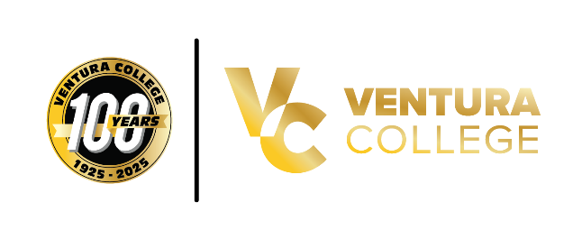
Ventura College Launches County’s First Speech-Language Pathology Assistant Program
Offered at the East Campus, the new program expands local access to high-demand careers
Santa Paula, Calif. (Sept. 11, 2025) — Ventura College is proud to announce the launch of Ventura County’s first Speech-Language Pathology Assistant (SLPA) program, located at the Ventura College East Campus in Santa Paula. The program, which began this fall, exceeded expectations with full enrollment in all first-semester courses within 48 hours, a rare milestone for a brand-new academic offering.
The SLPA program offers hybrid and online courses designed to provide students with flexible access while addressing the region’s shortage of speech-language pathology assistant professionals. In addition to SLPA-specific classes, the program’s popularity has boosted enrollment in related subjects, including American Sign Language and Communications, across Ventura, Oxnard and Moorpark colleges.
“This is more than just a new academic program; it’s a direct response to the needs of our region,” said Deanna Hall, co-chair of the department and program co-founder. “The excitement from our community has been overwhelming. Parents, educators and healthcare providers have told us time and again how critical it is to have local training opportunities for speech-language pathology assistant professionals.”
Approved by the California Department of Consumer Affairs Speech-Language Pathology and Audiology and Hearing Aid Dispensers Board, the program prepares students to complete required clinical hours and pursue licensure as speech-language pathology assistants.
According to regional labor market information, in 2020 there were 92 job openings for SLPA-related positions but only 71 completions, highlighting a clear gap in the workforce. Previously, Ventura County residents seeking SLPA training had to commute to Pasadena City College, the nearest available program.
The new SLPA program was developed with strong support from community stakeholders, including the advisory board members and local SLPs. Faculty leaders Rachel Johnson and Deanna Davis Hall worked closely with college leadership and the state board to bring the program forward.
"Our department now has Child Development, Education and Speech-Language Pathology Assistant programs, which is an amazing intersectionality of all the best programming for working with children, families, and people in our community," said Rachel Johnson, co-chair of the department and program co-founder. “The SLPA program not only creates high-demand career opportunities for our students but also strengthens essential services for children and families across Ventura County.”
With 172 students enrolled in introductory courses this fall and rapidly growing interest in future pathways, including potential dual enrollment opportunities for high school students, the SLPA program is already shaping the future of education and healthcare in Ventura County. One of the first students in the program, Alyssa Lopez, shared her excitement: “I am very excited to finally begin a new journey in life. This program truly feels like a godsend. I wasn’t sure how to move forward with my speech pathology degree, and now I feel blessed to have this pathway.”
As the program continues to grow, it promises to transform not only individual lives, but also the future of care, education and equity in Ventura County. To learn more about the SLPA program, visit venturacollege.edu/slpa
About Ventura College
Ventura College, part of the Ventura County Community College District, has been serving the region for 100 years by providing accessible, high-quality education and career training. With campuses in Ventura and Santa Paula, the college continues to expand opportunities for students to achieve their academic and career goals while supporting the workforce needs of the community.
Media Contact:
Vanessa Stotler
Director of Marketing and Outreach
(805) 289-6410
vstotler@vcccd.edu

