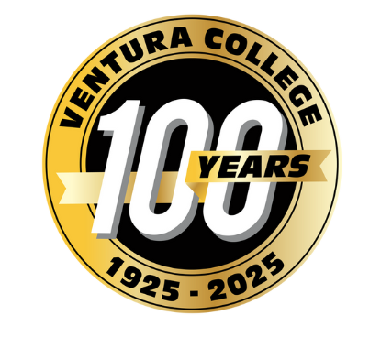
FOR IMMEDIATE RELEASE
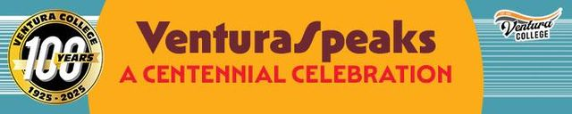

Ventura College Launches “Ventura Speaks” — A Day of Stories, Reflections and Celebration
Oral Histories, Liberal Arts Symposium and Centennial Celebration to be held on October 29
Ventura, Calif. (Oct. 28, 2025) — Ventura College invites the community to "Ventura Speaks," a public humanities event that explores questions of meaning, value and identity through the power of storytelling and reflection. The day-long celebration will take place on October 29 in Guthrie Hall at Ventura College. The event is free and open to the public.

"Ventura Speaks" is the inaugural public event of the Ventura College Liberal Arts and Public Humanities Initiative. The new initiative seeks to strengthen the college's liberal arts mission and create a vital community space where people engage with the big questions: Who are we? Where have we come from? What does our shared human journey mean?
"This initiative is about reconnecting people with their history and traditions, their identity and creativity," said Anthony Mansueto, dean of the Division of Arts, Humanities, and Social Sciences and organizer of the event. "We want to help our community reflect on the meaning of this common human journey that we all share."
Multiple programs will be featured throughout the day. Attendees can also view photography by Yvette Marthell and a faculty exhibition featuring objects that represent their identities and work.
The Oral History Forum will start the day, held 10 a.m.-12 p.m. Moderated by Michael Ward, students and faculty will present original research based on oral histories and local archival materials, bringing community voices and forgotten stories to light.
In the afternoon, guests can attend the Liberal Arts and Public Humanities Initiative symposium. This event from 1-4:30 p.m. will include a project overview by Mansueto, faculty panel discussions, and an exploration of the college’s liberal arts mission: past, present, and future.
The evening will wrap with the Division of Arts, Humanities, and Social Sciences Centennial Celebration from 6-8 p.m. The celebration will include a performance by acclaimed New Zealand musician Mark Menzies, the honoring of Division Centennial Alumna, Emeritus Faculty member, and community leader Ola Washington, and a poetry reading and conversation with poet Luzmaria Espinosa. Light refreshments will be available.
Community members are additionally invited to participate in the initiative’s oral history project by sharing their own stories. Interviews will be recorded, and participants will receive a consent form explaining how interviews will be preserved and shared.
To learn more about sharing your story, contact Anthony Mansueto at amansueto@vcccd.edu or 805-289-6230. For details on Ventura Speaks and the Ventura College Liberal Arts and Public Humanities Initiative, visit venturacollege.edu/ventura-speaks-liberal-arts-and-public-humanities-project
About Ventura College
Ventura College, the first institution of higher education in Ventura County, has provided quality education to the community since 1925. A designated Hispanic-Serving Institution, the college enrolls over 13,000 students each semester at two campuses. VC offers over 70 disciplines of study in STEM fields, business, the arts, education, social/behavioral sciences, liberal arts, and the health sciences. Named one of the nation’s top 150 community colleges by the Aspen Institute College Excellence Program, it is the largest provider of workforce participants in the county in manufacturing, automotive technology, and nursing. To learn more, visit VenturaCollege.edu.
Media Contact:

Director of Marketing and Outreach
(805) 289-6410
vstotler@vcccd.edu

