FOR IMMEDIATE RELEASE
Updated Schedule for Ventura College Presidential Finalist Forums
General Public invited to attend Open Forums to provide feedback on candidates
Ventura, Calif. (March 7, 2024) — Ventura County Community College District (VCCCD) announces an updated schedule for the open forums featuring finalists for the Ventura College Presidential Search. College faculty, staff, administration, and community members are invited to attend.
Ventura College President Finalist Forums
Ventura College Performing Arts Center﻿
4700 Loma Vista Road, Ventura, California
Due to wide demand, the forum times on each date have been updated as follows:
Monday, March 11, 2024
Dr. Claudia Lourido-Habib: 9:00 a.m. – 10:00 a.m. and 2:00 p.m. – 3:00 p.m.
Tuesday, March 12, 2024
Dr. Jennifer Kalfsbeek-Goetz: 9:00 a.m. – 10:00 a.m. and 2:00 p.m. – 3:00 p.m.
Tuesday, March 19, 2024
Dr. Vinicio López: 9:00 a.m. – 10:00 a.m. and 2:00 p.m. – 3:00 p.m.
Wednesday, March 20, 2024
Dr. Monica Chahal: 9:00 a.m. – 10:00 a.m. and 2:00 p.m. – 3:00 p.m.
Thursday, March 21, 2024
Dr. Roberto Gonzalez: 9:00 a.m. – 10:00 a.m. and 2:00 p.m. – 3:00 p.m.
Public forums will take place the weeks of March 11 and 18, and each finalist will participate in two (2) open forums. Each forum will be one (1) hour and open to all faculty, administrators, staff, students, and the general public. There will be a brief introduction of each candidate, followed by a question-and-answer session. Forums will be conducted in-person at Ventura College’s Performing Arts Center (PAC) Theatre. All who attend will be asked to complete a feedback form.
We are looking forward to a successful completion of the presidential search process. If you have any questions or suggestions, please feel free to reach out to our ACCT Search Consultant, Julie Golder, ACCT Vice President of Search Services, at jgolder@acct.org or (202) 384-5816.
The Ventura College presidential finalists are (in alphabetical order):
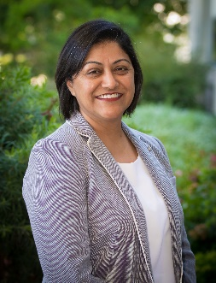
Monica Chahal, Ed.D., is the current Vice President of Instruction at Clovis Community College, State Center Community College District, CA. Previously, Dr. Chahal served as the Dean of Instruction at Woodland Community College, Yuba Community College District, CA. Dr. Chahal earned a Doctorate in Education in Educational Leadership from the University of California, Davis; a Master of Arts in English from California State University, Sacramento; and a Bachelor of Arts in English from the University of California, Davis.

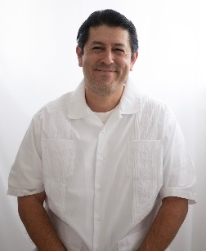
Roberto Gonzalez, Ed.D., is the current Vice President of Student Services, Enrollment Management, and Equity Initiatives at West Los Angeles College, Los Angeles Community College District, CA. Previously, Dr. Gonzalez served as a Dean at Santa Monica College in Santa Monica, California. Dr. Gonzalez earned a Doctorate of Education in Higher Education Administration from the University of Southern California; a Master of Science in Counseling from California State University, Long Beach; and a Bachelor of Arts in History from the University of California, Los Angeles.
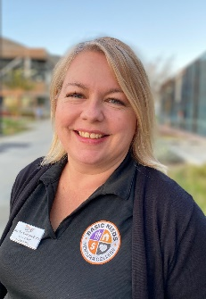
Jennifer Kalfsbeek-Goetz, Ph.D., is the current Vice President of Academic Affairs at Ventura College, Ventura County Community College District, CA. Previously, Dr. Kalfsbeek-Goetz served as the Dean of Student Learning and the Title IX Coordinator at Moorpark College, VCCCD, in Moorpark, California. Dr. Kalfsbeek-Goetz earned a Doctorate of Philosophy in Educational Leadership from Capella University, MN; a Master of Arts in Sociology from the University of Maryland, Baltimore County; and a Bachelor of Applied Science in Psychology from the University of Minnesota, Duluth.

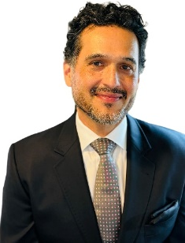
Vinicio López, Ed.D., is the current Vice President of Instruction at Skyline College, San Mateo Community College District, CA. Previously, Dr. López served as the Campus Dean of the Mission Campus for the City College of San Francisco. Dr. López earned a Doctorate of Education in Educational Leadership, Administration, and Policy from Pepperdine University, CA; a Master of Arts in Education from the University of Phoenix; a Bachelor of Arts in History from the University of California, San Diego; and an Associate of Arts in Social and Behavioral Sciences from Miramar College, San Diego Community College District, California.
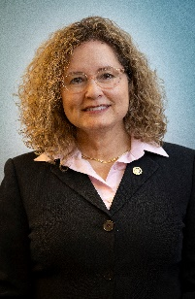
Claudia Lourido-Habib, Ed.D., is the current President of Porterville College, Kern Community College District, CA. Previously, Dr. Lourido-Habib served as the Vice President of Madera and Oakhurst Community College Centers, State Center Community College District, in Madera, California. Dr. Lourido-Habib earned a Doctorate in Education from California State University, Fresno, CA; a Master of Science in Instructional Technology from National University; and a Bachelor of Arts in Interior Design from California State University, Fresno.

About Ventura College
Ventura College, the first institution of higher education in Ventura County, has provided quality education to the community since 1925. A designated Hispanic-Serving Institution, the college enrolls over 13,000 students each semester at two campuses. VC offers over 70 disciplines of study in STEM fields, business, the arts, education, social/behavioral sciences, liberal arts, and the health sciences. Named one of the nation’s top 150 community colleges by the Aspen Institute College Excellence Program, it is the largest provider of workforce participants in the county in manufacturing, automotive technology, and nursing. To learn more, visit VenturaCollege.edu.
About Ventura County Community College District
The Ventura County Community College District is a member of the 116-campus California Community College system and serves approximately 30,000 students annually. The District's three colleges—Moorpark, Oxnard and Ventura—offer programs in general education for degrees and certificates, transfer to four-year colleges and universities, career technical education and provide opportunities to engage in co-curricular campus activities. For more information, visit vcccd.edu.

