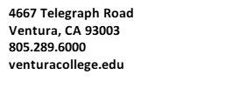
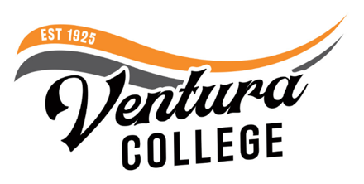
FOR IMMEDIATE RELEASE
Ventura College to Offer Bachelor’s Degree in Automotive Career Education
Four-year degree is one of two Automotive Technology programs in California

Ventura, Calif. (June 8, 2023) — Ventura College will join the exclusive club of California community colleges offering a four-year bachelor’s degree in the 2025-2026 academic year as part of a bill signed by Governor Newsom in 2021. The Bachelor of Science Degree in Automotive Career Education is designed to provide students with the knowledge and skills needed for high demand jobs within the changing high technology automotive industry. As the demand for electric vehicles (EV) increases, so too does the need for individuals trained in advanced diagnostic skills to service and maintain the EVs of the future.
“This new bachelor’s degree at Ventura College will unlock the road to success for our students interested in automotive education,“ said Kim Hoffmans, president of Ventura College. “As the demand for skilled professionals in the automotive industry continues to surge, we take immense pride in equipping our students with the hands-on training and expertise they need to thrive.“
Primarily specializing in vehicle electrification, advanced driver assistance systems (ADAS), and autonomous vehicle systems, the baccalaureate program will build on the college’s existing and highly regarded associate degree in automotive Career Education. The new four-year degree is designed for students seeking to work as master technicians trained on new and emerging technology and for current automotive master technicians looking for career advancement opportunities.
The Ventura College program is only the second of its kind in the state, after Rio Hondo College was selected to offer a baccalaureate degree in Automotive Technology in 2016. Before these programs, students seeking a bachelor's degree in automotive technology had to go out of state to complete their coursework. Such constraints in program availability can significantly increase a student’s expenses to further their education. To further impact student success, Ventura College will offer the program’s upper division coursework fully online, providing students with the flexibility to pursue their bachelor’s degree while continuing to work.
“This program will open many doors for career advancement to students in Ventura County and throughout the state,” said Felicia Dueñas, Dean of Career Education. “Offering a bachelor of science degree through community college makes a high-quality program affordable and accessible to those who have traditionally been unable to pursue a baccalaureate education.”
Courses in the baccalaureate program will be offered with low or zero textbook cost, increasing affordability for students looking to advance their careers.
The program launch will coincide with Ventura College’s 100-year anniversary. To learn more about Automotive Career Education at Ventura College, visit venturacollege.edu/departments/academic/automotive.
About Ventura College
Ventura College, the first institution of higher education in Ventura County, has provided quality education to the community since 1925. A designated Hispanic-Serving Institution, the college enrolls over 13,000 students each semester at two campuses. VC offers over 70 disciplines of study in STEM fields, business, the arts, education, social/behavioral sciences, liberal arts, and the health sciences. Named one of the nation’s top 150 community colleges by the Aspen Institute College Excellence Program, it is the largest provider of workforce participants in the county in manufacturing, automotive technology, and nursing. To learn more, visit VenturaCollege.edu.

Media Contact:
Vanessa Stotler
Director of Marketing and Outreach
(805) 289-6410
vstotler@vcccd.edu

