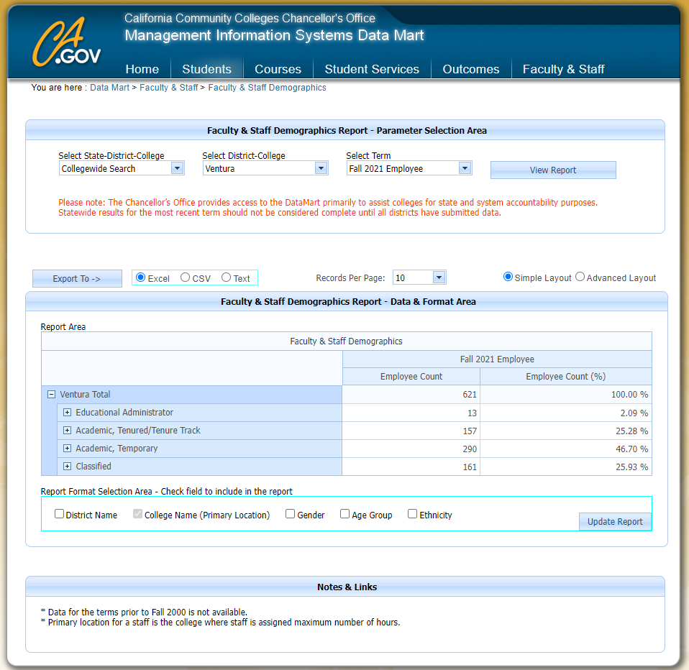

California Community Colleges Chancellor's Office
Faculty & Staff Demographics Report
 |  | Fall 2021 Employee | Fall 2021 Employee
 |  | Employee Count | Employee Count (%)
Ventura Total |  | 621 | 100.00 %
 | Educational Administrator | 13 | 2.09 %
 | Academic, Tenured/Tenure Track | 157 | 25.28 %
 | Academic, Temporary | 290 | 46.70 %
 | Classified | 161 | 25.93 %
Report Run Date As Of : 1/27/2022 12:58:35 PM

Data source: CCCCO Datamart (1/27/2022): https://datamart.cccco.edu/Faculty-Staff/Staff_Demo.aspx

