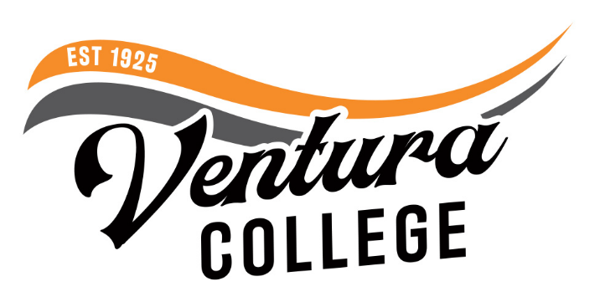
4667 Telegraph Road
Ventura, CA 93003
805.289.6000
venturacollege.edu

FOR IMMEDIATE RELEASE
American Veterinary Medical Association Gives Prestigious Stamp of Approval
to Ventura College’s Veterinary Technology Program
Accreditation recognizes program’s rigor

Ventura, Calif. (December 9, 2022) — Ventura College’s Veterinary Technology program is less than two years old and already has been granted initial accreditation by the American Veterinary Medical Association (AVMA). This recognition signifies the success and rigor of the young program, as graduates will now be qualified to sit for the Veterinary Technician National Exam to become Registered Veterinary Technicians.
The accreditation process involves detailed evaluations by the AVMA’s Committee on Veterinary Technician Education and Activities (CVTEA) and is designed to ensure veterinary technology programs produce practice-ready graduates. Students are required to demonstrate competency in over 300 essential skills that span all sectors of veterinary medicine and involve hands-on skills working with over 10 species of domestic animals.
Ventura College’s two-year vet tech program, launched February 2021, is a partnership with Ohana Pet Hospital. Classes are held at Ventura College East Campus in Santa Paula with students getting practical experience working with animals at off-campus animal care facilities throughout Ventura County. Students also participate in clinical externships at veterinary hospitals and clinics, including Ohana Pet Hospital, where they gain valuable field experience. Upon completing their first year in the program, students receive a veterinary assistant Certificate of Achievement, which enables them to seek entry-level employment in the field of veterinary technology. Graduating students receive an Associate of Science degree in veterinary technology.
“In 2021, Ventura College’s East Campus welcomed its first cohort of 26 students in the program. We were the first in the Tri-County region to have a vet tech program, so receiving the AVMA Committee on Veterinary Technician Education and Activities stamp of approval is important for the program’s longevity and our students’ futures,” said Kim Hoffmans, president of Ventura College.
“This program will meet the high demand for qualified and educated veterinary technicians and assistants in local veterinary hospitals and other organizations that provide medical care for animals,” added Dr. Jill Muraoka Lim, a founding partner of Ohana Pet Hospital. “In addition to veterinary medical knowledge and technical skills, the program also emphasizes communication and professionalism in working with pet owners and teammates, which is a reflection of the real-world clinical experience.”
For more information about the vet tech program, visit https://www.venturacollege.edu/departments/academic/veterinary-technician
About Ventura College
Ventura College, the first institution of higher education in Ventura County, has provided quality education to the community since 1925. A designated Hispanic-Serving Institution, the college enrolls over 13,000 students each semester at two campuses. VC offers over 70 disciplines of study in STEM fields, business, the arts, education, social/behavioral sciences, liberal arts, and the health sciences. Named one of the nation’s top 150 community colleges by the Aspen Institute College Excellence Program, it is the largest provider of workforce participants in the county in manufacturing, automotive technology, and nursing. To learn more, visit VenturaCollege.edu.
Media Contact:
Vanessa Stotler
Director of Marketing and Outreach
(805) 289-6410
vcmarketing@vcccd.edu

