Signing up for the 2021 Virtual CA College Fairs is as Easy as 1, 2, 3

Visit CACollegeFairs.org
Create your account and sign up.
Select and enter your email and create a password.
Finish the registration by telling us a little bit about yourself and selecting the fair you will be attending.

Go to the Live Sessions tab and select the sessions you would like to attend by selecting Remind Me.
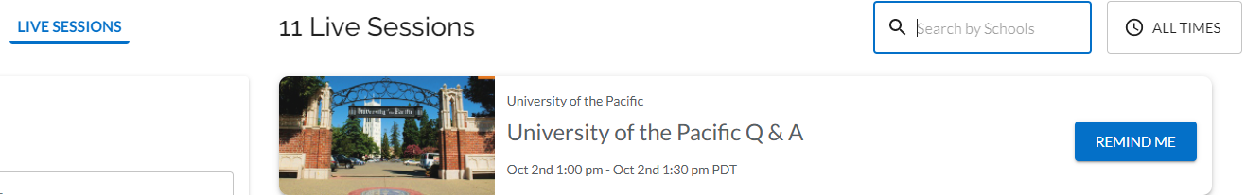
Visit the Schools section to explore. Go ahead the schools you are interested!

Check back frequently as more schools and content is added.

