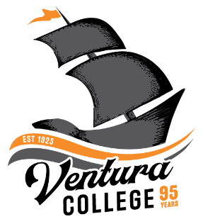
4667 Telegraph Road
Ventura, CA 93003
805.289.6000
venturacollege.edu

FOR IMMEDIATE RELEASE

Ventura College Hosts Registration Event and Open House for Students
Campus tours available for programs offering in-demand skills

(VENTURA, Calif.) August 2, 2021—Ventura County Community College District colleges, including Ventura College, begin their fall semester this month. To assist students with the registration process for fall 2021, the college will host a Set Sail Saturday registration event on Saturday, August 7, from 9 a.m. to 1 p.m.

“Ventura College is committed to student success and making sure our students start on the right course towards their completion success. Visit on August 7, so we can help you register for your fall classes and begin your successful journey at Ventura College,” said Jesus Vega, dean of student services.

Representatives from Student Services, Admissions and Records, Counseling, and Financial Aid will be available to answer questions at the event. In addition, the campus is hosting a Career Education Programs Open House to provide information and campus tours for in-demand career programs such as Automotive Technology, Child Development, Diesel Mechanics, Manufacturing, and Social Media Marketing.

The event is free and open to the public; free parking is available in the college’s West Lot. Current students with a valid college ID can ride the bus for free (Go to goventura.org for information). Attendees can follow the signs for check-in in the Main Quad.

All students should bring a photo ID, and those applying for financial aid should bring the following items:

• 2019 Student/Parent tax information
• 2019 Student/Parent W2s
• Other 2019 income information for Student/Parents
• Social Security numbers (or Deferred Action for Childhood Arrivals - DACA number) for
Student/Parents, if you have one
• Alien registration number (A#), if you have one
• Driver’s license, if you have one

For questions about the event, visit www.venturacollege.edu/setsailsaturday.

Media Contact:
Sue Royer
College Services Supervisor, Ventura College
(805) 289-6433 (office)
SRoyer@vcccd.edu

About Ventura College
Ventura College, the first institution of higher education in Ventura County, has provided quality education to the community since 1925. A designated Hispanic-Serving Institution, the college enrolls over 13,000 students each semester at two campuses. VC offers over 70 disciplines of study in STEM fields, business, the arts, education, social/behavioral sciences, liberal arts and the health sciences. Named one of the nation’s top 150 community colleges by the Aspen Institute College Excellence Program, it is the largest provider of workforce participants in the county in manufacturing, automotive technology and nursing. To learn more, visit VenturaCollege.edu.

