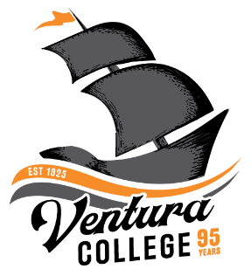
4667 Telegraph Road
Ventura, CA 93003
805.289.6000
venturacollege.edu

FOR IMMEDIATE RELEASE
Contact: Jeanne Tanner
jeanne_tanner1@vcccd.edu

Ventura College Celebrates its 95th Anniversary by Collecting Alumni Stories, Photos and Memories

VENTURA, Calif. (October 21, 2020)—To commemorate Ventura College's 95th anniversary this year, the Ventura College Foundation has created a new web page where alumni, employees, and friends of the community can share their college years' stories and photos. The collected memories will then be used as part of Ventura College's 100th celebration in 2025.
Ventura College began in 1925 and was the first institution of higher learning in the county. Since its inception, Ventura College has been driven to provide high-quality and affordable instruction and services to community members. Today, it serves over 13,000 students each semester.
To ensure the health and safety of the public, and to allow opportunities for greater community participation, in-person celebrations for Ventura College’s 95th anniversary have pivoted to online platforms this year due to COVID-19. In addition to the virtual event arrangements, the college decided to jumpstart plans for the 2025 centennial commemoration.
“We are excited to hear how Ventura College has impacted, influenced or changed your life or the life of someone you know,” says Ventura College President Kim Hoffmans. “If you started your athletic career at VC, for example, or if you have several generations of Ventura College students in your family, we can’t wait to hear your stories and see your photos.”
The Ventura College Foundation's web page, Ventura College 100th (https://venturacollegefoundation.org/venturacollege100th) is where the community can upload Ventura College memories and images, and make donations that will go toward the college's centennial celebration.
The collected remembrances may be added to the college's historical archives, used for videos, website, social media or other marketing materials for Ventura College.
###
About Ventura College
Ventura College, the first institution of higher education in Ventura County, has provided quality education to the community since 1925. A designated Hispanic Serving Institution, the college enrolls over 13,000 students each semester at two campuses. VC offers over 70 disciplines of study in STEM fields, business, the arts, education, social/behavioral sciences, liberal arts and the health sciences. Named one of the nation’s top 150 community colleges by the Aspen Institute College Excellence Program, it is the largest provider of workforce participants in the county in manufacturing, automotive technology and nursing. To learn more, visit VenturaCollege.edu.

About Ventura College Foundation

Established in 1983, the Ventura College Foundation transforms students’ lives through education by providing innovative and vital resources and financial support. The Foundation collaborates with Ventura College to enhance human potential, civic engagement, careers, and academic success of students enabling their effective impact and legacy on the college, local workforce, and our community. The Foundation also hosts the Ventura College Foundation Marketplace, an outdoor shopping experience held every weekend on the Ventura College campus parking lot. For more information, contact Julie Harvey at (805) 289-6502 or jharvey@vcccd.edu or visit www.VenturaCollegeFoundation.org.

