Ventura College
2012
Integrated Planning Manual
Planning, Program Review, Resource Allocation
This document provides an overview of Ventura College’s integrated
planning, program review, and resource allocation model and process.

Integrated Planning

In an integrated planning process, all college planning is part of a functional system unified by a common set of assumptions and well-defined procedures, and is dedicated to the improvement of institutional effectiveness. The driving force for all college efforts is student learning. Assessments focus on how well students are learning and based on those assessments, changes are made to improve student learning and success.

Dialogue regarding the improvement of institutional effectiveness occurs in an ongoing and systematic cycle of evaluation, integrated planning, resource allocation, implementation, and re-evaluation. These practices and procedures are summarized in this planning manual.

The planning model and process are summarized on the following page.

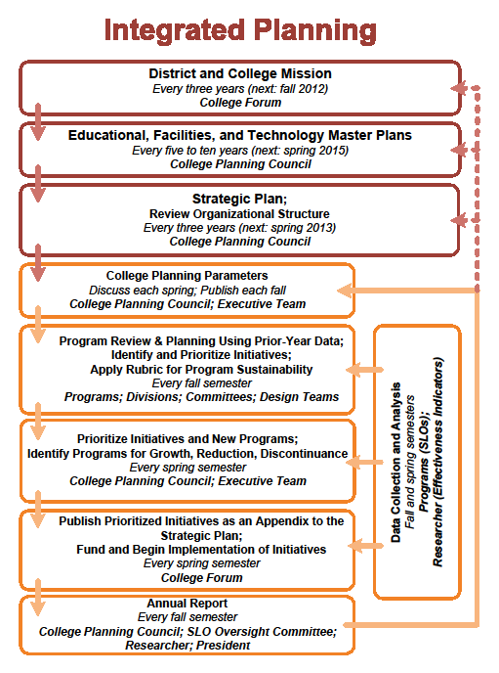
College Mission
The college mission is the touchstone for the entire planning process in that it describes the college’s intended student population and the services the college promises to provide to the community. The college mission is periodically reexamined to assure that it remains congruent with the district mission and with the needs of the population served.

The college’s schedule for reviewing the mission statement is every three years in a cycle that sequences this review during the year prior to the development of the next strategic plan. In keeping with the schedule identified later in this Manual, the college’s mission will be reviewed in 2013, 2016, and 2019.

The current college mission statement is:

Ventura College, one of the oldest comprehensive community colleges in California, provides a positive and accessible learning environment that is responsive to the needs of a highly diverse student body through a varied selection of disciplines, learning approaches and teaching methods including traditional classroom instruction, distance education, experiential learning, and co-curricular activities. It offers courses in basic skills and English-language learning; programs for students seeking an Associate’s Degree, certificate or license for job placement and advancement; curricula for students planning to transfer; and training programs to meet worker and employee needs. The College is a leader in providing instruction and support for students with disabilities.

With its commitment to workforce development in support of the State and region’s economic viability, Ventura College takes pride in creating transfer, career technical and continuing education opportunities that promote success, develop students to their full potential, create lifelong learners, enhance personal growth and life enrichment and foster positive values for successful living and membership in a multicultural society. The College has a dedicated, caring faculty and staff who are committed to student success and to continual assessment of learning outcomes in order to maintain high quality courses and programs.

Originally landscaped to be an arboretum, the College has a beautiful, park-like campus that serves as a vital community resource.

(Mission approved by the Ventura County Community College District Board of Trustees on October 13, 2009.)

The Accrediting Commission for Community and Junior Colleges standard most relevant to the development and review of college missions is I.A.1-4:

I.A. Mission
The institution has a statement of mission that defines the institution’s broad educational purposes, its intended student population, and its commitment to achieving student learning.
- The institution establishes student learning programs and services aligned with its purposes, its character, and its student population.
- The mission statement is approved by the governing board and published.
- Using the institution's governance and decision-making processes, the institution reviews its mission statement on a regular basis and revises it as necessary.
- The institution’s mission is central to institutional planning and decision making.

Educational, Facilities, and Technology Master Plans

The Educational Master Plan projects the future of Ventura College for the coming decade, and makes general recommendations that address current and foreseeable challenges. The Educational Master Plan is supplemented by the Facilities Master Plan and the Technology Plan.

The analysis of internal and external data to prepare these plans and the resulting recommendations provide a common foundation for the dialogue about the college’s effectiveness in fulfilling its mission. These recommendations are intended to serve as the basis for the college’s three-year Strategic Plans and to inform annual unit plans. In this manner a direction is established for the college under changing conditions and for the long-term development of programs and services.

The current Education Master Plan spans from 2009 to 2019. The Facilities Master Plan spans from 2004 to 2015. The Technology Master Plan spans from 2011 to 2016. Subsequent iterations of these plans will be developed when the terms of these plans expire or if there is a major change of internal or external conditions.

The Accrediting Commission for Community and Junior Colleges standards most relevant to the development and implementation of the all processes described in the remainder of this Ventura College Integrated Planning Manual 2011 are I.B.1-5, III.B.1.a, III.B.2.b, and III.C.3:

I. B. Improving Institutional Effectiveness
The institution demonstrates a conscious effort to produce and support student learning, measures that learning, assesses how well learning is occurring, and makes changes to improve student learning. The institution also organizes its key processes and allocates its resources to effectively support student learning. The institution demonstrates its effectiveness by providing 1) evidence of the achievement of student learning outcomes and 2) evidence of institution and program performance. The institution uses ongoing and systematic evaluation and planning to refine its key processes and improve student learning.
- The institution maintains an ongoing, collegial, self-reflective dialogue about the continuous improvement of student learning and institutional processes.
- The institution sets goals to improve its effectiveness consistent with its stated purposes. The institution articulates its goals and states the objectives derived from them in measurable terms so that the degree to which they are achieved can be determined and widely discussed. The institutional members understand these goals and work collaboratively toward their achievement.
- The institution assesses progress toward achieving its stated goals and makes decisions regarding the improvement of institutional effectiveness in an ongoing and systematic cycle of evaluation, integrated planning, resource allocation, implementation, and reevaluation. Evaluation is based on analyses of both quantitative and qualitative data.
- The institution provides evidence that the planning process is broad-based, offers opportunities for input by appropriate constituencies, allocates necessary resources, and leads to improvement of institutional effectiveness.
- The institution uses documented assessment results to communicate matters of quality assurance to appropriate constituencies.

III B. Physical Resources
Physical resources, which include facilities, equipment, land, and other assets, support student learning programs and services and improve institutional effectiveness. Physical resource planning is integrated with institutional planning.
- The institution provides safe and sufficient physical resources that support and assure the integrity and quality of its programs and services, regardless of location or means of delivery.
- The institution plans, builds, maintains, and upgrades or replaces its physical resources in a manner that assures effective utilization and the continuing quality necessary to support its programs and services.
- To assure the feasibility and effectiveness of physical resources in supporting institutional programs and services, the institution plans and evaluates its facilities and equipment on a regular basis, taking utilization and other relevant data into account.
- Physical resource planning is integrated with institutional planning. The institution systematically assesses the effective use of physical resources and uses the results of the evaluation as the basis for improvement.

IIIC. Technology Resources
Technology resources are used to support student learning programs and services and to improve institutional effectiveness. Technology planning is integrated with institutional planning.
3. Technology planning is integrated with institutional planning. The institution systematically assesses the effective use of technology resources and uses the results of evaluation as the basis for improvement.

Strategic Plan

The Strategic Plan is the college’s short-term plan. This plan identifies the specific actions that the college must take to implement the institutional strategic goals identified in the Educational Master Plan.

This planning process is initiated by reviewing the Educational Master Plan recommendations and determining which will serve as the college’s top institutional strategic goals for the next three years. For these institutional strategic goals, a number of strategic objectives are identified. For each strategic objective, measurable action steps are identified. Each action step includes a timeline for completion, a description of indicators of success, and the assignment of parties responsible for implementing the action.

The Strategic Plan promotes continual improvement over time because the process calls for the prioritization of a reasonable number of institutional strategic goals and objectives for college wide concentration each year. Each year the college produces an annual institutional effectiveness report that documents progress on the objectives and that reinforces and sustains the college dialogue about the achievement of the college’s long-term and short-term goals.

The College Planning Council calls for the subsequent strategic plan when the term of the current strategic plan expires or when all strategic objectives have been achieved. The schedule for the coming decade is:
- Strategic Plan 2010-2013 (fall 2010 through spring 2013)
- Annual Institutional Effectiveness Reports in fall 2011 and fall 2012
- Final Institutional Effectiveness Report of Strategic Plan 2010-2013 in spring 2013
- Strategic Plan 2013 - 2016 (fall 2013 through spring 2016)
- Annual Institutional Effectiveness Reports in fall 2014 and fall 2015
- Final Institutional Effectiveness Report of Strategic Plan 2013-2016 in spring 2016
- Strategic Plan 2016 - 2019 (fall 2016 through spring 2019)
- Annual Institutional Effectiveness Reports in fall 2017 and fall 2018
- Final Institutional Effectiveness Report of SP 2016-2019 in spring 2019 --> these final strategic plan progress reports feed into the Educational Master Plan to be developed in the 2018 – 2019 academic year.

Program Review

Program Review is an annual process that enables programs to use data to assess their performance relative to established goals and expectations and to use these findings to design initiatives for improvement. At Ventura College, a program is defined as any course of study that counts toward a certificate, degree or transfer and/or any stand-alone or combined student support services that may enhance students’ academic achievement. These are broken down into two main categories, Instructional Programs and Service Unit Programs. Further, Service Unit Programs are divided into three subcategories: Student and Instructional Service Programs, Business Service Programs and Institutional Offices.

Components of program review include:

- Program Description and Alignment (including program mission, contribution to institutional strategic objectives, catalog description, history, organizational structure, staffing)
- Performance Expectations (including established student learning outcomes, benchmarks, operating rations, advisory committee expectations)
- Operating Information (including budget, equipment, scheduling, facilities utilization, resource replacement cycles)
- Performance Assessment (including enrollment, FTES and headcount ratios, success rates, persistence, retention, completion/placement, productivity)
- Findings (including the need for curriculum improvements, service improvements, operating improvements, resource management, personnel, material and supplies, equipment, technologies, facilities, consideration of program reduction or discontinuance)
- Initiatives / Program Growth, Reduction or Discontinuance (including the including the application of a college-established rubric and the analysis of the need for new programs, new resources or the reallocation of existing resources in the areas of personnel, operating budget, facilities, equipment, training)
- Process Assessment (including status of initiatives from prior year and assessment of the program review process itself)

Program Reviews are completed at the department/program level and are reviewed and discussed at a Division meeting. Divisions submit prioritized lists of initiatives to the College Planning Council for consideration of funding or other institutional support.

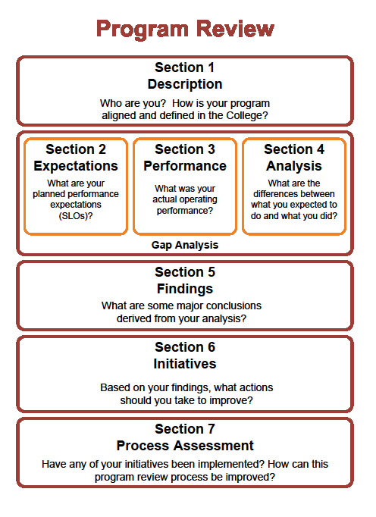
Lexicon for Planning

Educational Master Plan:
The ten-year Educational Master Plan charts the college’s long-term course. Based on internal and external scans and enrollment projections, the Educational Master Plan serves as the foundational document for the Strategic Plan, the Technology Plan, and the Facilities Plan. The Educational Master Plan may be updated if warranted by a major change of conditions

Strategic Plan:
The Strategic Plan is comprised of a limited number of three-year institutional strategic goals derived from/based on the Educational Master Plan. These three-year goals are further divided into strategic objectives, each operationalized through action steps. The College Planning Council will call for the next three-year strategic plan when the term of the strategic plan expires or when all strategic objectives have been achieved.

Institutional Strategic Goals:
Statements of broad institutional intentions, derived from/based on the Educational Master Plan. Example: Provide instruction and student services for underserved groups of potential students.

Strategic Objectives:
Statements articulating the strategies to be used to achieve the goals, specifying measurable outcomes. Example: Increase alternative modes of offering instruction and student services to working adults.

Action Steps:
Statements defining the specific steps that will be taken to achieve the objectives and that include the identification of a timeline and the individuals or groups responsible for completing or ensuring the completion of the action steps. Example: (1) Train faculty on best practices in online instruction. (2) Increase the number of online courses offered. (3) Offer online tutoring and counseling.

Program Review:
Program Review is an annual process that enables programs to use data to assess their performance relative to established goals and expectations and to use these findings to design initiatives for improvement. At Ventura College, a program is defined as any course of study that counts toward a certificate, degree or transfer and/or any stand-alone or combined student support services that may enhance students’ academic achievement. These are broken down into two main categories, Instructional Programs and Service Unit Programs. Further, Service Unit Programs are divided into three subcategories: Student and Instructional Service Programs, Business Service Programs and Institutional Offices. Program Review documents are consolidated at the Division level and submitted for review and consideration to the College Planning Council.

Annual Report:
A report, distributed each annual Flex Day, from the College Planning Council, the SLO Oversight Committee and the President on the progress made on the Strategic Plan’s action steps from the prior year, the conclusions drawn from the SLO assessment process, and the college progress on achieving its institutional strategic goals.

