Ventura College Academic Senate
Survey on Faculty Professional Life & Satisfaction
Spring 2010

Overview
During the middle of the spring 2010 semester, the Ventura College Academic Senate Executive Committee conducted a survey of all full- and part-time faculty to gauge the temperature of professional life and satisfaction at Ventura College. The survey was modeled after a similar instrument distributed in the fall 2009 semester to Moorpark College faculty by their Academic Senate. The survey consisted of a series of questions in five categories: 1.) General Professional Level of Satisfaction; 2.) Professional Satisfaction Now vs. Previous Year; 3.) Student Learning; 4.) Assisting Students Outside the Classroom; and 5.) Student Services. Over 120 faculty began the survey and close to 110 completed it. Given anecdotal experience with past faculty surveys, this is a very high response rate.

1. General Professional Satisfaction
In this first area of the survey, faculty were asked to rate their state of being in the following areas: Energized, Effective, Satisfied, Appreciated, Frustrated, Stressed, and Resentful. Generally, Ventura College faculty responded that they were energized, felt effective and satisfied in their jobs. However, a majority of faculty also indicated that they felt frustrated and stressed this academic year (61 out of 122 and 62 out of 123, respectively). Despite the fact that many faculty felt unappreciated (49 out of 120), a sizable portion of the respondents noted that they do not feel resentful, or at least not yet. It is indeed telling that faculty feel good about the work that they do that they are increasingly being asked to do more and more work in addition to their teaching/counseling/library workloads and that this is causing frustration and stress but not yet to the point of generating resentment. The comments provided in this section attest to many faculty feeling stressed and burned-out, although some comments noted a very positive note despite the current economic situation. Many of the comments in this section attest to the high degree of frustration and stress that faculty feel.

2. Professional Satisfaction Today vs. Previous Year
This second area of the survey asked faculty to gauge their state of being in the same seven categories listed in Question 1 but to compare their feelings from this academic year to last academic year. Faculty clearly indicated that they feel both less energized and satisfied this year than they did last year. Equally important was that while 50 out of 116 respondents noted that they felt “no change” in how appreciated they are, an almost equal amount (46) noted that they feel less appreciated now than this time last year, an amount nearly equal to those who noted a feeling of lack of appreciation in Question 1. Similarly, while many respondents (48 out of 118) indicated they felt “no change” in how frustrated they are, a significant minority (46 out of 118) indicated that they feel more frustrated this year than they did last year. Faculty also indicated “no change” in how stressed and resentful they feel compared to last year. Seeing that faculty indicated in Question 1 that they feel stressed this year, the “no change” in this category in Question 2 indicates that stress levels remain high on campus. Lastly, and perhaps most importantly, despite decreased energy and satisfaction levels, it is vital to note that faculty feel that their effectiveness has not changed at all since last year. This self-assessment of our teaching effectiveness is corroborated by Ventura College’s continued maintenance of unsustainably high college productivity, as measured by the “525 Report.”

3. Student Learning
This section of the survey concentrated on faculty members’ perceptions on how increased enrollment has impacted teaching and learning. For all nine (9) aspects of this question, faculty indicated that they have seen “no change” in student learning based on the college’s increased enrollment. Coupled with the fact that Ventura College has far exceeded the state measure of productivity as measured by the 525 Report for multiple years now, this indication of “no change” can perhaps be read thusly: Ventura College faculty have developed teaching and assessment techniques that have allowed them to cope with the persistent student demand for additional class sections, limited course offerings and—as as result of the previous two causes—increasingly large class sizes. While all the responses in this section indicated “no change”, the comments in this section were enlightening. Many comments attest to lack of student preparation/attention AND to the diminishing time that teachers have to provide individualized assessments, discussion or one-on-one attention to students. While it is easy to speculate on why these remarks were made—and indeed one comment even notes that “[a]lthough there has been a decrease in performance, I don’t know if it is due to impaction”—regardless, this is an area of concern for both teaching and learning at Ventura College. Future research and efforts are needed to ensure that as a college we foster an environment that supports effective and quality teaching and student learning through meaningful student-to-teacher interaction and classroom assessments that can only be achieved via reasonable class sizes and adequate course offerings. As a college, we must ensure that we are not concerned solely with maintaining or (in future years) generating additional FTES, but that we are also focused on the quality of the education that we provide.

4. Assisting Students Outside the Classroom
This section of the survey focused on how faculty’s workload outside of the classroom/counseling office/library and how this impacts their instructional effectiveness. By far and away the largest concern for faculty was the amount of work/tasks to be completed each semester in addition to their primary assignments in the classroom, in the counseling office or in the library. A full 50 out of 109 respondents indicated that the amount of work and/or tasks to do in addition to their primary assignment have a “high impact” or “critically high impact” on their ability to do their classroom/counseling/library work. A further 35 respondents indicated a “some impact, but manageable” response to this question. Summed, that indicates that 84 out of 109 respondents clearly stated that the amount of work that faculty have to do in addition to their regular assignment is reaching a critical mass. Faculty further indicated that the amount of work to be completed every day also is creating some impact in their ability to function effectively. Perhaps the high degree of stress and frustration that faculty indicated that they feel in their responses to the first two questions may be tied to the (perceived or real) increased amount of additional tasks (think paperwork, forms, etc.) that faculty are asked to do. Two of the comments in this section clearly indicate just such a correlation. On other aspects in this section, a majority of respondents indicated that the number of irate, distressing or distressed students, the number of students seeking assistance and the amount of time spent with individual students have all had some impact on their effectiveness, yet these impacts were manageable. Lastly, while a majority of respondents noted that there was little to no impact on their delivery of services due to academic staffing shortages within their departments, an almost even amount of respondents indicated that classified shortages within their departments have had either little impact or some impact on the faculty member’s delivery of services. This bifurcated response might best be explained by the uneven and disparate manner in which classified staffing cuts have been made on campus. Several comments also indicated that cuts to classified staffing within their departments—or were soon to have—a “critically high impact” on the services that those departments provide. It is worthy to note that several comments focused on the critical and devastating cuts made to our Educational Assistance Center (EAC).

5. Student Services
This section of the survey was designed primarily to gain the insights from Ventura College’s counselors. Future versions of this survey will make this intent more explicit. Indeed, many of the responses yielded a high return of “no opinion” answers and this most likely reflects non-counselors responding to questions specifically geared toward counselors. Given that the categorical areas of EOPS and EAC have incurred significant programmatic cuts over the past 18 months and coupled with the dramatic increase in enrollment at the college during that same time period, it is indeed not surprising that a many respondents (42 out of 109) indicated that as a college we have somewhat decreased or dramatically decreased in our ability to provide services as outlined in a department’s program review program narrative. Perhaps also linked to cuts in categorical student services and to increased enrollment was the faculty’s perception of decreased student satisfaction with student services. All other facets of this section yielded results of “no change” or “no opinion”, again, most likely due to survey design error as outlined above.

Conclusion
To summarize, the results of this survey indicate the following major trends:
- Faculty feel frustrated, stressed, unappreciated. Evidence also shows that faculty feel less energized, satisfied and appreciated than they did at the same time last year. We must be careful to monitor how faculty feel in these critical areas lest faculty become unmotivated, or worse, resentful.
- Lack of student preparation, increasing workload outside of the classroom (writing reports, filling out forms, etc.), larger class sizes, fewer sections and increased enrollment combined are taking their toll on faculty. We must ensure that as a college we foster an environment that supports effective and quality instruction and student learning through meaningful student-to-teacher interaction and classroom assessments that can only be achieved via reasonable class sizes and adequate course offerings.
- Student services provides an integral part of the core mission of the college. We must closely monitor and ensure that students receive the best services and options possible in this critical area, despite cuts in funding.

Overall, the feelings quantified in this survey indicate that Ventura College faculty have worked remarkably well under trying times and ever-increasing enrollments. While we cannot control the quality, and to a lesser extent, the quantity of students that we serve, there are other domains that we can control and should evaluate. Indeed, we should be ever mindful that the well-being and satisfaction of faculty should remain paramount concerns to everyone at our college and within our district. Increased FTES growth does not happen in a vacuum and our faculty’s willingness to accommodate additional student growth coupled with diminishing class offerings, lack of student preparation and seemingly never-ending amount of work that needs to be done in addition to a faculty member’s work in the classroom/counseling office/library are factors that need constant review and concern as we strive to be both a sustainable and quality institution of higher learning.

Addendum: Actual Survey Results
Question 1. General Professional Level of Satisfaction
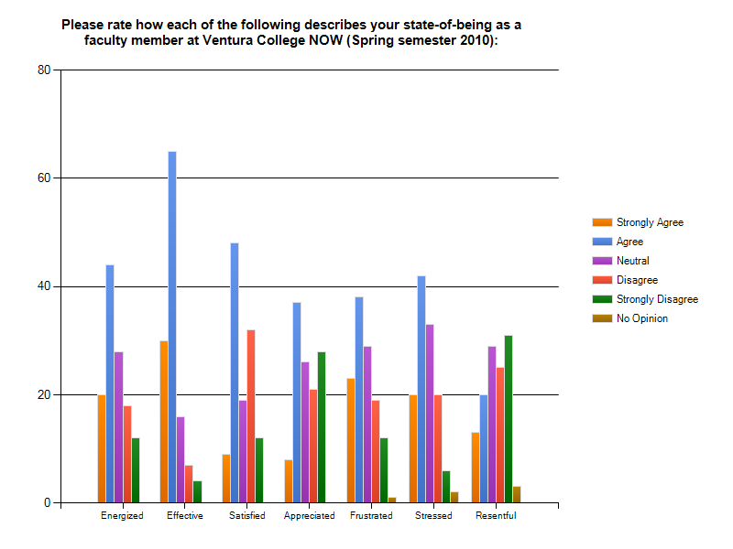

Question 1. Responses:
1. | Unappreciated
2. | Worn down by a hiring process that does not give credit for a track record of excellent evaluations and success with students. It is demoralizing to see instructors with little or no experience or those from outside the district hired time after time for full time jobs, especially when some of those from outside seem to have a higher incidence of being less than they advertised themselves as to the detriment of our students.
3. | With so many layoffs, our department is basically gone. Assignments are being cut, and morale is  L O W. Feeling quite unimportant to the college; although my students need me.
4. | No recognition of the good work I do.
5. | Tired of the over priced cold coffee
6. | Resent not being allowed to work as a professional. My Dean seems to think "Dean = Dictate" rather than "Dean = assist/facilitate in making my job better"
7. | Depressed because NO MANAGEMENT furloughs during cancelled 4-week session!!
8. | For the Neutrals, the real answer is "sometimes agree, sometimes not"  As for "Appreciated," the real answer is generally agree with peers and students, but disagree with some administrators.
9. | Lack of support for initiatives has created lots of frustration.
10. | Nature of students changing drastically, more unprepared, less willing to work, less sense of own responsibility for success.
11. | I am feeling like the district is making decisions without faculty involvement and they do not care to seek important information from us.
12. | Since I am on leave, this may not apply well. Basically I am Energized and Stressed by my remodel project, but at peace with the amount of school stuff I am doing (a little every day, but MUCH less that usual. Miss the teaching, but I am teaching pre-algebra a couple days a week to some 7th graders at my kid’s school.
13. | Without the prospect of a contract for the next year, my commitment and energy are compromised.
14. | Discouraged (due to class cuts and not having the schedule I worked hard to attain)
15. | Frustrated in seeing good people laid off and my dept. chair is extremely NOT  supportive especially to part time instructors and minority students.
16. | Moving out of old locations to temporary settings is many hours of labor and much adjustment. The dean and staff have been congratulated and complimented, both verbally and in writing. To know someone notices or appreciates the dedication is meaningful.
17. | Discouraged, ignored, de-valued, taken for granted
18. | Department head politics are controlling and punitive with no regard for faculty competence or program integrity.
19. | I love my job and the people I work with. District is the one thing that makes every endeavor and every job more challenging and difficult. I wish they were more of a support, not an antagonizer.
20. | Suppressed, isolated, victimized, unheard, fearful for the future of our VC community, appreciated by the students we serve, under-appreciated by those who control our workplace, silenced, proud.
21. | Excluded from decision making process - no shared governance
Question 2. Professional Satisfaction Now vs. Previous Year
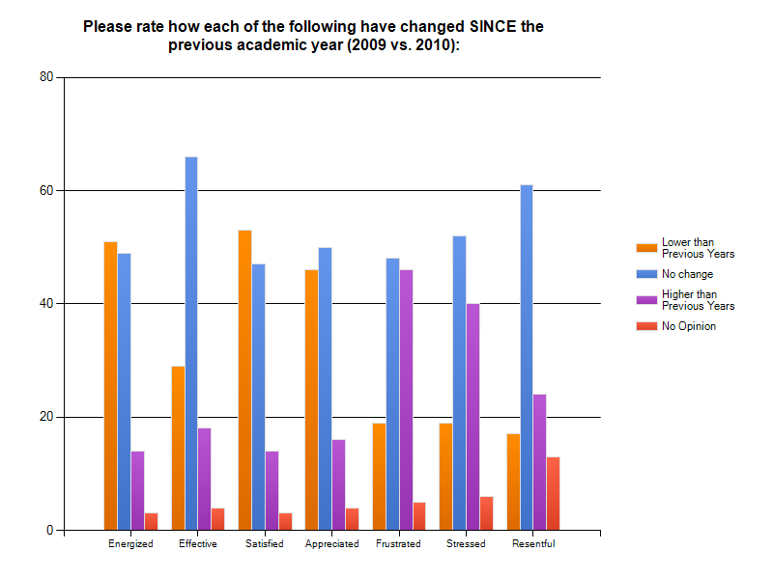
Question 2. Responses:

1. | The hiring process needs to be up-dated, more realistic to what an interview truly is and should be. Do away with the point system and hire the person who truly deserves and will do well in that position. Hire from within!!
2. | I think this has more to do with my own personal mental shift and how I cope with challenges, these days.
3. | Again, huge $$$ cuts have a way of doing this....our department is going away, and students NEED help....we are the EAC, and serve a HUGE # of students...with a vastly diminishing staff.
4. | A change in departments has shifted my whole attitude
5. | I do not believe that it is just the budget that is the source of the problems, I believe that it is the quality of the leadership!
6. | I have noticed a marked increase in the level of rudeness in the classes I teach which I feel is due in part to the environment (torn up, dirty, noisy campus, ill-equipped classrooms, etc.) BUT ESPECIALLY the out-of-control use of electronic devices causing constant distraction and the refusal of students to TURN THEM OFF. Simply pathological and depressing.
7. | More discouraged as budget cuts continue
8. | N/A. Was not at this campus to say
9. | Again, this is due to the fact that district does not work effectively with the faculty.

Question 3. Student Learning

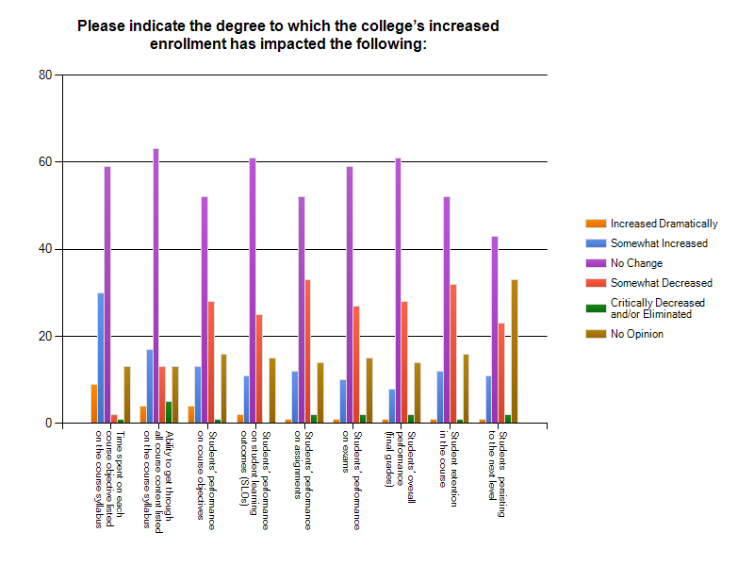

Question 3. Responses:

1. | I am non-instructional faculty
2. | The increased enrollment caused to include students with very deficient education who should not have been admitted to the college level
3. | I've had to reduce total question time in class so that I can get through the material.
4. | It should be noted that my courses are always full, and the number of sections has not (yet) changed.
5. | Retention has risen because students are afraid if they dropped, it will take a while to get into another class.
6. | Bigger classes and lower # of teachers = students not receiving as much assistance. Also, the lack of $$ for assistants in the classrooms, as well as additional accommodations for Learning Disabled students all add up to a very frustrating situation for students.
7. | My classes were capped and still are.
8. | this page not applicable
9. | Student performance varies greatly between my majors classes and my non-majors one. In majors there has been little change, but in the non-majors they are not doing as well.
10. | I have noticed better retention in my courses, but I don't know if it is connected to increased enrollment. Too soon to tell.
11. | I have marked "No Opinion" on some of these questions because our increased enrollment has brought many overqualified students to the community colleges that are performing exceptionally in the courses, while other students are falling through the cracks. So I cannot judge overall student performance as a whole.
12. | My ability to form relationships with students has decreased.
13. | At East Campus there has been no appreciable difference in numbers
14. | I am encountering more basic skills challenges than ever before (students are distracted and less motivated to succeed through effort ... much more hand-holding and "study skills" reinforcement.. much more disruption and distress in the classroom, including violence outbursts and inappropriate behaviours).
15. | Above not applicable in my area
16. | The placement tests for ESL students are a joke. Many students put themselves in classes that work for their schedules and depending on if the faculty member has a good reputation.
17. | Although there has been a decrease in performance, I don't know that it is due to impaction.
18. | With more students comes the greater chance of "missing" key opportunities with individual students to strengthen their academics. The teaching has not changed, but one-on-one time and focus has led to less awareness for me, as an instructor.
19. | Over-crowding creates more disruptive environment. Less time to individualize.

Question 4. Assisting Students Outside of the Classroom
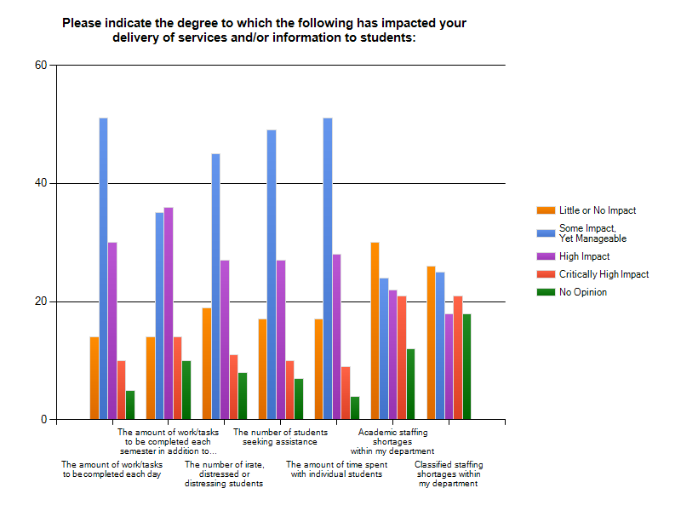

Question 4. Responses:

1. | The increasing bureaucratic requirements, like filling out forms etc, which serve absolutely no purpose but to justify a bloated amount of good for nothing administrators
2. | Classified staffing shortages outside my department has reached the "Critically High Impact" level, and it will be worse next year with the loss of even more EAC personnel as well as other support staff.
3. | EAC took a disproportionate hit. Compare our department with other departments, and also think about the ratio of staff to students...we have only 2 full-time instructors now. Plus, we've lost almost all of our classified staff and are losing our Coordinator. Those that were on staff providing the testing for learning disabilities are gone; hmmm....getting students to qualify as LD is how we get $$$, so...when we were cut there, we lost a big chunk of our ability to be self-supporting. Additionally, aren't we FEDERALLY MANDATED to offer SPED services?
4. | Am deeply concerned about the number of cuts that Classified Staff have taken---ask this question again (after all the cuts have been implemented) to gage their impact.
5. | Our department has not had a NEW fulltime faculty hire in 6 years! and most recent classified hires were "laid off" in this last budget cut.
6. | Academic staffing INCREASES have had critically high impact. My department hired full-time faculty who have taken the courses that I've taught for the last 15 years.
7. | Number of students seeking assistance seems to have dropped (from me directly, but also fewer inquiries about tutoring).  Academic staffing shortages have been balanced by section cuts this year.  Classified staffing shortages have so far not had a major impact, but scheduled/projected ones will probably do so.
8. | The amount of paperwork that faculty members must complete, which is unrelated to teaching and student contact, have dramatically increased. This decreases the amount of time each instructor can spend with students and/or preparing for class. This has had the biggest impact on many faculty members.
9. | Next semester East Campus will be severely impacted, then we'll feel it.
10. | In the music area, there is so much behind the scenes preparation for events, publicity, paperwork, more staff would be great!

Question 5. Student Services
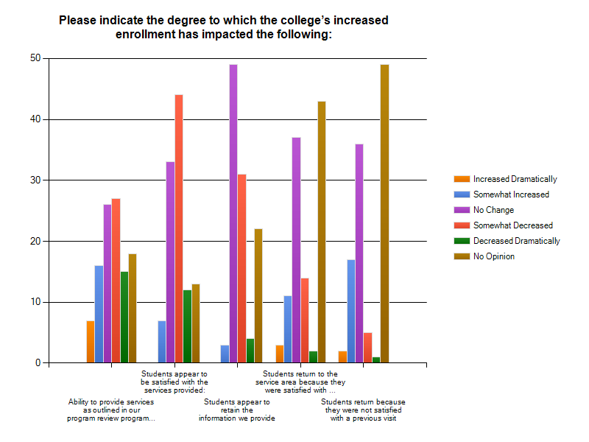

Question 5. Responses:

1. | The one with "dramatically decreased" refers to counseling: students are complaining more to me about (perceived & in some cases real) inaccuracies and inability to register for necessary classes in their sequences.  The "no opinion" ones are where I have not heard of retention or follow-up.
2. | Students return only out of necessity. They get frustrated with student services. Students have had trying experiences at student services.

Demographics:
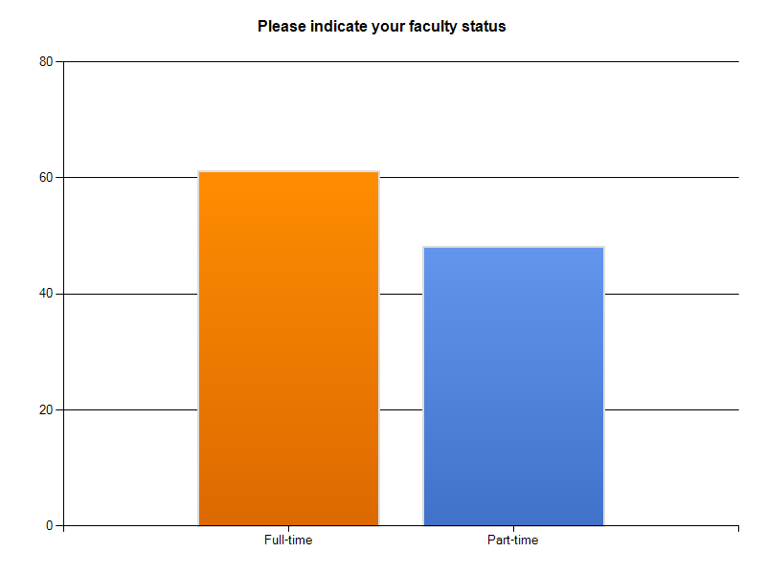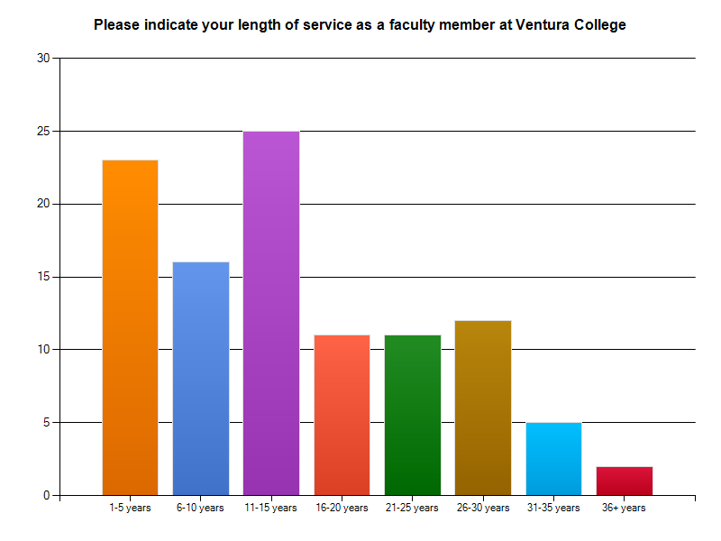

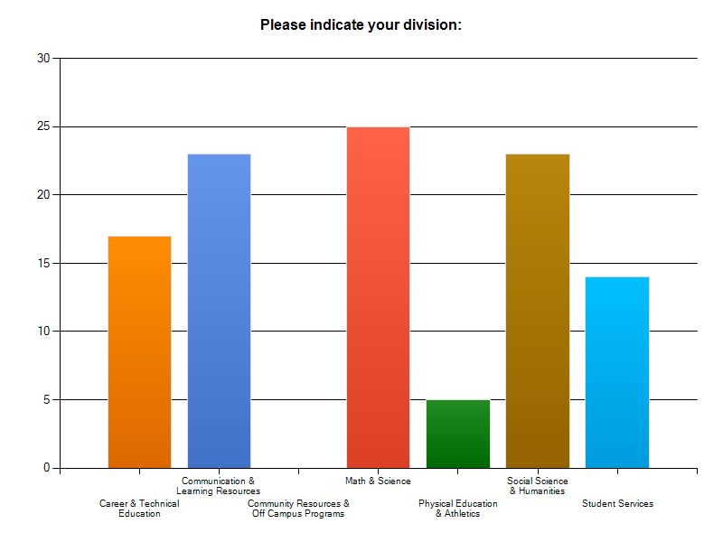

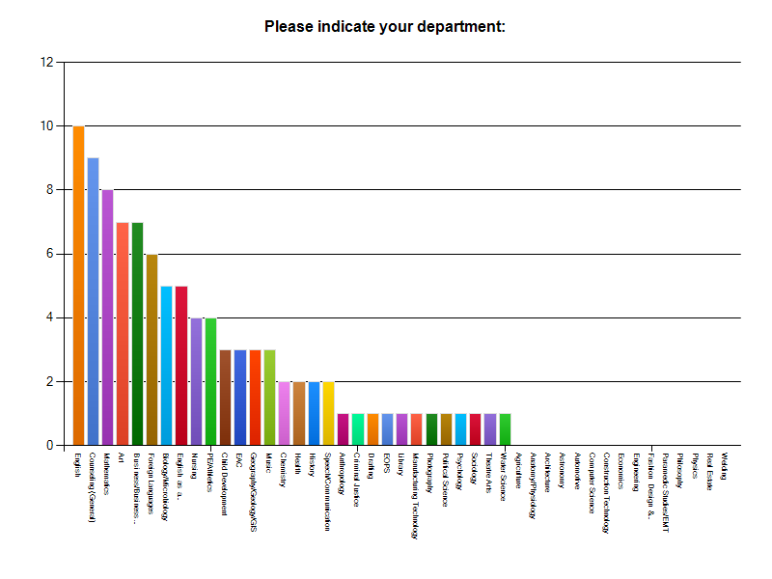
General Comments:

1. | All things considered -- this has been a wonderful year for me and I am ever so grateful for the opportunity to be part of the Ventura College promise.
2. | We faculty never felt so unappreciated, and taken advantage of, before. While we carry the burden of budget cuts, a bureaucracy of useless administrators has taken over our institutions; we became their employees. These people have little regard for the good of teachers and students, they mainly care about justifying the need for their own employment. Thus, they generate more and more bureaucracy like filling out endless online forms on websites which seem designed by mentally challenged children. I, and many of my colleagues, believe that the entire district office ought to be dismantled, all administrative personnel fired and the administration be given to a private contractor. They will manage to better administrate the district with only 10 employees and a 100th. of the current budget. Additionally, I believe that teachers should be considered for employment, or full time promotion when a position opens, based not on seniority, but on their performance, excellence in their field and dedication to teaching at VC District. The emphasis on seniority and degrees, has left us with bad teachers employed forever, good teachers who are not recognized and eventually leave, and the hiring of young teachers who know nothing about their fields except what they were just told by their teachers and books in order to obtain their fresh Ph.D's. Until we solve some of these problems America will keep producing more functionally illiterate graduates and continuing its present path towards becoming a third world country.
3. | I am very sad for our students. Many of these students will be on the streets, and unable to work, etc. if the EAC is gone. We WILL end up paying for them one way or another. Personally, I would rather sink our $$$ into educating them so they can be productive members of society as opposed to paying for them to be on the streets. Also, it's amazing to watch our tiny department become almost invisible. No body making decisions seems to look at the big picture; the EAC services impact EVERYONE at VC. Without our services, a large number or students will be GONE, disengaged, failing, or just out of control in classes when they aren't receiving the assistance they need. Really sad to me that the Board is not speaking to our students, or staff prior to making decisions that have HUGE implications.
4. | Thanks for fixing the survey allowed entries
5. | Thanks for asking us!!
6. | Thank you for taking the time to survey the faculty.
7. | Counselors generally find it difficult to interact with faculty on committees or on other assignments (and, in this sense, be a part of the VC campus community) as most requests are denied----or we are asked to perform these functions on our own time.
8. | To address the need of too many students seeking counseling our department is now offering group workshops on various topics to reduce the impact on individual counseling sessions and needs. We remain flexible in our schedule. We change our schedule voluntarily so that we can have evening coverage. We also cover summer by changing our contract days to include limited summer coverage.
9. | Thank You for asking these questions! Feel somewhat better and hope others are honest too.
10. | Thanks for a thoughtful survey.
11. | Current rebuilding of S building is very difficult.
12. | While I love VC, the districts concentration of power and sacking of key individuals that helped weave us together is taking the life out of the college.  In addition, I am finding students less prepared and willing to take on the challenges of college coursework.  Finally, "it's the economy ..." The economic stresses make it hard.  Thanks for all you work on our behalf.
13. | Counting the days until this semester is over.
14. | There has to be a faculty-driven mechanism to ensure that FT teachers are pulling their weight in committee work. There are those who do a lot and those who almost never get involved. Given the lack of hiring and loss of classified, the burden increases even more on those who traditionally carry the load.  If faculty cannot figure this out, we leave this kind of thing to management to sort out for us.
15. | District Office appears to be running the colleges at the expense and on the backs of faculty and students.
16. | Where is the Music Department listed? It is a huge department in terms of number of students. I think someone made a mistake to not list it as a department option!
17. | It would be constructive to have a performance evaluation for all college employees, including administrators.
18. | I see positive changes happening slowly (but surely)
19. | As decisions are made, it becomes increasingly clear that the administration, especially at the district level, have little to no idea what we do as faculty and student services. Everyone understands that these are difficult times and changes need to take place. However, it seems that there is a disregard for the two key groups - 1) faculty and staff 2) students. The solutions being implemented will no doubt work out on paper but appear to disregard the mission of community colleges and who and how we are to serve. Very sad.
20. | I think that the most significant change in my work life over my years at VC has resulted from the decreased level of student readiness for college level work. By this I mean that the deficiencies in basic skills are a major part of the increased work load.

