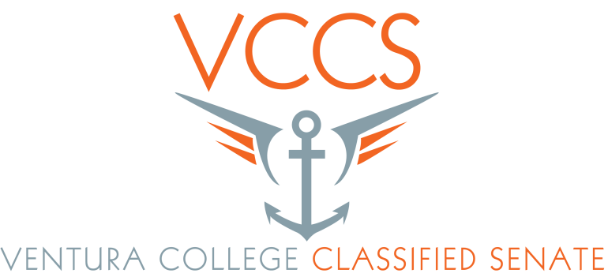

Staff Development Retreat
March 31, 2015
Retreat Evaluation

- How would you rate the overall Staff Development Retreat? (Will this retreat help you to better improve student success?)
1 2 3 4 N/A
Poor Fair Good Excellent
2 19 22
- This was not specific to success, but having classified get together helps increase student success. We know who to refer students to.
- We are implementing a retreat that does not happen at every community College. Kudos!

- How would you rate the Emergency Training?
1 2 3 4 N/A
Poor Fair Good Excellent
7 34
- I enjoyed the hands on training with Mr. O’Connor.
- Very good! I would love more hands on trainings.
- Chair training was excellent! Shooter training great! (A bit of a commercial.)
- Evacuation chair training was excellent. We still need general emergency planning information.
- Biggest “action” takeaway that will make a difference.
- We need to implement changes!!! Great trainings.
- I still have questions for specific locations.
- Would like to see a class offered to employees; self-defense how to disarm a shooter, etc.
- For Active Shooter Training, should be more example of actions taken.
- Training should be made mandatory.
- More confident about using evacuation chairs. More aware of potential strategies in emergency situations.
- The Active Shooter section needed training for each building we work in.
- More hands on re-enactment would have been appreciated.

- How would you rate the Vision Plan Presentation
1 2 3 4 N/A
Poor Fair Good Excellent
8 19 15
- From comments later in program the tuition and release time benefit for education would be good future discussion item.
- Presenter was very clear.
- Very helpful
- It did not cover other plans that district covers.
- Need to use! Thanks.

- How would you rate the ASVC Presentation?
1 2 3 4 N/A
Poor Fair Good Excellent
2 9 29
- Nice!
- Thank you for the t-shirt!
- Always love hearing from students since that’s why we work here!
- Thank you!
- Do this again always love hearing from students.
- Students are always a good plan.

- How would you rate the Personal Professional Development Plan (PPDP) presentation?
1 2 3 4 N/A
Poor Fair Good Excellent
1 11 29
- Open, great questions and answers.
- A lot of classified are unaware of the structure of our college district.
- Seems like a work around so administration and district doesn’t have to provide professional development for classified staff.
- Thank you for all your good work. You are appreciated.
- This is a good idea. I wonder what will happen.
- Give a movement for employees to express concerns and to clarity questions.
- It looks to me that district does not want to take responsibility for classified staff development as a whole and now classified have to seek out their own trainings.

- What other workshops would you like to see in the future?
- Health, Wellness, Stress Relaxation
- It was good!
- More motivational and inspirational speakers.
- Small group meeting within the Big retreat to discuss how to help make VC a better place to work or advice to help you on your job or department.
- Ice Breakers to meet employees that work here, but you don’t know them!
- Wellness, stress & relaxation, nutrition
- I will need more time to think about. Send survey out in email.
- Additional emergency and safety trainings.
- Encourage wellness, taking breaks, get away for lunch, taking kinesiology class.
- Thank you!
- Communications between departments and understanding what they do.
- Morale boosting activities
- A off campus location for retreat and training would be nice.
- More workshops about the fundamentals of communication; conflict resolution
- Lynda.com, Excel, How to write and be notices in a job application.
- Where is Hans? I need a gift reminder.
- Emergency Trainings!!!
- Communication and collaboration workshops with all personnel. Combine management, classified and faculty.
- We need to continue with safety trainings.
- Would be excellent opportunity to discuss Master Plans and other campus wide planning from classified perspective.
- Agenda item specifically related to HR issues since these came up and cost time to.
- How to supervise student works.
- Emergency Plan – duties of staff and college personnel what is our plan?
- Non-violent communication
- How to interview for a job.
- How to prepare for a reclassification.
- Presentation by Personnel Commission

