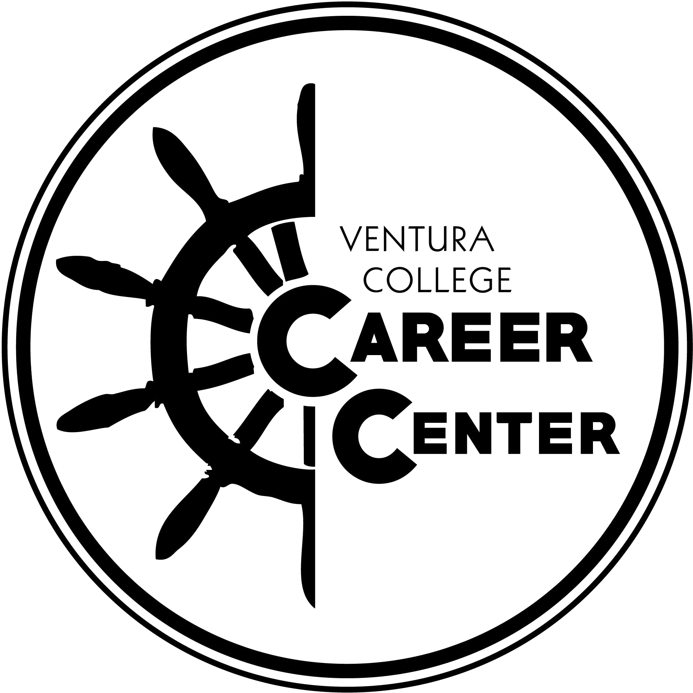 | Resume Brainstorming Worksheet

CONTACT

Name _______________________________________________ City, State________________________________

Phone __________Email

LinkedIn/Portfolio URL

OBJECTIVE OR SUMMARY
A brief statement of the position you are applying for and/or your relevant skills(not always necessary).

EDUCATION
List all colleges and universities. No need to include high school. Do not abbreviate.

School City, State

Degree Graduation Date

Major(s)/Minor(s) GPA

CERTIFICATIONS & LICENSURES
Examples include: CPR/First Aid, EMT, Teaching, etc.

Certificate/License Dates -

HONORS & AWARDS
Include name of honor/award, date received & name of organization giving award.

Honor/Award Date Received

Honor/Award Date Received

Skills (Languages, computer programs, research/lab techniques)
•

Experience
Describe all experiences including: full-time and part-time jobs, internships, volunteer work, leadership roles, class/personal projects, research, etc. When writing your accomplishment statements, use action verbs to describe your skills and activities; quantify when possible. See the Career Manual for a list of action verbs/skill sets.

Position/Title Dates -

Employer/Company City, State

Accomplishments & Skills

Position/Title Dates -

Employer/Company City, State

Accomplishments & Skills

Position/Title Dates -

Employer/Company City, State

Accomplishments & Skills

Professional Associations/Extracurricular Activities
May include sports, clubs, student organizations, and professional associations. Include length of membership. Organization Dates -

