Adobe Download Instructions for installing Adobe products.
Step 1. Click on the link on the vc website that takes you to this link (or click this link): https://helpx.adobe.com/download-install/using/download-creative-cloud-apps.html
The webpage that appears looks like the photo below: Click “Sign in to your Adobe account” on the actual website like it shows below (see blue arrow is pointing to the link). Go on to step 2 on this pdf.
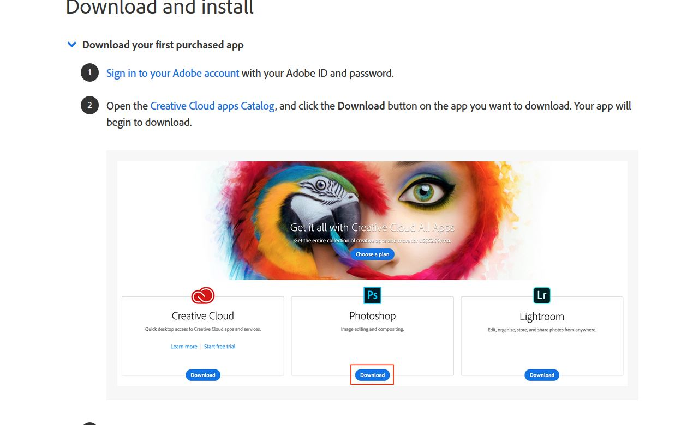
Step 2. Once you click that link you get a sign on page. It looks like this photo below:
Sign in with your VCCCD username & password, just like you do for the VCCCD portal.

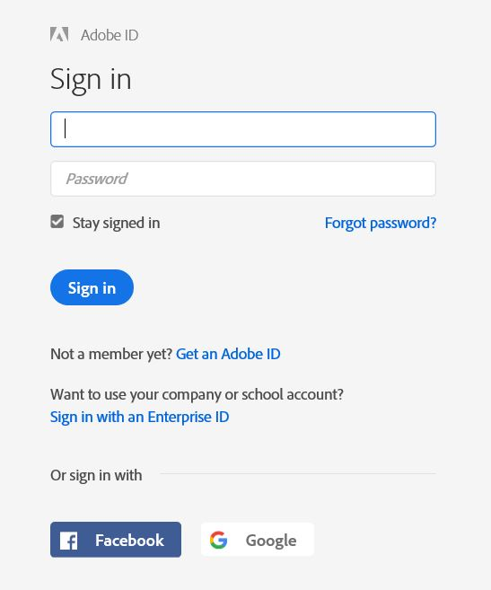

Once you sign in you may have one or two choices (choose Enterprise ID) you may see Adobe ID, or you may not see it. Just click on Enterprise ID either way.
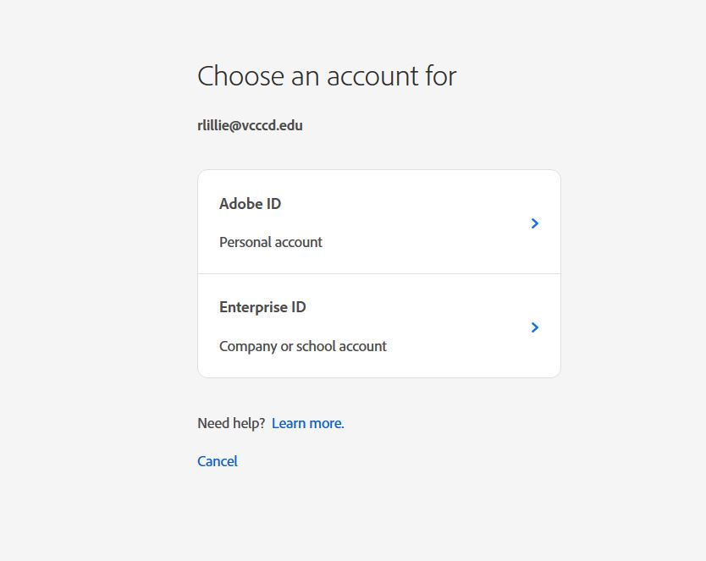

Step 3. It will then prompt you to log on again at VCCCD. Do this next. Once again;
Log in with your VCCCD username and password
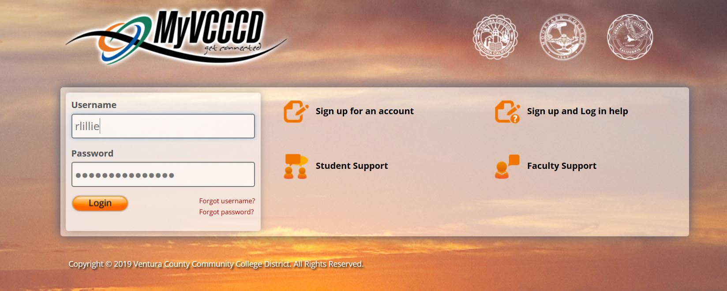

Step 4. Once you are logged on you will see this blank page with the Creative Cloud logo, when you see that go back to this link: https://helpx.adobe.com/download-install/using/download-creative-cloud-apps.html and go on to step 2.
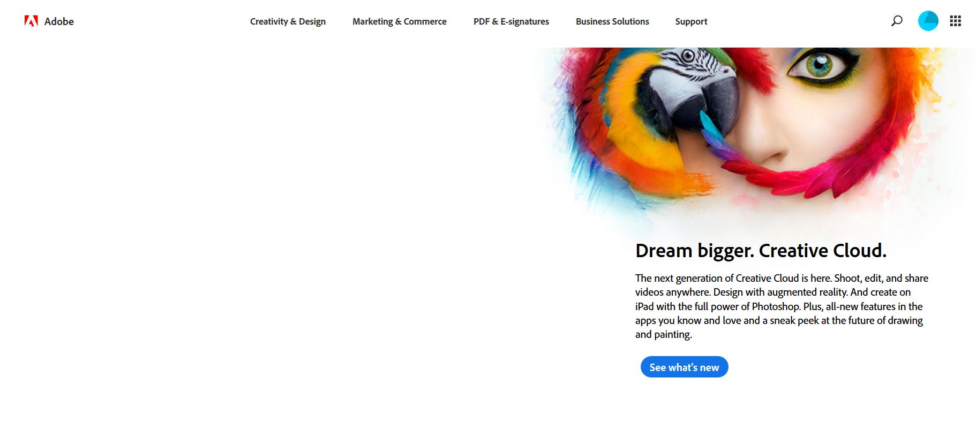

Once you click on Step 2 link, you will be brought to this page:
Here’s a shortcut to Step 2 link (only works after you are logged in): https://www.adobe.com/creativecloud/catalog/desktop.html
On this page you can now click whichever apps you wish to use, and download them.
