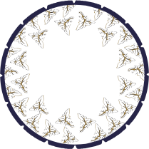
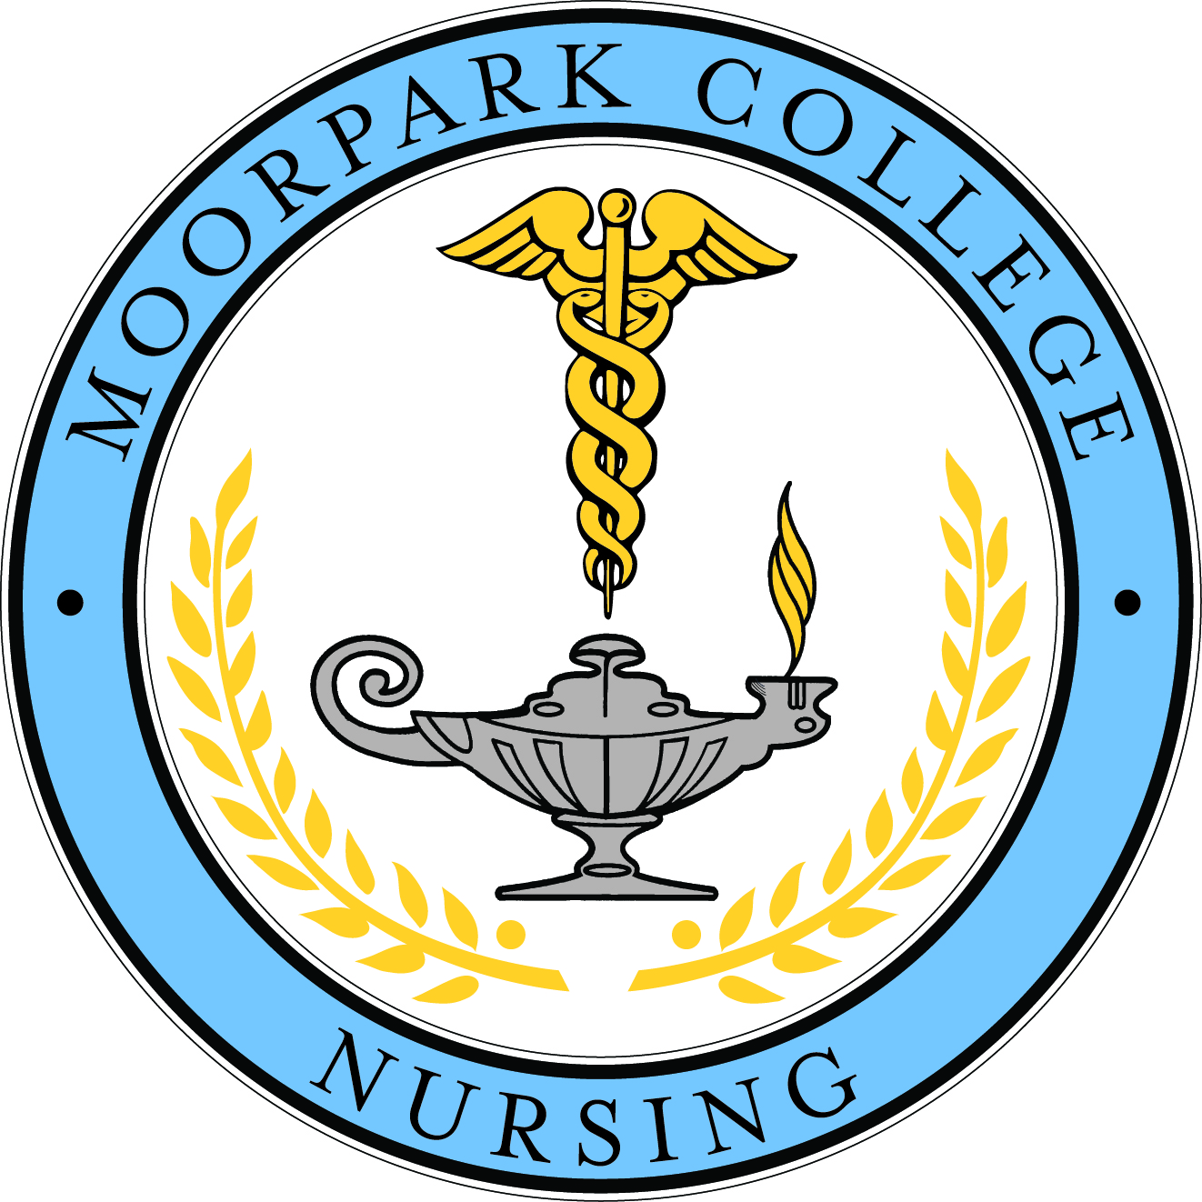

Nursing Advisory Committee
April 10, 2015
8:15 am-12:00 pm
River Ridge Golf Club

NAMES OFAVISORY COMMITTEE MEMBERS | ATTENDANCE; Present or Absent | Name of Company, Business, College, High School | Email Address | Telephone Number | Mailing Address
Nursing Director, Carol Higashida |  | Moorpark College
Nursing Director, Karen Jensen |  | CSUCI
Nursing Director, Sandy Melton |  | Ventura College
Refer to sign-in sheets
Industry Partners
Dean
Student Representatives
Faculty
Staff
Guest

AGENDA ACTION SUMMARY
 | Notes | ACTION
1.Welcome and Introductions | Introductions are given at each table.
2. Current Status of Programs: CSU Channel Islands, Moorpark College, and Ventura College  2.1Student Success  - Retention  - NCLEX First Attempt Pass Rate  - Employment | Moorpark College:  -67% retention rate reported in the 13/14 academic year for Generic Students, 33% for Generic Student “At risk”, and 88% for Multi-Criteria Students  -87.88% NCLEX Pass Rate reported in the 13/14 Academic Year  -Employment rate: 55% employed from last year’s grad, 45% unemployed. 15% of 45% entered a BSN program, 13% unemployed by choice, 17% unemployed not by choice.  - Admits 33; 157 students in the program.  - Retention rate has improved. Defined as onschedule completion in 4 consectuive semesters.  -Time mgmt. test taking strategies are covered.  -74 grads for Spring 2015.  -First attempt pass rate for NCLEX has taken a dip to 88%. Lower than prior years.  -Grad employment rate improved with 67% employed at 6 months. Still taking grads almost a year to find employment. 12% are currently enrolled in BSN program and more scheduled to enroll in Fall 2015.  Ventura College:  -100% retention rate for LVN-RN program, about %70 for Generic Students.  -%98 NCLEX Passing Rate  -No employment data for Fall 2014, Fall 2012 showed 100%  -50th year for VC School of Nursing. (100 semesters of graduates).40 graduate this Spring 2015.  -Program outcomes NCLEX pass rate of 98%.  -Employment rate is high and above 75% for graduates since Spring 2011.  -Retention rate remains above 65% since 2012/13.  CSU Channel Islands  -96% NCLEX Pass Rate for Class of 2014  -90% Employment Rate for Class of 2014  -%100 Retention Pass rate for Goleta students, 97% for Camarillo Students  -CCNE visited in October 2014. Outcome announced May of 2015.  -NCLEX pass rate dipped to 96%.  Employment rate CO14 – 90%. Retention rate; CO15 – 100% Goleta & 97% Camarillo.  - Admitting 44 student for Fall 2015 start (Spring 2018 grads) - Camarillo. Admitting 22 for Cottage program in Spring 2016.  -2 RN-BSN tracks, Fast Track(14 mos.) and Track II (22mos.)Fast Track admitted 34 graduating 34. 22 mos program – designed for working RN’s or Fast Track students that obtain a job.  -Currently working on a Masters grant through Extended Univ. Curriculum is currently being developed.Anticipated start is Fall 17 but could be Fall 18.  -Public Health placement is getting more and more difficult due to so many schools coming to this area for rotations.  -Study Abroad programs available. Ireland trip in January and Costa Rica in the summer. | Moorpark College Goals: Improve Retention Rate to > 80%, Maintain NCLEX Pass Rate of >90%, Increase employment rate to >80%, and continue to collaborate with health care partners.  Ventura College goals: Increase retention rate
3. Current Status of Industry  3.1 Hiring Practice  - Number of graduates hired in Fall 2013 to Spring 2014 from CSUCI, MC, and VC  - Projected number of graduates to be hired in 2015 from ADN and BSN programs  - Documents expected of interviewee for the interview panel  3.2 Strengths and weaknesses of new ADN and BSN graduates in terms of the following  competencies:  - Technical skills and Safety  - Critical Thinking and Clinical Reasoning  - Communication  - Responsibility and Accountability  - Organization and Prioritization  - Leadership  3.3 Partnership to improve student learning outcomes (competencies) and graduate  performance  3.4 New Graduate/Residency Program  3.5 Rate of RNs leaving the profession | Cottage Health System:  - New Graduate Program offered each year with 13 new grads joining past March, 15 expected to join in May  - Applicants to Hospital positions are expected to arrive with resumes  - Strengths of new grad program: ADN students join with strong skills, BSN students show Global perspective. BSN grads bring exciting leadership projects  - Weakness of new grad program: both ADN and BSN students need to work on communication skills especially when communicating with patients.  - Expectation from students: minimum 2 years’ experience, impeccable appearance, enthusiasm for students, good employee, responds to emails, submits required documents when expected, receptive to coaching.  - SBCC & CSU CI are schools that are prevalent at Cottage for hiring. Do hire ADN & BSN graduates.  Simi Valley Hospital  - Not many employment opportunities available due to small size facility  - Mostly have hired BSN grads but will consider all candidates equally  - Not enough employees to support a new grad program, therefore nothing has been established yet  - New applicants are expected to bring resume and letters of recommendation  - New graduates are expected to not request special shifts, no requests for time off.  Community Memorial Health System:  - 74 total nurses hired within past year. 34 were ADN’s and 40 BSN’s. 43 of 74 were new grads. Equal opportunity for everyone  - New applicants are expected to bring polished resume and cover letter, letters of recommendation are not so important. Compassionate, engaged, and willing to take care of patients with warm heart  - Hired for attitude and trained for skill.  - New FLEX Team (New Grad Program) has been developed, new cohort to be admitted in September. 83% retention rate for new grads  Ventura County Medical Center:  - 27 new grads from all schools in Ventura County to assist with new CERNER system  - New applicants are expected to bring resume, certifications such as ACLS, CPR, NRP. “Dress to Impress”  Los Robles Hospital  - Residency program offered for new grads in need of employment. Admit 2 cohorts per year.  - New applicants expected to bring resume, three letters of recommendation (one from a previous faculty member), copy of RN license, school official transcript, proof of graduation within twelve months, CPR card.  Northridge Medical Center  - New grad program offered in 2012, anticipate doing programs in the future. 22-hired total, hired from both CSU Channel Islands and Moorpark College. Good experience from students who graduated in both schools.  - New applicants are expected to bring resume, paper application, transcripts (unofficial ok), 3.0 GPA or higher. Two letters of recommendation, one from a clinical instructor, with signature and letterhead included. Expect no vacation time during program, full time commitment.  - Strengths of new grads: BSN’s are well prepared, leadership qualities are good, must develop good organizational skills.  St. John’s Regional Medical Center  - Looking for good attitude, kind and compassionate. Reason why into nursing, and sharing patient stories. Will ask reason behind why still in nursing profession.  Providence Tarzana  - Hires ADN’s.  - Looks for active plan to get BSN in interview process.  - Strengths & weaknesses noted students are equally lacking clinical skills because of “out” of clinical rotation for some time approx.. 9 mos.  - Having to go back to clinical skills to bring new hires current.  - Residency fellow program from Med surg to telemetry. 10-12 week program and is shared regionally.  - Projected hiring (23 in March) runs 3 programs a year (Spring, Summer & Fall). Spring 23 hired, Summer 8 hired, and Fall 10 open spots  Cottage Health System  Herb Geary – grand open Santa Ynez coming in May. Just launched witching to EPIC throughout the entire hospital.  Santa Paula – ADN vs. BSN students – Most ADN students are pursing a second career and have life experience to bring to the job. BSN students have better writing skills & presentations. New grad program offered in NICU, ER, and ICU. They are run for 6 mos. out of a year. They are offered in specialty areas. 7 RN’s retired last year. Building a new building and are currently at or over capacity. Adding 24 FTES and 12 in 6 mos. New faiclty to open in April. Wants nurses from local community.
7. Set next meeting time, place, date. | To be determined

Meeting Summary completed and distributed by:_Cesar Rangel, CSU Channel Islands & Jodi Delmonte, CSU Channel Islands
Date:_07/2015

HANDOUTS:
Ventura College PowerPoint Handout, Moorpark College PowerPoint Handout, CSU Channel Islands PowerPoint Handout, Small Group Discussion Questions, Survey Handout

