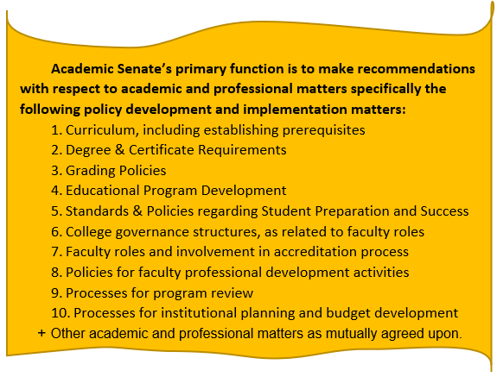
Ventura College Academic Senate

Dan Clark (President) Preston Pipal (Vice President)
Email: dclark@vcccd.edu Email: rpipal@vcccd.edu
Phone: (805) 289-6368 Phone: (805) 289-6368

Colleen Coffey (Secretary) Andrea Horigan (Treasurer)
Email: ccoffey@vcccd.edu Email: ahorigan@vcccd.edu
Phone: (805) 289-6194 Phone: (805) 289-6196

__________________________________________________________________________________________________________________

Ventura College Academic Senate
Agenda
Thursday, February 6th, 2020
3:30-5:00
Multidiscipline Center West (MCW – 312)

VENTURA COLLEGE ACADEMIC SENATE MEMBERS

Constituency | Representative | Attended | Constituency | Representative | Attended
PRESIDENT | Dan Clark |  | SECRETARY | Colleen Coffey
VICE PRESIDENT | Preston Pipal |  | TREASURER | Andrea Horigan
CURRICULUM REP | Michael Bowen
MATH & ENGLISH  (4 FACULTY REPS) | (NAME) |  | STUDENT SERVICES  (4 FACULTY REPS) | (NAME)
 | Jaclyn Walker |  |  | Paula Munoz
 | Chris Frederick |  |  | Gema Espinoza Sanchez
 | Gabe Arquilevich |  |  | Yia Vang
HEALTH, KINESIOLOGY, ATHLETICS, & PERFORMING ARTS  (3 FACULTY REPS) | Nathan Cole |  | BEHAVIORAL & SOC. SCI, LEARNING RESOURCES  (3 FACULTY REPS) | Ron Mules
 | Mary McDonough |  |  | Michael Ward
 | Bill Hendricks
 | (NAME)
SCIENCE  (3 FACULTY REPS) | Erin Brocker |  | CAREER EDUCATION II  (1 FACULTY REPS) | (NAME)
 | Cari Lange/Marta De Jesus
CAREER EDUCATION I  (3 FACULTY REPS) | Rachel Johnson |  | SELF-NOMINATED AT-LARGE PART-TIME FACULTY REPRESENTATIVE | Greg Cooper
 | Lazaro Salinas
 | Deanna Hall

Agenda Item | Discussion Notes | Action?
- 3:30 Call to Order

- 3:31 Public Comments (2 min. max. per comment)

- Acknowledgement of Guests (1 min.):

- Informational Items (These are agenda items intended to provide the body with brief updates or reports of activities or actions from outside. If the Senate wishes to debate or discuss an item presented as information, they must request that it be placed on an agenda at future meeting as an action or discussion item.)
- Faculty PD Update

- Action Items:
- Approval of 1/16/20 minutes (2 min.)
- Guided Pathways SOAA—2nd reading (3 min.)
- Community Class Request

- Discussion Items (Discussion items are a chance for the body to discuss and debate any matter related to the business of the senate, often leading to action at a future meeting or providing the President or Chair with direction for discussions with the Administration, State Academic Senate, or other bodies.)
  - SEP Rewrite Workgroup
- SEA Budget
- SEP Letter
- Compressed Calendar

- President’s Report:

- Senate Subcommittees/Task Forces/Work Groups Reports:
- Curriculum Committee (Michael)
- Guided Pathways
- CTE liaison report (Deanna Hall)
- Treasurer’s Report (Andrea)
- OER Report (Andrea)
- DE (Colleen)
- Faculty PD Committee (Colleen)

Announcements for the Good of the Order:
- AFT Update (Michael Ward)
- Upcoming ASCCC Events:

Details can be found at https://asccc.org/calendar/list/events

- Requests for Future Agenda Items:

- Adjournment

