YOU ARE INVITED TO
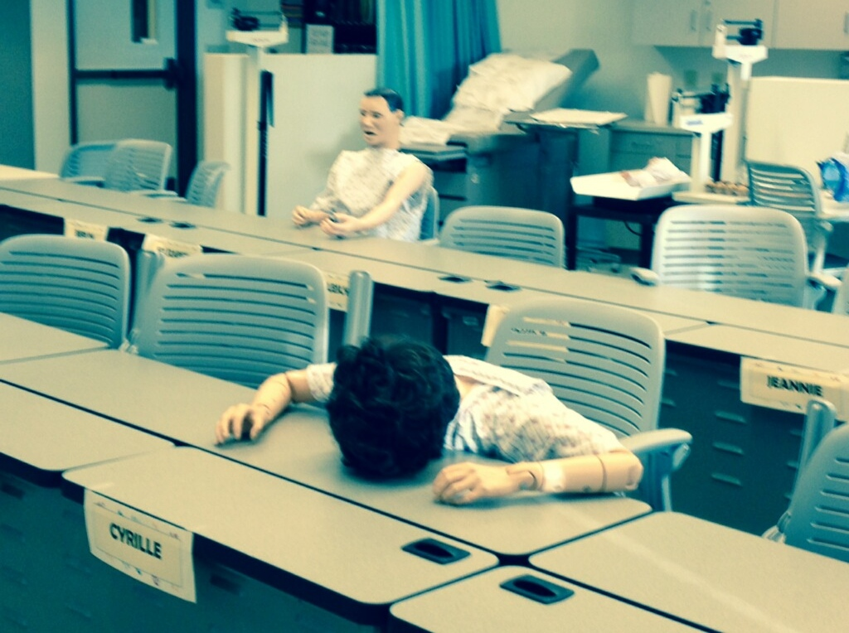
BRING YOUR DATA DAY!
Are you ready for summer?
Are you tired and want to knock out those SLOs assessments in TracDat so you can head out for some relaxation?

We have just the solution for you! Come to “Bring Your Data Day”. You bring your assessment data and we’ll ensure that you get it entered into Trac Dat.
Want assistance entering the data? BYOA! Bring your own assistant or use one of ours.

Need a refresher on Trac-Dat? We can help with that too.

WHEN: Friday, May 15th from 9:00 to 12:00
Monday, May 18th from 1:00 to 4:00
Drop in any time during these hours

WHERE: MCE-340

BRING: SLO assessment forms and a flash drive with your rubrics

Refreshments will be served to brighten your experience.

Can’t make it? We are available other times by appointment or phone. Contact Andrea Horigan or Debbie Newcomb. Note: We are only available until May 20th.

