AGENDA

Date: 11/13/2015
Time: 10 a.m. to 11a.m., Thanksgiving potluck lunch to follow
Room: CCCR

- Call to Order
- Adoption of the Agenda
- Public Comments
- Guest introductions
a. Chancellor – Bernard Luskin
b. Chair Professional Development Comm. - Sharon Beynon
- Approval of Minutes
- Treasures report - Rachel
- Action items
a. Teaching and Learning Center – Sharon Beynon
8. Information Items
a. Making Decisions Document – Rick & Peder
9. SEIU update - Olivia
10. For the Good of the Order
11. Adjournment

POTLUCK time.
Happy Thanksgiving

A special THANK YOU to Lester Tong
for cooking the Ham and Turkey for the Classified Senate.
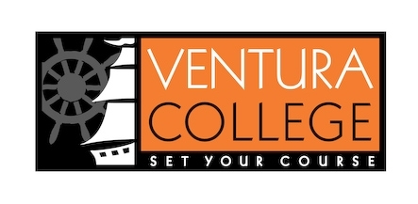
Our College Mission
At Ventura College, we transform students’ lives, develop human potential, create an informed citizenry, and serve as the educational and cultural heart of our community. Placing students at the center of their learning experience, we serve a highly diverse student body by providing innovative instruction and student support, focusing on associate degree and certificate completion, transfer, workforce preparation, and basic skills. We are committed to the sustainable continuous improvement of our college and its services.

9 + 1

1. Standards or policies regarding student support and success
2. College governance structures, as related to classified roles
3. Classified roles and involvement in accreditation processes
4. Policies for classified professional development activities
5. Processes for program review
6. Processes for Institutional planning and budget development
7. Curriculum systems integrations and implementation
8. Degree and certificate requirements
9. Educational program development
- Any other district and college policy, procedure, or related matters that will have a significant effect on Classified Staff

