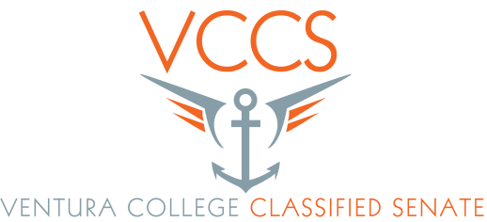
AGENDA

Date: 3 / 3 / 16
Time: 3:00 p.m. - 5:00 p.m.
Room: CCCR

- Call to Order
- Adoption of the Agenda
- Public Comment
- Re-org. in-put needed – Action needed
- New EEO position (Possible)- Pamela - Action needed
- Minutes approval (Sept. 2015, & Jan. 2016) Eileen – Action needed
- Accreditation Report (First reading) Copy and paste link below, or go to
Ventura College web page scroll down near the bottom and
click on working draft for 2016. Or use both lines below as link https://docs.google.com/document/d/1AQ2bldFe493IwCyVdGNvav
BMLS1z34gqFi44f84V3mI/edit?pref=2&pli=1 (the link you will need this line and the line above ge Integrated plan – First reading - Attached
- Integrated plan draft – First reading – See attachment
- SUO – Needed for senate for accreditation – Rachel/Peder
- Information items
a. Spring retreat – Rick/Rachel/ Eileen
b. Orientation for new Classified – Eileen
c. Elections
d. State Classified Senate board meeting here 3/11 to 3/12.
e. Santa Paula – What’s up – Sabrina
f. SEIU update – Olivia/Felicia

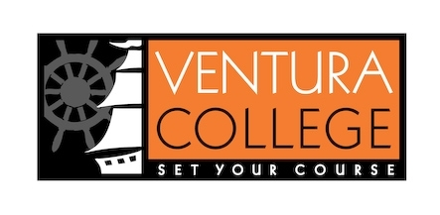
Our College Mission
At Ventura College, we transform students’ lives, develop human potential, create an informed citizenry, and serve as the educational and cultural heart of our community. Placing students at the center of their learning experience, we serve a highly diverse student body by providing innovative instruction and student support, focusing on associate degree and certificate completion, transfer, workforce preparation, and basic skills. We are committed to the sustainable continuous improvement of our college and its services.

9 + 1

1. Standards or policies regarding student support and success
2. College governance structures, as related to classified roles
3. Classified roles and involvement in accreditation processes
4. Policies for classified professional development activities
5. Processes for program review
6. Processes for Institutional planning and budget development
7. Curriculum systems integrations and implementation
8. Degree and certificate requirements
9. Educational program development
- Any other district and college policy, procedure, or related matters that will have a significant effect on Classified Staff

