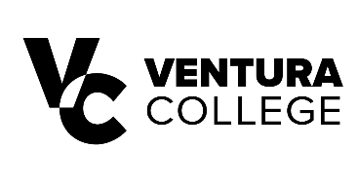

FOR IMMEDIATE RELEASE
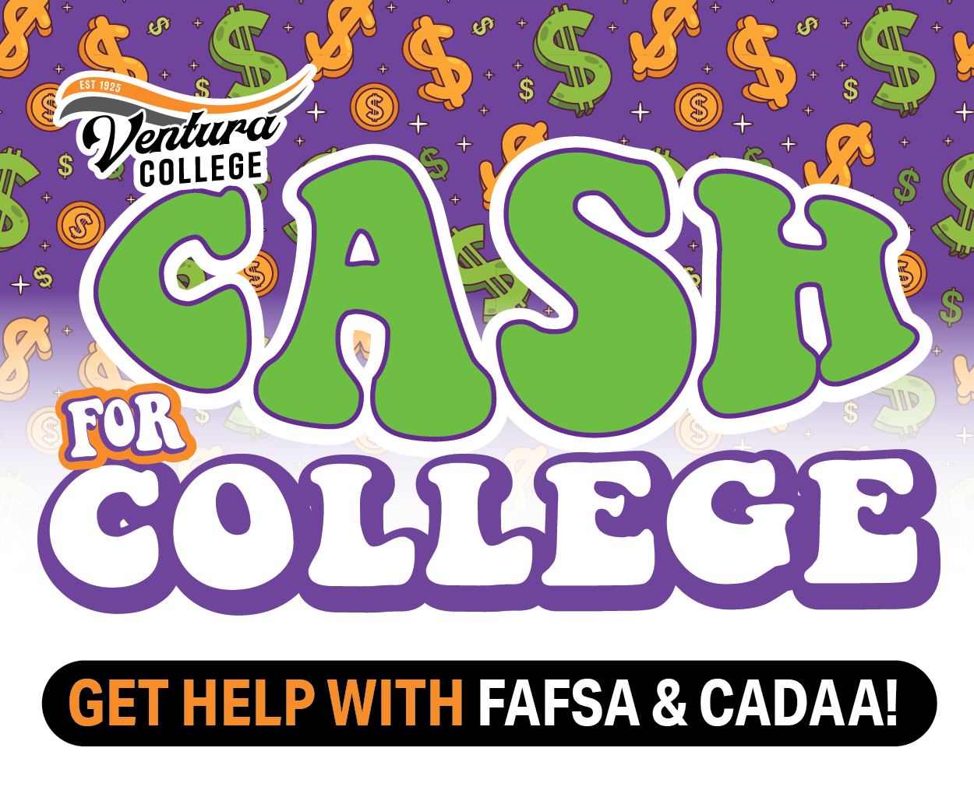
Ventura College to Host Cash for College Workshops in October
Free workshops will help students access financial aid and other resources to pay for college

VENTURA, Calif. (Sept. 29, 2026) — Ventura College will host two free Cash for College workshops in October to help students and prospective students apply for financial aid and access funds to help cover the cost of college. Financial aid can help students pay for tuition, books, housing, transportation, child care, computers and other educational expenses.
“Understanding how to access financial aid can make a meaningful difference in a student’s ability to pursue their educational goals,” said Dr. Luca E. Lewis, Ventura College president. “We want to make sure students and families have the information and support they need to navigate the financial aid process and take full advantage of the resources available to them. At Ventura College, opportunity starts here, and we are committed to helping our students take that next step toward their future.”
The workshops are free and open to the community. Dedicated and experienced financial aid staff will be onsite to provide bilingual, one-on-one, step-by-step assistance with completing the Free Application for Federal Student Aid (FAFSA) or California Dream Act Application (CADAA), as well as information about financial aid eligibility and deadlines. Students may qualify for grants, work-study opportunities and low-interest loans.
Ventura College
Saturday, Oct. 10
9 a.m. to noon
Ventura College Learning Resource Center – 1st Floor
4667 Telegraph Road, Ventura
100.7 KHAY will broadcast live from the Ventura College workshop on Oct. 10 and give away theme park tickets.
Ventura College East Campus
Saturday, Oct. 24
9 a.m. to noon
Ventura College East Campus Learning Resource Center
957 Faulkner Road, Unit 106, Santa Paula
The Cash for College workshops are free, and no appointment is required. Students are encouraged to attend either workshop for assistance completing their financial aid application.
For more information, contact the Ventura College Financial Aid Office at (805) 289-6369 or vcfinancialaid@vcccd.edu, or visit vcccd.edu/cash4college.

About Ventura College
Ventura College, the first institution of higher education in Ventura County, has provided quality education to the community since 1925. A designated Hispanic-Serving Institution, the college enrolls over 13,000 students each semester at two campuses. VC offers over 70 disciplines of study in STEM fields, business, the arts, education, social/behavioral sciences, liberal arts, and the health sciences. Named one of the nation’s top 150 community colleges by the Aspen Institute College Excellence Program, it is the largest provider of workforce participants in the county in manufacturing, automotive technology, and nursing. To learn more, visit VenturaCollege.edu.

Media Contact:
Andrea Rambo
Acting Director of Marketing
(805) 289-6102
Arambo@vcccd.edu

