Ventura College
Facilities Master Plan
2017-2023
DRAFT 5

Table of Contents
SECTION 1 – EXECUTIVE SUMMARY 3
SECTION 2 – INTRODUCTION 5
SECTION 3 – STRATEGIC GOALS 7
SECTION 4 – FACILITIES HISTORICAL PERSPECTIVE 9
SECTION 5 – SPACE UTILIZATION DATA FROM 2015 FMP 15
SECTION 6 – FACILITIES MASTER PLAN OUTREACH 18
SECTION 7 – GOALS AND OBJECTIVES 20
SECTION 8 – CHALLENGES 25
SECTION 9 – OPPORTUNITIES 28
SECTION 10 – NEXT STEPS 29
APPENDIX A 30
APPENDIX B 31
APPENDIX C 34
APPENDIX D 37

SECTION 1 – EXECUTIVE SUMMARY

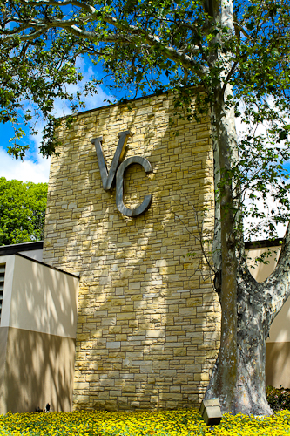
The purpose of the 2017-2023 Facilities Master Plan is to serve as a guide for campus development over the next five years – at the main campus in Ventura and at instructional sites in Santa Paula and Camarillo. This is an exciting time for planning as we implement the Sail to Success Initiative, fulfill the growing demand for distance education, and look toward redefining spaces into interactive environments to enhance opportunities for collaboration, communication and socialization.
This plan honors the collaborate efforts of a multitude of stakeholders, both past and present, who contributed their expertise and time to earlier plans, as well as to this current plan.
The 2017-2023 Educational Master Plan, along with strategic enrollment management, are the key drivers for the new Facilities Master Plan. In addition, this plan seeks to implement recommendations provided by the 2016 Sustainability Plan and the 2017 Technology Master Plan. For purposes of clarity, this plan uses the word “space” to reference all areas on campus, both indoors and outside, while the word “facility” refers to buildings. Finally, this Facilities Master Plan contains five goals that speak to the future of Ventura College:

GOAL 1: Create and maintain spaces and infrastructure that represent Ventura College’s Guiding Principle: We believe that students come first and all else follows.
- Objective 1: Improve access to Student Services facilities.
- Objective 2: Conduct Utilization studies of the current facilities on campus with the goal of determining methods for achieving greater access and efficiency.
- Objective 3: Design spaces to encourage student learning through communication, collaboration and socialization.
- Objective 4: Improve traffic flow, wayfinding, and safety on campus.
GOAL 2: Improve and/or replace aging facilities to support student learning with consideration of funding sources and Total Cost of Ownership.
- Objective 1: Develop a timeline to refurbish and/or replace aging facilities.
- Objective 2: Improve Heating, Ventilation, and Air Conditioning (HVAC) throughout campus.
- Objective 3: Ensure that new and existing facilities align with the energy goals of the 2016 Sustainability Plan and the initiatives delineated in the 2017 Strategic Technology Plan.
GOAL 3: Enhance opportunities for student success through strategic enrollment management as a guide to the use of facilities.
- Objective 1: Ensure accuracy of current and projected space utilization data, including Weekly Student Contact Hours, to help inform scheduling.
- Objective 2: Maximize learning opportunities and improve facility utilization rates by scheduling courses during all available periods.
- Objective 3: Provide opportunities for students to earn bachelors’ degrees onsite through partnerships with local and regional universities as new program developments are initiated.
GOAL 4: Continue to develop and increase access to off-campus programs and facilities.
- Objective 1: Develop and offer curriculum at the Ventura College East Campus such that a significant increase in fulltime equivalent students (FTES) is realized.
- Objective 2: Engage the business and civic leadership as well as other partners in Santa Paula to develop a cost-sharing strategy for a new college facility in the Santa Clara River Valley.
- Monitor the needs of the Sheriff Academy in Camarillo.
GOAL 5: Ensure that Ventura College updates spaces and facilities such that it remains the educational, cultural and innovative hub of the community.
- Objective 1: Balance the needs of the community and campus to mutual benefit.
- Objective 2: Ensure that all Career Education labs meet or exceed industry standards.
- Objective 3: Support educational opportunities for non-traditional students through the restoration of a fee-based, community education program.

There are a number of significant challenges to achieving the Facilities Master Plan Goals and objectives, but perhaps the most formidable is the need for financial resources. Much of the 2004 Facilities Master Plan was accomplished through Measure S bond funds. Addressing the renovation or replacement of the College’s aging facilities will only be realized through similar funding sources.

SECTION 2 – INTRODUCTION

PURPOSE
The purpose of the 2017-2023 Facilities Master Plan (FMP) is to serve as a guide for campus development over the next five years – both at the main campus in Ventura and at instructional sites in Santa Paula and Camarillo. The plan will ensure a world-class learning environment by advancing the College’s Mission, Vision, and Guiding Principles.
The breadth and direction of the Facilities Master Plan are driven by:
- 2017-2023 Educational Master Plan
- Enrollment Management – A critical element of strategic planning for the College as it concerns academic program growth, facility needs, and the Guiding Principle: At Ventura College we believe that students come first and all else follows.

PROCESS
The planning process at Ventura College is collaborative and cyclical, exemplifying the College’s commitment towards continuous improvement (Appendix A). Planning involves faculty, staff, students, community members and administrators who participate in developing the master plans to “operationalize the College Mission into long-term goals and objectives” (2017 EMP, page 52).
Educational Master Plan – Articulates how the college will advance its mission and meet current and anticipated challenges and opportunities.
Facilities Master Plan – Supplements the Educational Master Plan. This is a long-term plan that articulates how the college will meet facilities-related challenges and opportunities.
Technology Master Plan – Supplements the Educational Master Plan. This three-year plan articulates how the college will meet technology-related challenges and opportunities.

VENTURA COLLEGE MISSION
At Ventura College, we transform students’ lives, develop human potential, create an informed citizenry, and serve as the educational cultural heart of our community. Placing students at the center of their learning experience, we serve a highly diverse student body by providing innovative instruction and student support, focusing on associate degree and certificate completion, transfer, workforce preparation, and basic skills, We are committed to the sustainable continuous improvement of our college and services.
VENTURA COLLEGE VISION
Ventura College will be a beacon of learning – a source of inspiration and guidance – for our students and community.

VENTURA COLLEGE GUIDING PRINCIPLES
At Ventura College, we believe that students come first and all else follows. We strive to create a campus environment that fosters collaboration, communication, and mutual respect. We are committed to these Guiding Principles in all that we do:
- Embrace the strength of diversity.
- Listen with intensity and compassion.
- Communicate with integrity and patience.
- Design student-centered solutions.
- Spark self-confidence and a sense of discovery.
- Pursue our vision and goals with passion.

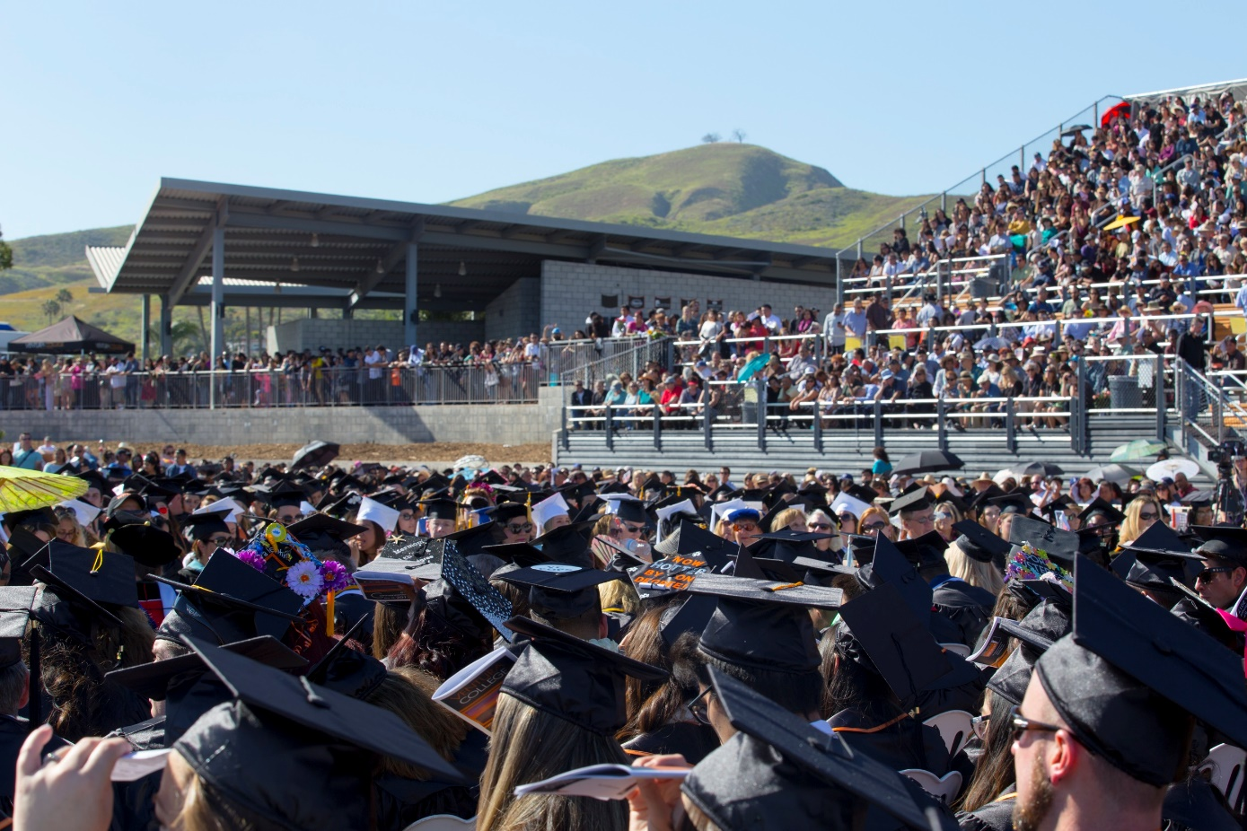
Ventura College Graduation – May 2017

SECTION 3 – STRATEGIC GOALS

The California Community College System, the Ventura County Community College District, and the Ventura College Educational Master Plan all focus on strategies supporting student success. As the Educational Master Plan drives the Facilities Master Plan, its goals are embedded in the
larger vision for the District as well as the California Community College System.

The strategic vision for the California Community College Chancellor’s Office (CCCCO) includes the following goals that the system will strive to achieve by 2022 (https://vision.foundationccc.org/looking-ahead):

- Over five years, increase by at least 20 percent the number of CCC students annually who acquire associates degrees, credentials, certificates, or specific skill sets that prepare them for an in-demand job.
- Over five years, increase by 35 percent the number CCC students transferring annually to a UC or CSU.
- Over five years, decrease the average number of units accumulated by CCC students earning associate’s degrees, from approximately 87 total units (the most recent system-wide average) to 79 total units – the average among the quintile of colleges showing the strongest performance on this measure. (Associate’s degrees typically require 60 units.)
- Reduce equity gaps across all of the above measures through faster improvements among traditionally under-represented student groups, with the goal of cutting achievement gaps by 40 percent within five years and fully closing those achievement gaps within 10 years.

On August 9, 2016, the Ventura County Community College District approved the following District 2013-2019 Strategic Goals:
- Increase access and student success.
- Partner more effectively to meet community needs.
- Promote effective use of organizational resources.
On June 13, 2017, the Ventura County Community College District (VCCCD) Board of Trustees approved the Ventura College 2017-2023 Educational Master Plan with the following goals:
- Increase the success of our students while closing equity gaps.
- Increase our community’s access to transfer, workforce preparation, and basic skills education.
- Strengthen local/regional partnerships and community engagement.
- Enhance institutional effectiveness and accountability to improve innovation and student outcomes.
- Effectively manage campus resources to meet student and community needs.

SECTION 4 – FACILITIES HISTORICAL PERSPECTIVE

Ventura College was founded in 1925 as the Ventura Junior College Department of Ventura High School (the 14th of California’s 114 Junior Colleges). The College’s original mission was to provide the first two years of college education free to Ventura County students preparing to go on to a four-year college or university.
The school opened with 22 students at the Cabrillo campus on Santa Clara Avenue, the current site of Cabrillo Middle School. Classes were taught in the auditorium, which was remodeled into six classrooms, a library and a study hall. The office was located in the tower above the main entrance to the school and an adjacent house was rented as a student activities center.
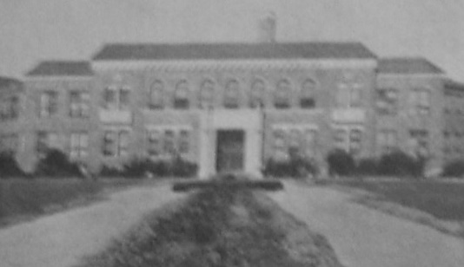
In 1928, a $400,000 bond was passed to purchase a nearby 15-acre site and begin construction on the new Ventura High School & Junior College Campus. In 1930, Architects John C. Austin and Frederick Ashley finished the grand 2-story structure that was to house the Ventura Senior High School and Ventura Junior College for the next 25 years. The new ivy-covered, redbrick building at the corner of Main Street and Catalina contained every aspect of the college: the library, cafeteria, administration offices,
Ventura Junior College - 1930
faculty offices and classrooms. The “L” shape design gave the building three fronts: the center section facing the intersection of Catalina and Main Streets, one wing extending down Catalina, and the other wing extending to the East along Main Street.
In 1934, a 17-acre farm and several residential lots were purchased to accommodate expanding campus needs. By 1939, seven new buildings had been constructed, including the Agriculture building, the Industry and Trades building, and the Commerce building. By 1941, enrollment had reached 800 students and the curriculum adjusted itself accordingly. New vocational courses in police and fire training, carpentry, electrical and mechanical engineering, automotive shop, aviation, and home arts, together with the traditional curriculum occupied the six new campus buildings.
The war years had a major impact on faculty and enrollment. By 1943 faculty numbers had been reduced by 50% and by 1945 only 9 students (one male and eight females) remained in college courses. After the war, enrollment grew rapidly and in 1949 the District Board commissioned the Melbo Study, carried out by the University of Southern California, to plan for a future, independent two-year Junior College.
In 1951, Ventura voters passed a $5.75 million school bond issue by an 89% majority. The Ventura Board voted for a 3-3-2 plan, which created a 3-year high school and proposed a new campus for a 2-year Ventura Junior College. In 1952, construction began on the current Ventura College campus. The site’s picturesque walnut and lemon groves were removed to make way for Ventura’s ultramodern $5,000,000 campus.
The Campus dedication was on April 29, 1955, celebrating the new Telegraph Road campus and the 10 buildings within the campus: the Small Gymnasium, Library, Student Center, Agriculture Building, Automotive Shop, Maintenance, Warehouse, “P”, “O” and “Q” buildings. The campus was landscaped with trees and plants from around the world, creating a campus arboretum.
At the new campus opening, the students placed the large letters “VC” on the hill above campus. Maintaining the school colors of black and orange, the Pirate mascot and all of the other emblems associated with the previous Ventura Junior College gave continuity. The campus that emerged was considered the most modern and best-equipped Junior College in Southern California. These facilities were constructed for a capacity of 2,000 students, which was felt to be adequate until the year 2000. By 1956, enrollment reached 3,562.
Between 1956 and 1958, in order to meet growing enrollment needs, the campus added 6 new buildings in accordance with the original master plan. These included the “J”, “K”, “T”, and “U” buildings, Administration and the Large Gymnasium.

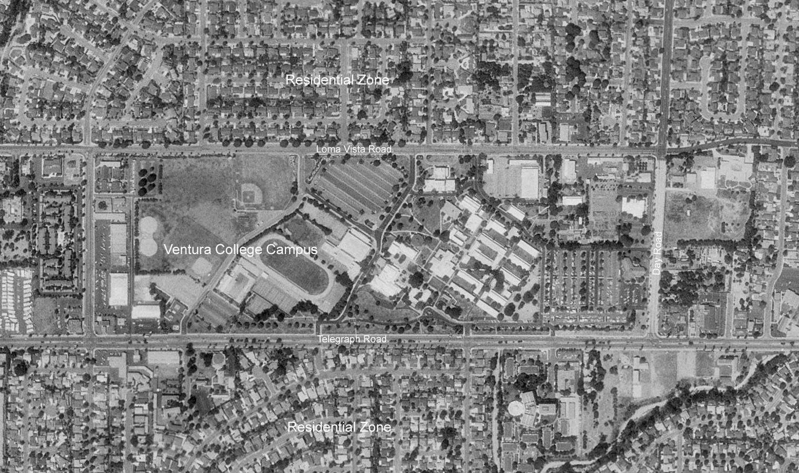
Aerial Photograph of Ventura College 2004

2004 FACILITIES MASTER PLAN
Consultants Leo A. Daly Architects along with Ventura College faculty, staff and administrators developed the 2004 Ventura College Facilities Master Plan. The goals of the 2004 FMP included:
- Maintain quality open space
- Create better classroom and lecture facilities
- Pedestrian circulation improvements
- Create additional parking to meet persistent needs
- Consolidate programs into larger multi-story building to maximize land use
- Allow for future campus growth and development
- Create a more logical, clearly defined entrance to the campus
- Create “Welcome to Ventura College” signage along Telegraph Avenue
- Maintain and enhance the existing landscaping as an Arboretum
- Resolve pedestrian and vehicular circulation conflicts
In addition to those goals, the 2004 FMP also focused on accomplishing the following:
- Implementation of the Measure S projects to achieve a balanced campus
- Provide direction for projects beyond the Measure S funding horizon
- Balance campus and surrounding community needs to mutual benefit
- Improvements to the campus utility systems
- Provide suitable adjacencies and campus organizational concepts
- Encourage the construction of low-maintenance, low-operating cost facilities
In 2002, Ventura County voters passed Measure S, authorizing a $356 million general obligation bond to renovate and expand the campuses of the District’s three colleges as well as the District training facilities for police, fire, and law enforcement officers. The first Ventura College building constructed using bond funds was the Library and Learning Resource Center that opened in 2005. The remodeled Student Services Center opened in 2008, and the Sportsplex opened in 2009. In 2011, Ventura College dedicated a new Health Science Complex and two classroom buildings: Multidisciplinary Center East and West. In 2012, a new professional-caliber Performing Arts Center opened its doors for educational and community programs. In 2015, the college began offering classes in the new Applied Science Center with three large classrooms, one out door classroom, and a state-of-the-art Career Technical Center with training simulators and simulator software to provide hands-on, real life lab experience for students. (2016 Ventura College Accreditation Report, page 1). See Appendix B for the complete list of Measure S Projects.

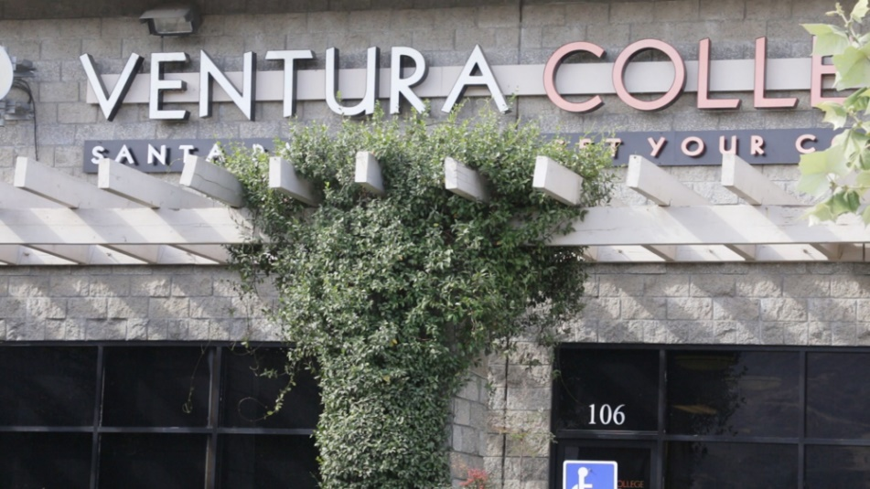
VENTURA COLLEGE EAST CAMPUS, 1974 TO PRESENT
In 1974, Ventura College began offering classes in Fillmore to serve the Santa Clara River Valley’s predominantly Hispanic population. The Santa Paula Vocational Center, later known as Ventura College East Campus, opened in 1980 on Dean Drive in Santa Paula. A Santa Clara Valley Advance
Ventura College East Campus Entrance
Technology Education Center was on the list of Measure S Projects initially. In 2006, the Ventura County Community College District Board of Trustees voted not to fund the $25 million required for this project. Subsequently, the Santa Clara River Valley Task Force was established to plan for the development of an educational center, possibly in the Harvest at Limoneria community.
This satellite campus moved to its current location on Faulkner Road in Santa Paula in 2011. Designated as a Hispanic Serving Institution by the United States Department of Education, Ventura College continues to expand access to high education for the under-represented areas of the Santa Clara River Valley (2016 Ventura College Accreditation Report, page 1).

CAMARILLO SITE
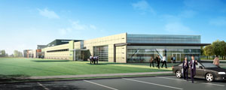
Another capital project that funded through the Measure S Bond was the Regional Fire, Sheriff & Police Education and Training Academy in Camarillo. This $23.9 million project of a 48,000 square feet facility on over six acres houses facilities for the Fire Department and the
Artist’s Rendering – Camarillo Academy
Sheriff Academy. Construction was completed in 2011, and the maintenance of most of this facility and grounds has been the responsibility of Ventura College since 2016. See Appendix D for the full list of areas of responsibility.

2015 FACILITIES MASTER PLAN UPDATE
STV Consulting developed the 2015 Facilities Master Plan Update with input from the College’s Facilities Oversight Advisory Group (FOG), the Budget Resource Committee, administrators, faculty, staff, students, and members of the community. This plan served as a bridging document between the 2004 Facilities Master Plan and the 2017-2023 Facilities Master Plan while the College was developing the 2017-2023 Educational Master Plan. The 2017-2023 Educational Master Plan has since been completed and approved.
The process for the 2015 FMP update reconfirmed the 2004 FMP goals as still being relevant with these further clarifications and additions:
- Improved Entries/Identity – including Signage and Way-finding
- Better Facilities – Correctly Sized and Flexible
- Quality Open Space/Landscaping – including a Social Center to the Campus
- More Parking
- Better Pedestrian and Vehicular Flow
- Improved Utilities – including Technology
- Sustainable Approach – build with Total Cost of Ownership in mind
- Accommodate Distance Ed/Blended Programs and New Teaching Pedagogies
- Create Campus Environments that Encourage Students to Stay on Campus (by increasing outdoor gathering spaces and food options)
- Improve East Campus (Santa Paula Site) Facilities
- Maintain Faculty Center for Teaching and Learning (Faculty Resource Center)
- Meet the Career and Technical Education needs of Industry
- Enhance Industry/Community Partnerships
- Bring back Community Education
- Balance the Campus
- Leverage College Assets for Community Use
The 2015 FMP priorities echo the priorities cited for this most current plan. Facilities priorities includes:
- One-Stop Student Services
- Food/Drink Facilities
- Science/Mathematics Facility
- Athletics (Facilities and Fields)
- Community Education Facility
- Classrooms (Size and Flexibility)
- Parking Garage
- Social Areas/Lounges in Facilities
- Faculty Resource Center
- Event Center
- East Campus (Santa Paula)
- Housing
- Testing Center
Site priorities, again, include increased site parking, gathering places, sustainable landscaping as well as recycling and composting, pedestrian and bicycle pathways, and improved signage and way-finding. Additionally, the campus highly prioritized SMART technology, upgraded air conditioning, design standards and optimizing facilities utilization.

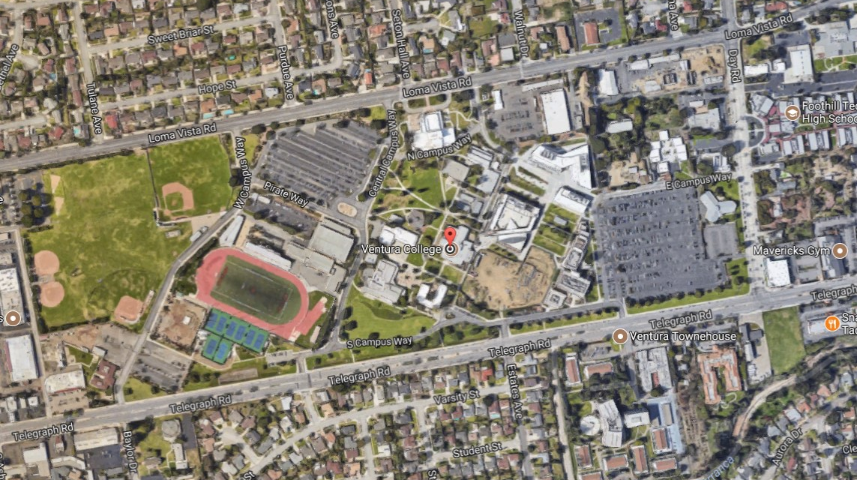
Ventura College on Google Maps - 2015

SECTION 5 – SPACE UTILIZATION DATA FROM 2015 FMP

Facility revenue is allocated by the state based on two factors: room utilization data and Weekly Student Contact Hours (WSCH) rates. Any discussion regarding facilities needs to include a review of these elements. Specifically, the State expects each Classroom to be utilized 48 hours out of 70 hours (8AM until 10PM, Monday through Friday), and for 66% of the student stations in each classroom to be occupied during those 48 hours. The State Standard for Class Labs is 27.5 hours of use out of the same 70 hours, and 85% of student stations to be occupied during those 27.5 hours.
The 2015 Facilities Master Plan Update recommended that the College undertake a process to have the space inventory verified and updated in FUSION, the Facility Utilization Space Inventory Option Net used by community colleges. The room utilization statistics below are cited from the update (page 24) and suggest that classrooms and labs are underutilized.
- 70 Classrooms
  - 9 of them (13%) meet State Standards for Utilization
  - 30 of them (43%) meet State Standards for Hours of Use but not Station Count for all hours used
  - 31 of them (44%) do not meet State Standards for Utilization for neither Hours in Use nor Station Count
- 32 Laboratories (not including Physical Education)
  - 3 of them (9%) meet State Standards for Utilization
  - 12 of them (38%) meet State Standards for Hours of Use but not Station Count for all hours used
  - 17 of them (53%) do not meet State Standards for Utilization for neither Hours in Use nor Station Count
The figures above came under scrutiny during the writing of this current Facilities Master Plan. Upon further investigation, the utilization rates for laboratories in the Science Building are much greater than indicated in the 2015 update. There are a number of factors relating to this possible miscalculation not the least of which is the classification of rooms in FUSION and actual utilization on campus. The project of correctly identifying classrooms and laboratories in the State database is vital to the College’s utilization rates and future financial allocations.
  - 7 Laboratories (22%) meet State Standards for Utilization
Representing one half of the total number of on campus, 50% of these laboratories meet State Standards for Hours in Use and 44% meet State Standards for Station Count (Spring 2018). However, rates for Hours in Use and Station Count of the laboratories in other buildings continue to fall short of state standards.

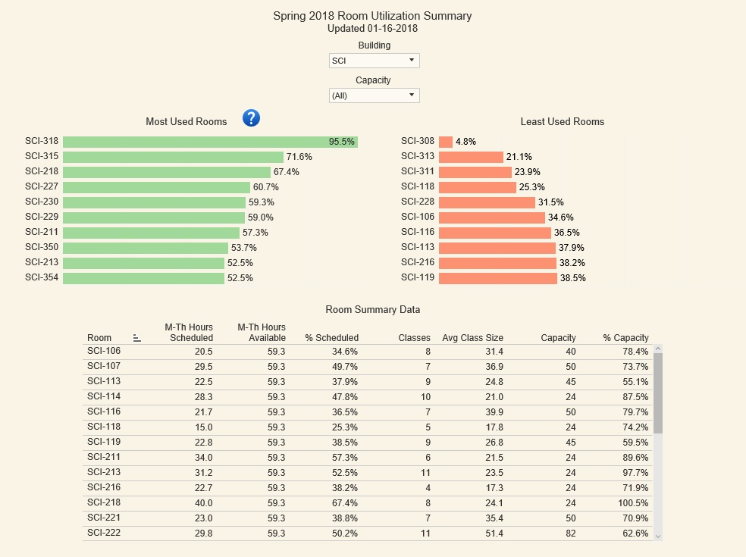
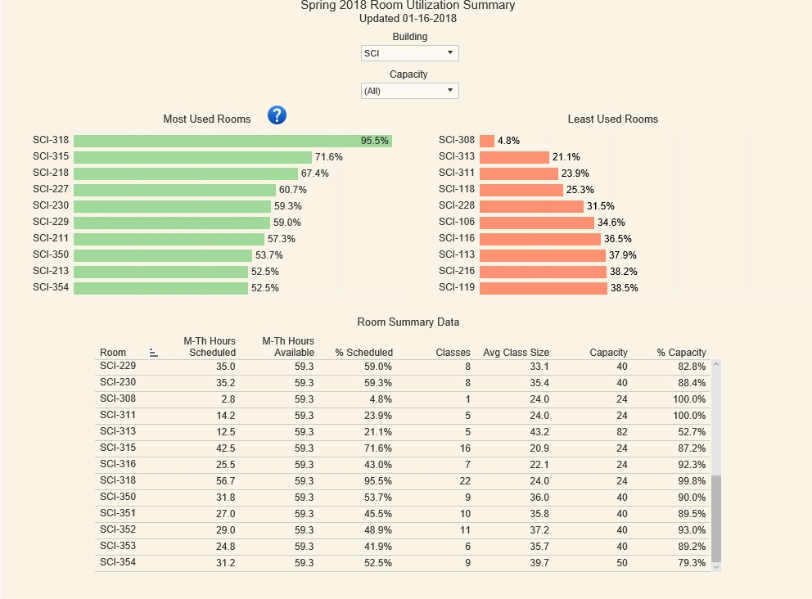
Utilization rates do not address the need to renovate or replace aging facilities that have reached their lifespan and no longer serve the best interests of students and the community. Using the State methodology for Facilities Condition Assessments, as documented in the State database, FUSION, several buildings on campus including the Athletic Event Center, Small Gym, Administration building, are 60 years old, have inappropriate foundations/fill and are inadequate for the current needs. Although the Facility Condition Index shows the Science and Mathematics building as being in good condition, the reality is that this building has the most maintenance and operations work order requests than any other building.
During its 2016 Accreditation Commission for Community and Junior Colleges (ACCJC) accreditation visit, Ventura College was commended for “its well-maintained and attractive grounds and facilities in a conducive educational learning environment despite the age of some facilities and continuing effect of the drought.”
The College also received the following recommendation for improvement:
“In order to increase effectiveness, the team recommends that the college and district consider various public and private funding sources, such as a local capital outlay bond, to upgrade and/or replace aging facilities (ACCJC Accreditation Standard III.B.1, III.B.2, III.B.3, III.B.4).”
The District may need to begin engaging in discussions regarding a new bond measure.

SECTION 6 – FACILITIES MASTER PLAN OUTREACH

As the 2017-2023 Education Master Plan began to take shape, the Office of Business & Administrative Services, the Facilities, Maintenance & Operations department, and College Services began inviting input from faculty, staff, students, and the community to develop the goals and objectives in the Facilities Master Plan. Stakeholder input is cited in Appendix C.
The Facilities Oversight Advisory Group (FOG) meets on the fourth Thursday of each month to provide input for all facility-related issues. FOG is an advisory group comprised of staff, administrators, and faculty representing various disciplines on campus. The Facilities Master Plan is an ongoing agenda item for discussion by this group. In November 2016, a subcommittee of FOG began meeting to draft the new Facilities Master Plan.
On March 31, 2017, the College held a Planning Retreat at the Ventura Beach Marriott. One hundred and seven members of the College’s staff, faculty and administration attended. During three, 30-minute breakout sessions, the Director of Facilities, Maintenance & Operations (pictured left) and the College Services Supervisor held concurrent workshops requesting input for the Facilities Master Plan. After a brief introduction of the planning process and key concepts, participants in the workshops broke into smaller groups to generate ideas for possible projects that should be incorporated into the new plan.
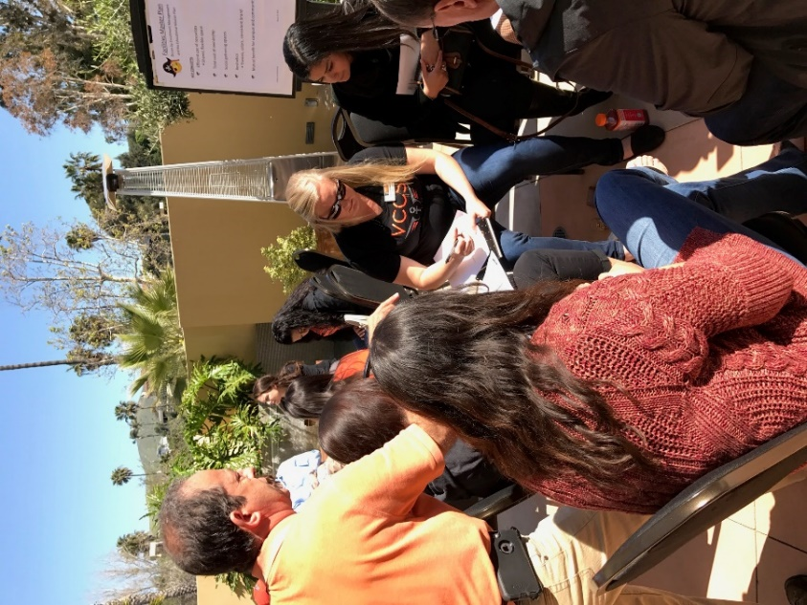

College Planning Retreat 3/31/17

On April 11, 2017, the same overview, key concepts and “big ideas” were shared at the Associated Students Ventura College meeting.
On April 26, 2017, the Director of Facilities, Maintenance & Operations and the College Services Supervisor addressed the College Area Community Council (CACC). The CACC’s input was consistent with feedback gathered for the 2015 update.
On May 4, 2017, input from the College Planning Retreat and the CACC meeting was shared at the Classified Senate meeting. As most of the individuals present had also attended the retreat in March, no new points were brought forth for consideration.
On August 29, 2017, the FOG subcommittee met to review and provide additional input for the second draft of 2017 Facilities Master Plan. This subcommittee met semi-monthly to review and revise the plan until its completion.
On September 27, 2017, a draft of the 2017-2023 Facilities Master Plan was presented to the College Planning Committee. Feedback from that presentation has also been incorporated into this document.
On November 2, 2017, draft presented to the Classified Senate for review.
On January 11, 2018, updated draft presented to the Classified Senate.
On February 1, 2018, updated draft presented to the Academic Senate.
On February 21, 2018, updated draft presented to the Budget Resource Committee.
On February 22, 2018, draft discussed at the Facilities Oversight Advisory Group.
On February 28, 2018, draft reviewed at College Planning Committee.

SECTION 7 – GOALS AND OBJECTIVES

Input from all campus constituencies, as well as the College Area Community Council, illustrates a passion for student success and a desire to ensure that Ventura College remain “a beacon of learning – a source of inspiration and guidance – for our students and the community” (Ventura College Vision). Following are the goals and objectives for the 2017-2023 Facilities Master Plan:

GOAL 1: Create and maintain spaces and infrastructure that represent Ventura College’s Guiding Principle: We believe that students come first and all else follows. (Supports EMP Goal 5 – Effectively manage campus resources to meet student and community needs.)
Objective 1: Improve access to Student Services facilities.
Objective 1a: Consolidate student services into a single facility, with consideration of potential funding sources and Total Cost of Ownership which reflects all direct and indirect costs. A Student Services “one stop shop” will increase efficiency and effectiveness of the services offered as access is streamlined.
Objective 1b: Remodel the Financial Aid department in the BCS Building to increase efficiency and improve communication.
Objective 2: Conduct utilization studies of the current facilities on campus with the goal of determining methods for achieving greater access and efficiency.
Objective 3: Design spaces to encourage student learning through communication, collaboration and socialization.
Objective 3a: Design comfortable gathering spaces, indoor and out (including Pirates’ Walk) with robust WiFi, charging stations, art exhibits and sculpture gardens.
Objective 3b: Preserve the arboretum elements of the campus including the Orchard, Garden, and AG area.
Objective 3b: Determine a long-term solution for food service on campus.
Objective 3c: Explore the development of a cyber café.
Objective 3d: Explore options for student housing.
Objective 4: Improve traffic flow, wayfinding, and safety on campus. Wayfinding is defined as all methods used to convey location and direction (i.e. signage, maps and other graphic or audible means.
Objective 4a: Redesign South Campus Way to include a roundabout and road extension.
Objective 4b: Balance campus traffic, East and West, morning and afternoon/evening.
Objective 4c: Explore options for new staff parking.
Objective 4d: Ensure that signage is maintained and well lit at night; explore the use of solar-powered lights on signage, as well as touch-responsive, talking signs to assist students with visual impairments, as well as individuals using wheelchairs.
Objective 4e: Upgrade facility locking mechanisms and campus-wide public address systems. This objective is also a component of the 2017-2020 Ventura College Strategic Technology Plan.
Objective 4f: Design bike and skateboard lanes that do not impede the flow or safety of pedestrians on campus.
Objective 4g: Ensure sufficient numbers of bicycle racks throughout campus.

GOAL 2: Improve and/or replace aging facilities to support student learning with consideration of funding sources and Total Cost of Ownership. (Supports EMP Goal 1 – Increase the success of our students while closing equity gaps; EMP Goal 2 – Increase our community’s access to transfer, workforce preparation, and basic skills education; and EMP Goal 5 – Effectively manage campus resources to meet student and community needs.)
Total Cost of Ownership is a significant component of this goal as well as the Facilities Master Plan as a whole in that it calls for an accurate financial estimate of all direct and indirect costs associated with each initiative.
Objective 1: Develop a timeline to refurbish and/or replace inadequate facilities.
- Student Services Center
- Science and Math Building
- Financial Aid Department in BCS
- Athletic Event Center
- Career Education Labs (includes Water Science, Forensics, Emergency Medical Technician, and Nursing)
- West Fields
- Agricultural Building to support the curriculum for emerging agricultural industries.

2018 CAMPUS MAP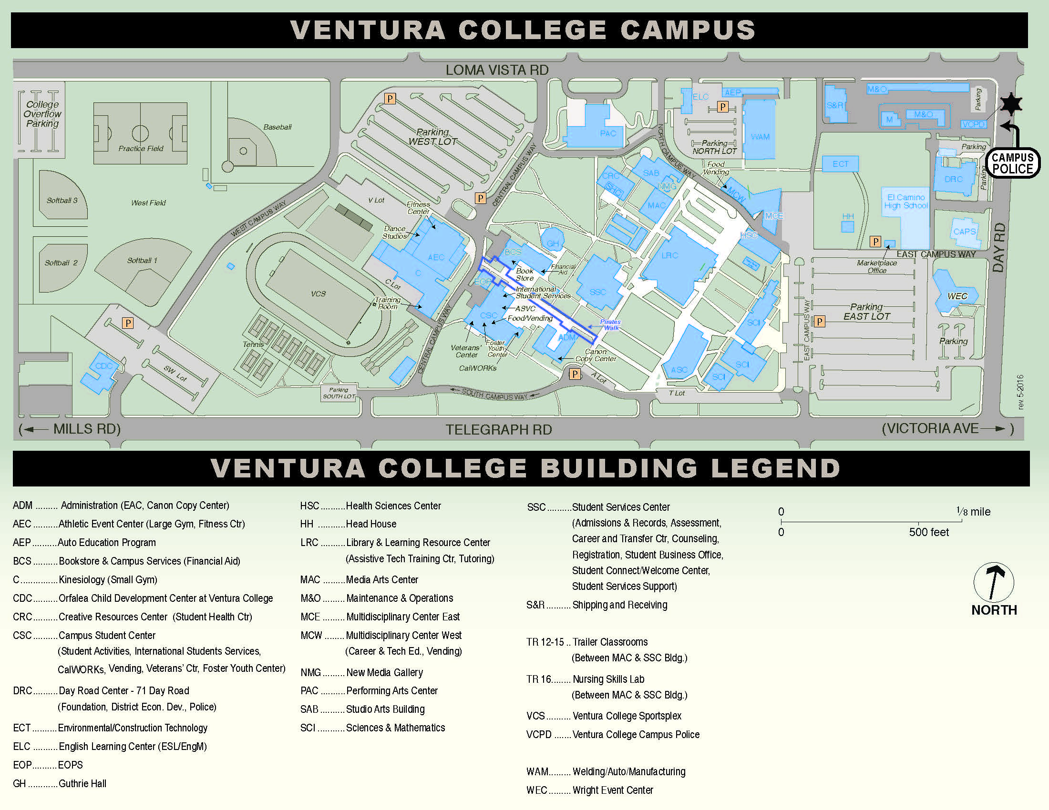
Objective 2: Improve Heating, Ventilation, and Air Conditioning (HVAC) throughout campus. Highest priority buildings are:
- Science and Math Building
- Learning Resource Center
- Athletic Event Center
- Creative Resources Center

Objective 3: Ensure that new and existing facilities align with the energy goals of the 2016 Sustainability Plan and the initiatives delineated in the 2017 Strategic Technology Plan.
Objective 3a: Install utility meters in individual buildings to monitor energy efficiency.
Objective 3b: Explore alternative energy options including the installation of solar panels on the West Parking Lot.
Objective 3c: Maximize use of smart classrooms through enrollment management by placing the most restrictive classes first.
Objective 3d: Explore “next generation” learning furniture for select classrooms.
GOAL 3: Enhance opportunities for student success through strategic enrollment management as a guide to the use of facilities. (Supports EMP Goal 1 – Increase the success of our students while closing equity gaps; EMP Goal 2 – Increase our community’s access to transfer, workforce preparation, and basic skills education; EMP Goal 3 – Strengthen local/regional partnerships and community engagement; EMP Goal 4 – Enhance institutional effectiveness and accountability to improve innovation and student outcomes: and EMP Goal 5 – Effectively manage campus resources to meet student and community needs.)
Objective 1: Ensure accuracy of current and projected space utilization data, including Weekly Student Contact Hours, to help inform scheduling.
Objective 2: Maximize learning opportunities and improve facility utilization rates by scheduling courses during all available periods.
Objective 3: Provide opportunities for students to earn bachelors’ degrees onsite through partnerships with local and regional universities as new program developments are initiated.

GOAL 4: Continue to develop and increase access for off-campus programs and facilities. (Supports EMP Goal 2 – Increase our community’s access to transfer, workforce preparation, and basic skills education; and EMP Goal 3 – Strengthen local/regional partnerships and community engagement.)
Objective 1: Develop and offer curriculum at Ventura College East Campus such that a significant increase in fulltime equivalent students (FTES) is realized.
Objective 2: Engage the business and civic leadership as well as other partners in Santa Paula to develop a cost-sharing strategy for a new college facility in the Santa Clara River Valley.

GOAL 5: Ensure that Ventura College updates spaces and facilities such that it remains the educational, cultural and innovative hub of the community. (This goal supports EMP Goal 1 – Increase the success of our students while closing equity gaps; EMP Goal 2 – Increase our community’s access to transfer, workforce preparation, and basic skills education; EMP Goal 3 – Strengthen loca/partnerships and community engagement; EMP Goal 4 – Enhance institutional effectiveness and accountability to improve innovation and student outcomes; and EMP Goal 5 – Effectively manage campus resources to need student and community needs.)

Objective 1: Balance the needs of the community and campus to mutual benefit.
Objective 1a: Establish a VC Visioning Committee to conduct research and forecast stakeholder needs regarding campus facilities for the next decade and beyond.
Objective 1b: Develop strategies for more efficient communication with the public regarding facility rental opportunities through the Civic Center.
Objective 1c: Rebrand the Wright Event Center into the Ventura College Community Center, which would be available for community conferences, and events.
Object 1d: Explore options to reuse the former pool site with respect toward landscaping and the college’s history as an arboretum.
Objective 2: Ensure that all Career Education labs meet or exceed industry standards.
Objective 2a: Engage Career Education advisory committees for ongoing review of facilities and equipment.
Objective 3: Support educational opportunities for the community through the restoration of a fee-based, community education program.
Objective 3a: Update institutional knowledge in best practices for operating a not-for-credit, community education program.

SECTION 8 – CHALLENGES

Some of the largest challenges to achieving the Facilities Master Plan goals and objectives are:
- Securing new financial resources
In the past 10 years, the College has been able to demolish a number of buildings that were past their useful life and replace them with fewer, larger buildings that collocated synergistic disciplines together. This level of renovation was possible through the passage of the Measure S Bond. There are several capital projects cited in this Facilities Master Plan that will only be addressed through a new bond measure.
- Effectively prioritizing existing resources
The 2015 FMP update reconfirmed that some of the projects addressed in the 2004 FMP were only partially completed or not done at all and that those projects remain among the top priorities for the College. Verifying that the information in FUSION is accurate may help the College secure an increased allocation in the future so to address, even partially, these outstanding needs.
- Disrupting the status quo regarding scheduling
Whether it is the practice of scheduling a greater number of afternoon, evening, or weekend classes or the design of a rolling two-year class schedule, strategic enrollment management is key to the effective use of campus resources. It is understandable that any scheduling changes will be a challenge to the existing program.
- Committing to funding the human resources necessary to advance these goals
- Creating alternate spaces to hold classes during construction, i.e. swing space
One of the greatest challenges when renovating spaces such as laboratories is the construction of alternative rooms to accommodate the curriculum. In many cases, the construction of swing space may add tens of thousands of dollars to the cost of the project.

- Changing climate temperatures and conditions in Ventura
According to Cal-Adapt Climate Projections for the South Coast Region, the average temperature departure from average for Ventura will be an increase of three to five degrees. A heat wave along the cost is defined as five days over temperatures in the 80s. It is expected that these periods will increase in frequency.

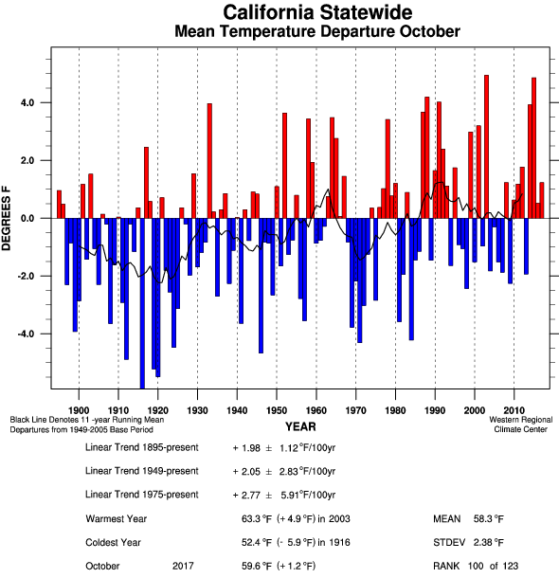
Source: Public Interest Energy Research, 2011. Cal-Adapt, OPC 2013.
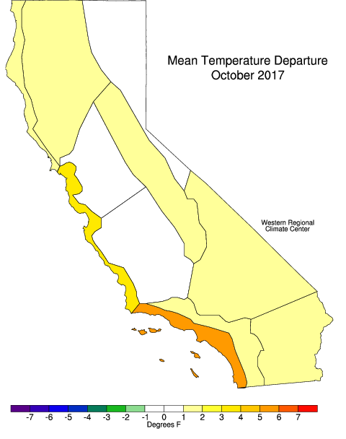
Source: Public Interest Energy Research, 2011. Cal-Adapt, OPC 2013.

SECTION 9 – OPPORTUNITIES

The Ventura College campus is located in a unique and scenic part of Southern California. The campus sits on a south-facing slope at a generally high elevation than the rest of the city and as a result, provides views to the surrounding hillsides, town and Pacific Ocean. These connections are an important part of the Ventura College image, making the campus part of the region, a place that both focuses inwards to campus life and outwards to the community and region.
The campus provides open space and recreational facilities to the Ventura community including use of athletic fields and facilities, the Performing Arts Center, and the landscaped areas as parkland and arboretum. Preserving and enhancing this relationship is central to the image of the campus in the community.
Our greatest opportunities rooted in the Facilities Master Plan goals and objectives include:
- Improved student outcomes due to enhanced access to student services
- Expanded and enhanced community partnerships
- Smoother traffic flow on and around campus
- Improved wayfinding
- Additional resources directed toward sustainability
- Expanded opportunities for non-traditional students and the community
- Enhanced opportunities for higher education across the Santa Clara River Valley

SECTION 10 – NEXT STEPS

The VCCCD Strategic Goals will remain the same through 2019, however Ventura College’s Educational Master Plan, Facilities Master Plan, and Information Technology Strategic Plans have all been updated. The Strategic Implementation Plan is currently being revised for the new Educational Master Plan. This revision will ensure expedient implementation of the master plans’ current goals.
Although there is no current discussion for a new bond measure, it would be prudent for Ventura College to have a capital projects list identifying and prioritizing the highest facility needs across campus. This prioritized list should be included in this and all future Facilities Master Plans.
The 2017-2023 Capital Projects List is as follows:
- Comprehensive Students Services Center
  - To include Financial Aid, Bookstore, Extended Opportunities Programs & Services (EOPS), Educational Assistance Center (EAC), and Veteran’s Resource Center in addition to all other services currently located in the Student Services Center.
- New Science Building
  - New Laboratory/Classroom facility
- Upgraded Athletic Event Center and C Building (Small Gym)
  - New additional facility for Fitness Center
- Career Education Laboratories
  - To accommodate Water Science, Forensics, Emergency Medical Technician, and Nursing curricula.
- Renovations of West Fields and Former Aquatic Area
- Agricultural Facilities
- Upgraded HVAC Systems
  - Science and Math Building
  - Learning Resource Center
  - Athletic Event Center and C Building
  - Creative Resources Center
- Performing Arts Center Classroom Expansion

APPENDIX A
MASTER PLANNING TIMELINE
From Education Master Plan

 | 2017 | 2018 |  | 2019 |  | 2020 |  | 2021 |  | 2022 |  | 2023 |  | 2024 |  | 2025 |  | 2026 |  | 2027 |  | 2028 |  | 2029
 | Fall | Spring | Fall | Spring | Fall | Spring | Fall | Spring | Fall | Spring | Fall | Spring | Fall | Spring | Fall | Spring | Fall | Spring | Fall | Spring | Fall | Spring | Fall | Spring
Educational Master Plan | 2017 - 2023 Educational Master Plan
 |  |  |  |  |  |  |  |  |  |  |  |  | 2023 - 2029 Educational Master Plan
Strategic Implementation Plan | 2017-2020 Strategic Impl Plan
 |  |  |  |  |  |  | 2020-2023 Strategic Impl Plan
 |  |  |  |  |  |  |  |  |  |  |  |  | 2023-2026 Strategic Impl Plan
 |  |  |  |  |  |  |  |  |  |  |  |  |  |  |  |  |  |  | 2026-2029 Strategic Impl Plan
Facilities Master Plan | 2017 - 2023 Facilities Master Plan
 |  |  |  |  |  |  |  |  |  |  |  |  | 2023 - 2029 Facilities Master Plan
Tech Master Plan | 2017-2020 Tech Master Plan
 |  |  |  |  |  |  | 2020-2023 Tech Master Plan
 |  |  |  |  |  |  |  |  |  |  |  |  | 2023-2026 Tech Master Plan
 |  |  |  |  |  |  |  |  |  |  |  |  |  |  |  |  |  |  | 2026-2029 Tech Master Plan

APPENDIX B
MEASURE S BOND PROJECTS

VENTURA COUNTY COMMUNITY COLLEGE DISTRICT MEASURES BOND PROJECTS - EXHIBIT B NUMBERED(SEE NOTE) COUNTYWIDE PROJECTS FOR PUBLIC SAFETY INSTRUCTION
Estimated Cost: $23,905,124
i • Construct Regional Fire, Sheriff & Police Education and Training Academy, Including classroom and instructional facilities and
equipment for Sheriff and Fire Training Academies, and replace outdated electrical and utility systems
2 • SITE PLANNING AND DEVELOPMENT
3 • DISTRICTWIDE PLANNING AND DEVELOPMENT MOORPARK COLLEGE REPAIR 8r. IMPROVEMENT PROJECTS
Estimated Costs: $104,239,503
4 • Expand Learning Resources and Telecommunications Center by improving library space and computer classrooms
5 • Add classrooms and lecture halls by converting old library space
15 • Complete site Improvements, upgrade fire safety and security alarm systems
7 • Construct Academic and Computer Center, including adding computer science labs and other classrooms
a • Construct classrooms for the new Conejo Education Center, a joint project with the Conejo Valley Unified School District to serve the TO community
9 • Construct a Joint Instructional Center with Moorpark Unified School District for college classrooms accessible to high school students
10 • Construct a Simi Valley Education Center
ii • Construct Health Sciences and math classrooms and lecture halls
12 • Expand Student Services Facility for counseling, financial aid, other services 13 • Repair old classrooms
14 • Expand Student Center
15 • Construct Child Development Center 16 • Refurbish physical education facilities
11' • Expand animal science education center to address student enrollment demand 18 • Construct new operations and warehouse facilities
19 • Build parking structure to alleviate neighborhood traffic congestion 20 • Construct Fine Arts building
21 • Expand Music Building 22 • Retire capital financing
23 • CAMPUS PLANNING AND DEVELOPMENT
24 • DISTRICTWIDE PLANNING AND DEVELOPMENT
25 • INFRASTRUCTURE NECESSARY TO SUPPORT SPECIFIED CAMPUS PROJECTS OXNARD COLLEGE REPAIR 8r. IMPROVEMENT PROJECTS
Estimated Costs: $110,983,187

26 • Construct additional classrooms, labs, lecture halls; replace old portables (Buildings A, B, C)
21 • Renovate Library & Learning Resource Center to bring library to current state standards 28 • Construct Health Sciences Building and Instructional Media Facility, including adding more classrooms and labs
29 • Renovate aging campus infrastructure by installing new wiring/electrical systems for technology
30 • Construct High Tech Building, including classrooms, lecture halls, labs 31 • Refurbish student facilities, expand bookstore
32 • Construct Student Services Building to address overcrowding
33 • Replace aging Child Development Center portables with improved, permanent facilities
• Construct Performing Arts classroom and auditorium, Including expanding teaching/performance space
35 • Replace inadequate Health & Safety Building (Student Health Center) with safe facilities 36 • Renovate athletic fields for safety compliance
37 • Add new parking structure for pedestrian, vehicular safety 38 • Construct maintenance warehouse
39 • Retire capital financing
40 • CAMPUS PLANNING AND DEVELOPMENT
41 • DISTRICTWIDE PLANNING AND DEVELOPMENT
42 • INFRASTRUCTURE NECESSARY TO SUPPORT SPECIFIED CAMPUS PROJECTS VENTURA COLLEGE REPAIR 8r. IMPROVEMENT PROJECTS
Estimated Costs: $117,220,000
43 • Renovate 37 year old G Building/Auditorium, including replacing antiquated electrical, heating, ventilation, plumbing and lighting systems
44 • Replace outdated Health Science Building (Nursing, Paramedics, Emergency Medical Technician and Certified Nursing Assistant Programs),
including adding labs, lecture halls, classrooms
45 • Replace Portables and build General Purpose Education Building for permanent classrooms, labs, lecture halls
46 • Construct Advanced Technology Education Training Building by building permanent classrooms, lecture halls, computer labs
47 • Construct and upgrade science classrooms and labs
43 • Complete construction of Learning Resource Center/library
49 • Upgrade Financial Aid, Disabled Student Services, Counseling, Student Services and Communications Building
50 • Construct Santa Clara Valley Advanced Technology Education Center including classrooms, computer labs, library, and Child Care Center
51 • Renovate athletic facility for health/safety, upgrade physical education facilities 52 • Upgrade electrical and utility systems
• Improve Fine Arts lab, Art Classroom Building H
• Renovate maintenance and operations facilities, including storage 55 • Construct and renovate parking facilities
58 • Renovate auxiliary services and Student Counseling Center
51 • Retire capital financing
5S • CAMPUS PLANNING AND DEVELOPMENT
59 • DISTRICTWIDE PLANNING AND DEVELOPMENT
• INFRASTRUCTURE NECESSARY TO SUPPORT SPECIFIED CAMPUS PROJECTS

APPENDIX C
FACILITIES MASTER PLAN – STAKEHOLDERS’ INPUT

March 31, 2017 Planning Retreat FMP Ideas Breakout Session – 10:30am
Banners, e-signs
Cafeteria, food center with seating Additional security measures, cameras HVAC
Inviting gathering spaces
Parking structure with solar panels Water conversation
Improved communication from M&O (TrackIt) Buses on campus
Charging stations – cyber café Better location for FIT lab Bicycle and skateboard parking New Science building
Breakout Session – 11:00am
Classrooms by day/units, not disciplines
Active furniture, student-friendly classrooms Faculty offices more accessible/visible Outdoor meeting spaces
HVAC
Use unutilized spaces for training Food service, price points, cafeteria
Campus Center is currently not inviting Need space utilization/visualization model
Better communication from administration re: class cuts and space utilization 3rd floor MCE gathering space
Look at why some classrooms are “preferred” and correct Maintain a quiet space on campus
“Digital Divide” – keep textbooks on campus STEM Center
Shared space impacts equipment purchases Accessibility
Protect keyboards Public printer
Locks inside of classroom
Breakout Session – 11:30am
One-stop buildings – Student Services + Admin + Bookstore Gathering quad
Cohesive, campus-wide theme/color Patio with shade
WiFi
More recycling
Solar charging stations Filtered water stations HVAC
Front of ASC – landscaping w/ color, monarchs VC stone structure

On April 26, 2017, College Area Community Council:
Sustainability – suggesting that the Agricultural program could begin growing food Would like a bigger, better library – more resources available to the public Athletics and Health could offer more options for use by the public
IT Support for the community – either through classes, workshops, or walk-in assistance availability
Move the weekend Market Place currently operated by The Foundation on Saturdays and Sundays in the East Parking Lot
More walking paths
Better utilization of Wright Event Center
Expressed some concern regarding the potential for student housing and its possible impact

Notes from Facilities Oversight Group -- Big Ideas:
Usage of former pool site and storage area near CDC West Field (SoccerPlex, softball fields)
New CTE Lab Building including Water Science, Forensics lab, EMT, NS New SCI Building and Science Wet Lab
New Student Services Building – consolidating services LRC – utilization study of building
Student Housing AG Facility
AEC Renovation/Expansion of building (demolish C Bldg) Performing Arts Center (Dance Studio)
Solar Panels on West Lot HVAC – campus-wide
Balance campus traffic – East/West and AM/PM South Campus Way, roundabout and road extension
New staff parking
Walking/Biking/Skateboarding paths throughout campus Social Gathering Space
Indoors adjacent to Student Services areas
SGS - Outdoors throughout campus including Pirates Walk Food Court(s)
Art – indoors and outdoors
Historical references – arboretum, agricultural
Budgets for Buildings, Fixtures, Furniture and Equipment (BFF&E) Locks/Safety Project including public address system
Wright Event Center - potential conference center

APPENDIX D
