WHAT ARE SLOS?

SLO Workshops
8/13 11 – 12 Closing the Loop
9/11 9 – 11 Simplifying Assessments
10/2 9 - 11 Closing the Loop
11/6 9 – 11 TBA
12/4 9 – 12 Bring your data day

SLOs (Student Learning Outcomes) are levels of knowledge, skills, and abilities that a student attains from their learning experience. SLOs must be measurable. A rubric must be created to be used in assessing each SLO.

What do SLOs do?
- Make students aware of what will be expected of them – they don’t have to guess.
- Provide meaningful assessments to see if expectations are met.

SLOs should be concise statements of what we want students to:
- Know/Understand in terms of content: facts, theories, concepts
- Values: open-mindedness, ethics, social responsibility
- Be able to do in terms of skills: computational, collaborative, communication, occupational, etc.

THERE ARE THREE TYPES OF SLOS AT VENTURA COLLEGE: ISLOS, PSLOS, AND CSLOS.
ISLOs (Institutional SLOs) are broad educational goals that are shared across campus. These are the outcomes every student who leaves VC with a degree, certificate, or vocational training should be able to do or know. Our ISLOs are:
- Communication (written, oral, visual)
- Scientific and Quantitative Reasoning
- Critical Thinking and Problem Solving
- Information Literacy
- Personal/Community Awareness and Academic/Career Responsibilities

We focus on a different ISLO each academic year so that all five ISLOs will be assessed during our 5-year rotational plan. We have rubrics for each of them. Each course at VC has been mapped to at least one ISLO. Your department chair will provide you with information about which one(s) you are to assess and when.

PSLOs (Program Level SLOs) are the knowledge, skills and abilities that a student should have after completion of a specific degree or certificate. They broadly cover knowledge gained from major- specific courses.

PSLOs only need to be assessed in courses that were mapped to that PSLO as a course that 'masters' that outcome at a 2-year college level.
CSLOs (Course level SLOs) represent the knowledge, skills and abilities a student should have after completing a course. These are course-specific areas of knowledge.
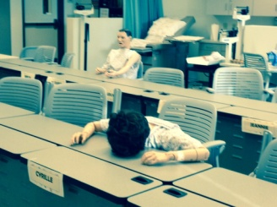
LEARN MORE ABOUT SLOs at VC:
Attend the upcoming workshops.

