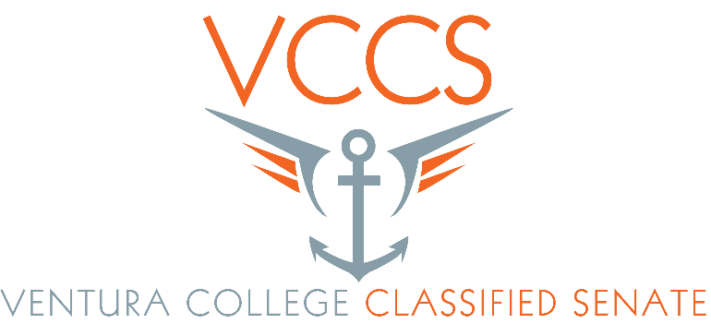

Classified Staff Retreat
March 22, 2016 – Guthrie Hall
8:00a – Sign In
8:15a – Continental Breakfast
8:45a – Welcome
9:00a – Senate Meeting
9:45a – Break
10:00a – Exercising In Your Workspace – Pamela Yeagley
10:45a – Team Building
11:50a – SEIU Update
12:15p – Lunch
1:00p – Emergency Training w/ Thomas O’Conner
2:00p – Evaluations & Wrap-Up

