Dear Mr. Peder Nielsen SEIU Local 99,
REC'D APR 2 8 2015

I am honor to be a recipient of the SEIU Local 99 Classified Senate Scholarship, I am extremely obligated and I want to thank you for choosing me for this award. Receiving this scholarship has been a major blessi ng to me and my family, not only am I thanking you for this award but my mother is also thankful that Ihave been awarded this scholarship. Out of all the
people you could have chosen I am extremely grateful to have been the person you did choose, I never would have thought I would be recei ving such an honor.

I will be attending Ventura College again next semester for my final semester at a commun ity college and then moving on to the next chapter of my life. I plan on studying kinesiology at the next college I attend and with my degree I plan to become a physical trai ner. This scholarship will be a major benefit and will provide a help an hand when its needed.

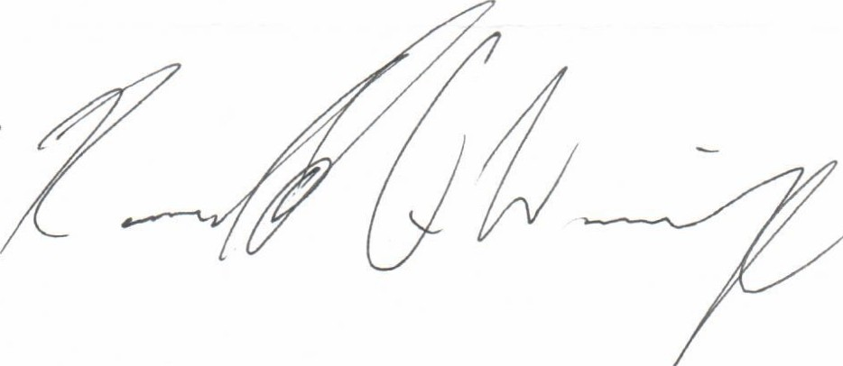Again I want to express my indebted gratitude to the SEIU Local 99 Classified Senate Scholarship and another huge thank you to Mr. Peder Nielsen and the scholarship foundation for choosing me as the recipient of this award. It is truly an honor to receive this award. Thank you again for making this possible and your generosity I highly appreciate it.

Sincerely,

REC'D APR 2 8 2015

Dear Mr. Peder Nielsen Classified Senate,

I am honor to be a recipient of the Classified Senate Scholarship, I am extremely

obligated and I want to thank you for choosi ng me for this award. Receiving this scholarship has been a major blessing to me and my fami ly, not only am I thanking you for this award but my mother is also thankful that I have been awarded this scholarship. Out of all the people you could
have chosen I am extremely grateful to have been the person you did choose, T never would have thought I would be receiving such an honor.
I will be attending Ventura College again next semester for my final semester at a community college and then moving on to the next chapter of my life. I plan on studying kinesiology at the next college I attend and with my degree I plan to become a physical trainer. This scholarship will be a major benefit and will provide a help an hand when its needed.

Agai n I want to express my indebted gratitude to the Classified Senate Scholarship and another huge thank you to Mr. Peder Nielsen and the scholarship foundation for choosing me as the recipient of this award. It is truly an honor to receive this award. Thank you again for making this possi ble and your generosity I highly appreciate it.

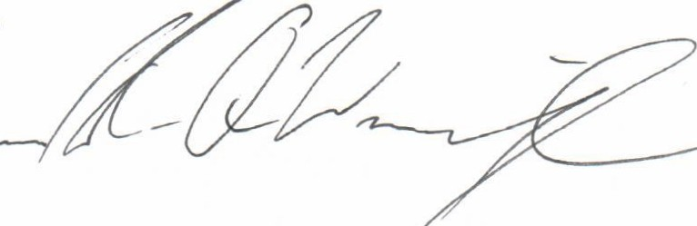Sincerely

Dear Mr. Peder Nielsen and the Classified Senate,

T am honored to be the recipient of the Classified Senate Scholarship. This truly opens the door to my future a little wider as I continue to pursue my degree in the medicaJ field. I am also grateful for those before me who have, and continue to contribute to the scholarship foundation.
It will be an honor and a blessing to graduate this May 21 , 2015. I plan on returning to Ventura Community College in the fall to take Algebra 1, and Spanish towards my associates of science degree as a multi-skilled medical assistant. It is my dream to eventually work in a Veterans hospital, giving back to those who have served our country.
Once again, I want to thank you for making this scholarship possible and for your generosity .

Sincerely,

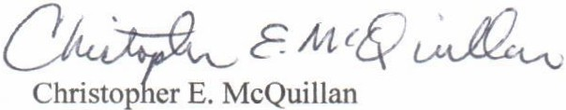

Dear Mr. Peder Nielsen and SEIU Local 99,

Iam honored to be the recipient of the SEIU Local 99 Classified Senate Scholarship. This truly opens the door to my future a little wider as I continue to pursue my degree in the medical field. I am also grateful for those before me who have, and continue to contribute to the scholarship foundation.
Itwill be an honor and a blessing to graduate this May 21, 2015. I plan on returning to Ventura Community College in the fall to take Algebra 1, and Spanish towards my associates of science degree as a multi-skilled medical assistant. It is my dream to eventually work ina Veterans hospi tal, giving back to those who have served our country.
Once again, I want to thank you for making this scholarship possible and for your generosity.

Sincerely,

{)u4C1Uct;'
Christopher E. McQuillan

