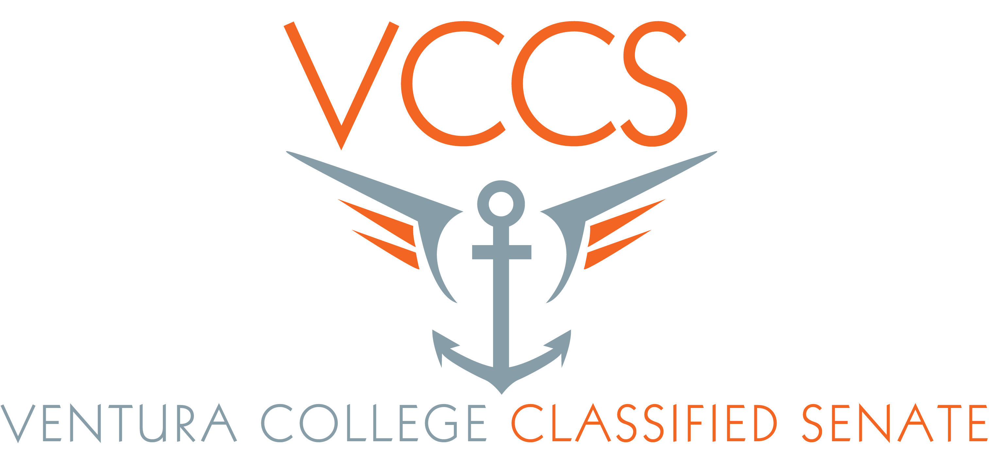

Agenda
March 12, 2015
11:00 a.m.
CCCR

- Call to order - Peder
- Public comments
- Approve minutes – Eileen
- Treasures Report – Rachel
- Governance Committee report – Rick, Linda, & Peder
- Retreat 2015 – Peder
- Classified Handbook – Need to update – Need help
- Review Senate Charge - Peder
- Committee updates:
- DCAP – Pamela & Peder
- Admin. Council – Peder
- Diversity – Eileen
- Professional Development VC – Eileen
- Professional Development District – Peder
- Announcements;
- Earth Day 4/23/15 – Barbara
- SEIU – Olivia
- Ajournment

