Ventura College
Accreditation Steering Advisory Group
9/4/2019
MCW – 312 | 3:00 – 4:30 PM
- Call to Order
- Public Comments and Introductions
- Approval of Minutes (May 2019 Meeting)
- Announcements/Information Items
  - Midterm Report due Oct. 15, 2020
  - Comprehensive review due fall 2023
- Discussion Items
  - Review Advisory Group Charge, Purpose, and Membership
  - 2019-20 Goals and 2018-19 Accomplishments
  - Review Current Accreditation Standard Subcommittees
(from May 2019 Meeting)
  - Preparing for Mid-Term Report Process and Timeline
(See Handout: Guidelines for Preparing Institutional Reports to the Commission)
  - Review recommendations in ISER and from visiting team (Standards IIIB, IIIC, and IV)
- Action Items
  - Review three meeting takeaway points
  - Determine Next Steps
- Adjournment
Items in reserve: Discuss naming convention for file evidence, evaluate QFE progress, map accreditation standards to new governance structure, Committees report activities related to accreditation standards (fillable form), and monitor compliance with posting minutes/agendas on web.
Next Meeting Date: 10/2/2019

Our Mission
At Ventura College, we transform students’ lives, develop human potential, create an informed citizenry, and serve as the educational and cultural heart of our community. Placing students at the center of their learning experience, we serve a highly diverse student body by providing innovative instruction and student support, focusing on associate degree and certificate completion, transfer, workforce preparation, and basic skills. We are committed to the sustainable continuous improvement of our college and its services.
Our Vision
Ventura College will be a beacon of learning—a source of inspiration and guidance—for our students and community.
Our Guiding Principles
At Ventura College we believe that students come first and all else follows. We strive to create a campus environment that fosters collaboration, communication, and mutual respect. We are committed to these Guiding Principles in all that we do:
- Embrace the strength of diversity
- Listen with intensity and compassion
- Communicate with integrity and patience
- Design student-centered solutions
- Spark self-confidence and a sense of discovery
- Pursue our vision and goals with passion
Advisory Charge
The Accreditation Steering Advisory Group (ASAG) monitors college compliance with regional accreditation standards in order to sustain continuous quality improvement. ASAG coordinates ongoing efforts to organize evidence used to prepare the Institutional Self Evaluation Report, follow-up reports, and mid-term reports. Recommendations from the ASAG are referred to the College Planning Committee.

Proposed Goals for Academic Year 2019-2020
- TBD
- .
- .

Accreditation Steering Advisory Group
2018-2019 Academic Year
Meeting Notes
May 1, 2019 ~ 3:00 p.m. – 4:00 p.m.
Members: ALO: Kim Hoffmans; Faculty Co-Chair: Eric Martinsen; Classified Co-Chair: Sebastian Szczebiot
Vice President of Academic Affairs (Accreditation Liaison Officer and Chair – Selected by advisory group), Vice President of Student Affairs, Vice President of Business Services, Dean of Institutional Equity and Effectiveness, Academic Senate Executive Committee members, ASAG Faculty Co-Chair, Basic Skills Advisory Group Co-Chairs, Budget Resource Council Co-Chairs, Classified Senate Executive Board members, College Planning Council Co-Chairs, Curriculum Committee Co-Chairs, Deans of Student Learning, Facilities Oversight Group Co-Chairs, Institutional Researcher, Librarian, SLO Advisory Group Co-Chairs, Student Success Committee Co-Chairs, Professional Development Advisory Group Co-Chairs, Technology Advisory Group Co-Chairs, Distance Education Advisory Group Co-Chairs, Equity Advisory Group Co-Chairs, SSSP Advisory Group Co-Chairs, CE Advisory Group Co-Chairs, ASVC Representative
Attended: Kim Hoffmans, Eric Martinsen, Sebastian Szczebiot, Grant Jones, Lynn Wright, Phil Briggs, Lydia Morales, Tim Harrison
DRAFT
Recorder: Sebastian Szczebiot
Notes:
Agenda Item |  | Summary of Discussion | Action  (If Required) | Completion Timeline | Assigned to:
- Call to Order |  | 3:05 pm
- Public Comments and Introductions
- Approval of Notes |  | Please send any changes to Sebastian
- Announcements/  Information Items | - ACCJC Reaffirmation Letter  - Midterm Report due Oct. 15, 2020  - Comprehensive review due fall 2023
- Discussion Items
- Review and make recommendations for revisions to Accreditation Standard Subcommittee from 2016  DRAFT | See Handout.  Vice President of Student Affairs to lead Executive team in Quality Focus Essay.  Standard 1B is very Student Learning Outcomes (SLO) heavy and it would be beneficial to involve the College Outcomes Group (COG) Co-Chairs  For Standard I – Phil will digest and bring recommendations to Deans Council in order to bring in more Deans as leads.  It might be important to include someone from student service for Standard 1C (i.e. Dean of Student Services)  Standard II A: include Professional Development co-chairs  Standard I IC: include Distance Education staff  Standard III A: Dean on DCHR - Tim Harrison to lead  Standard III B: FM&O Director (to be hired) to lead  Standard III C: IT Director to lead  Standard III D: College Fiscal Service Supervisor - Jeanine Day Lead  Standard IV C: Vice Chancellor of IE  Standard IV D: Vice Chancellor of IE and College President  SLOs and Professional Development and have been integrated well into the standards – no need for standalone leads now. |  | Recommendation where and how to bring in more deans as leads. |  | Phil Briggs
- Review recommendations in ISER and from visiting team  DRAFT | Standard I: Institution set standards – the standard can be considered the floor, then you have an actual goal, and finally, a stretch goal.  Is the terminology cleaned up now?  -We have offered some clarity through our Education Master Plan. However, with all the changes at the state Chancellor’s Office, we may need to revise our strategy again.  We have met our recommendations and the next step would be finding good ways to communicate this to the campus!  Recommendation Review:  Standard I  IB.1 – District to run perception surveys every other Spring. It is important to make sure these address all the components. We could also pull date for this from committee surveys.  IB.2 – Completed for ISLOs but not ISUOs? ISUO are compliance specific, but perhaps this needs to be revised and worked on by COG next year  IB.3 – Vision for Success Goals have replaced some of these, but yes we have completed.  IB.4 – we started doing this the year of the visit – via starfish for example.  IB.5 – Yes we are now doing this.  Overall – no big gaps in standard I  DRAFT  Standard II  IIA.4 – Completed  IIB.1 – Consolidated two locations into one, still discussing funding for expanding tutoring. Remainder of this recommendation is still in progress, but has already been included in program review.  IIC.1 – We have counselor designees, as well as online tutoring. DE does have a local readiness assessment. There has been progress even with financial aid.  NEED TO FOLLOW UP with DE  IIC.2 Completed  IIC.7 Completed  Standard III  IIIA.5 – Not yet actioned  IIIA.6 – this standard and recommendation have been removed (STRIKETHROUGH)  IIIA.12 – Progress has been made  IIIB and IIIC plus Standard IV still to be reviewed |  | Follow up with Distance Education regarding recommendations around standard II
- Committee Survey Results | Printout Distributed
- Action Items
- Review 3 meeting takeaway points  DRAFT | -Clarified subcommittee leads  -Reviewed standard I, II, and III recommendations (good progress has been made on completing most recommendations, and standard 4 recommendations will be reviewed in the fall)  -Noted collegial environment of committee even if all goals were not met |  | Review Standard IV recommendations
- Determine Next Steps | - Review
G. Adjournment | E. Martinsen adjourned the meeting at 4:00 p.m.
Next Meeting Date: | Fall 2019

GOALS
2018-2019
rev. 11-06-2018
# | GOALS | ACCOMPLISHMENTS
1 | Determine organization and taxonomy for use with SharePoint. Begin collection of evidence of documenting compliance with accreditations standards.
2 | Inform College Community of resources related to accreditation best practices; including:  - Accreditation tips  - FAQs  - Definition of terms
3 | Evaluate current status regarding VC Quality Focus Essay initiatives (Beacons of Success and Sail to Success), as well as an identified recommendation from the 2016 Accreditation Institutional Self-Evaluation Report (ISER) and the visiting team.
4 | Map accreditation standards to existing committee/governance structure.  - Standing agenda items for meetings  - Collection and posting of evident  - Compile annual summary of activities in relation to accreditation standards (online fillable form/survey)  - Monitor compliance with posting agendas and minutes

Ventura College
Accreditation Standards Subcommittees
(5/1/19 draft)

Area | Members by Position | Members
Accreditation Liaison Officer | Vice President, Academic Affairs (CIO) | Jennifer Kalfsbeek-Goetz

Area | Members by Position | Members
Introduction | Lead - ASAG Co-Chair | Lisa Putnam
- Structure of the Institutional Self-Evaluation Report/History and effectiveness data | ASAG Co-Chairs | Lisa Putnam  TBD  TBD
- Organization of the Self-Evaluation Report and Organizational Information | Institutional Effectiveness Dean | Phillip Briggs
- Eligibility Requirements | ALO | Jennifer Kalfsbeek-Goetz
- Compliance with Commission Policies | ALO | Jennifer Kalfsbeek-Goetz
Quality Focus Essay | Lead – VP Student Affairs  w/Executive Team | Damien Pena

Area | Members by Position | Members
Standard I: Institutional Mission and Effectiveness | Lead – Institutional Effectiveness Dean | Phillip Briggs
- Mission | Institutional Effectiveness | Phillip Briggs
- Assuring Academic Quality and Institutional Effectiveness | Institutional Effectiveness  College Outcomes Group (COG) Co-Chairs | Phillip Briggs
- Institutional Integrity | Institutional Effectiveness  Dean, Student Services | Phillip Briggs  Marcelo Vazquez

Area | Members by Position | Members
Standard II: Student Learning Programs and Services | Lead – Academic Dean | Lynn Wright
- Instructional Programs | Academic Deans  College Outcomes Group (COG) Co-Chairs  Academic Senate designee  Professional Development Co-Chairs  Curriculum Committee Faculty Co-Chair  Department Chair Council Co-Chair | All Academic Deans  Phillip Briggs  TBD  Chez Harper & Dan Kumpf  Michael Bowen
- Library and Learning Support Services | Librarians  Tutoring Center representatives | Peter Sezzi
- Student Support Services | Dean of Student Services  Registrar  Distance Education Staff | Marcelo Vazquez  Matthew Moore  Sharon Oxford  Ali Olson-Pacheco

Area | Members by Position | Members
Standard III: Resources | Lead – VP of Business Services | Cathy Bojorquez
- Human Resources | Dean on DCHR  H.R. College Staff  Director, Personnel  Director, Human Resources | Tim Harrison  Michael Arnoldus  Laura Baroso
- Physical Resources | FM&O Director | TBD
- Technology Resources | IT Director | Grant Jones
- Financial Resources | College Fiscal Service Supervisor | Jeanine Day

Area | Members by Position | Members
Standard IV: Leadership and Governance | Lead – College President | Kim Hoffmans
- Decision-Making Roles and Processes | College, Academic, and Classified Senate Presidents | Kim Hoffmans  Lydia Morales  Sebastian Szczebiot
- Chief Executive Officer | College President | Kim Hoffmans
- Governing Board | District Section: Vice Chancellor Institutional Effectiveness | Cathy Bojorquez
- Multi-College Districts or Systems | District Section: Vice Chancellor Institutional Effectiveness | Kim Hoffmans

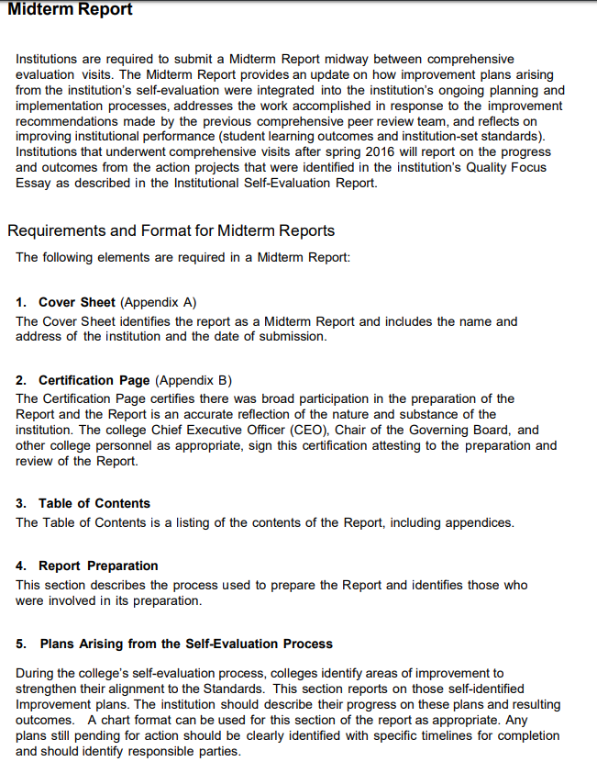

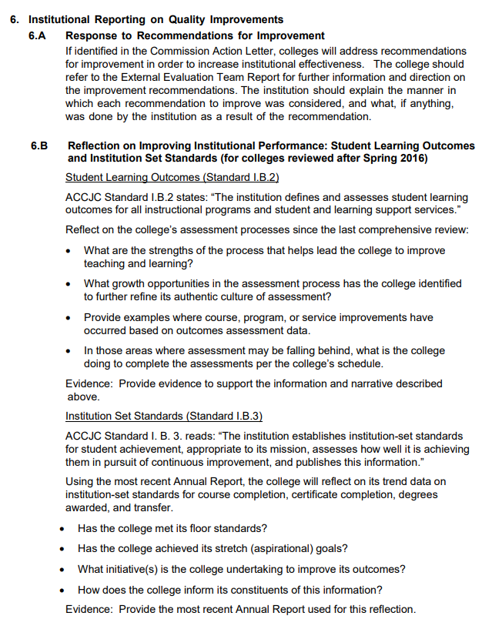
Excerpt from ACCJC Publication: https://accjc.org/wp-content/uploads/Guidelines-for-Preparing-Institutional-Reports_Fall-2020-and-beyond.pdf
Ventura College Accreditation Midterm Report Timeline
September 2016 ACCJC team visits Ventura College to validate the college’s Institutional Self-Evaluation Report (ISER) and review evidence of compliance with the accreditation standards.
February 2017 Ventura College accreditation is reaffirmed with the requirement that the college complete a Follow-Up Report on the issues identified in the team’s finding of non-compliance at the District, due March 2018.
DRAFT
Fall 2017 Accreditation Taskforce established to write draft of Follow-Up report and to gather evidence
Spring 2018 Follow-Up report approved by VCCCD Board (Jan 2018) and submitted to ACCJC March 2018.
Fall 2018/Spring 2019 Accreditation Steering Advisory Group begins preparing for Midterm Report; subcommittees established, leads identified; action planning items identified and organized; college begins providing input on progress on recommendations and planning agendas.
Fall 2019/Spring 2020 Midterm Report to be prepared – due October 15, 2020
September 2019 Accreditation Steering Advisory Group (ASAG) establishes Midterm Report process and timelines. Subcommittees finish collecting college input on progress on recommendations and planning agendas.
October 2019 Subcommittees prepare 1st draft of Report on Self-Identified Improvement Plans from ISER and Team Recommendations for Improvement from Team Report.
(Begin this process during working ASAG meeting)
Executive team prepares Report on the Quality Focus Projects.
Institutional Effectiveness prepares ACCJC Midterm Report Data Form (using Annual Report Data submitted in Spring 2017, 2018, and 2019)
ALO and ASAG Co-Chairs prepare:
- Cover Sheet
- Certification Page
- Table of Contents
- Description of Report Preparation Process

November 6, 2019 Accreditation Steering Advisory Group reviews and edits:
- Report on Self-Identified Improvement Plans from ISER
- Report on Team Recommendations for Improvement
- Report on Quality Focus Projects
- ACCJC Midterm Report Data Form

November 19, 2019 Executive management team reviews and provides input, filling in gaps and making corrections to facts, if needed
November 21, 2019 Academic Senate Meeting: Review and provide input, filling in gaps and making corrections to facts, if needed
DRAFT
December 5, 2019 Classified Senate Meeting: Review and provide input, filling in gaps and making corrections to facts, if needed
December 13, 2019 ASAG Co-Chairs collect feedback from Executive Management and Senates
January 2020 Subcommittees receive feedback on action plans and update reports as necessary
February 5, 2020 Accreditation Steering Advisory Group reviews updated draft of Report on Self-Improvement Plans
Mid-Feb - March 2020 Midterm Report posted online and portal for the all-college review. Executive Management Team reviews final draft.
April 2, 2020 Academic and Classified Senates’ Meetings, 1st Read of Midterm Report
April 16, 2020 Academic Senate Meeting, 2nd Read of Midterm Report
May 7, 2020 Last Academic Senate Meeting of 2019-20
Classified Senate Meeting, 2nd Read of Midterm Report
June 2020 Submit Midterm Report for Graphic Design Publication
July 2020 Submit Midterm Report to District for Agenda Setting
August 11, 2020 VCCCD Board Mtg, 1st Read of Midterm Report
September 8, 2020 VCCCD Board Mtg, 2nd Read of Midterm Report
October 1, 2020 College sends the Midterm Report and supporting evidence to ACCJC.
 | ISER Section | Item | Team or ISER Rec? | Anticipated Completion | Lead / Contact Person | Notes | Status  (as of Sept 2019)
1 | I.A.2.1  I.B.3.1 | In order to increase effectiveness, the team recommends that the institution adopt unambiguous definitions of data elements used in its institution set standards. | Team  (Improvement)
2 | I.B.1  I.B.6  QFE | See Action Project #2 in the Quality Focus Essay on shifting to a campus culture with broad participation, improved communication, and strong collegial support. Refer to Page. 289 | ISER  Action Plan
3 | I.B.2 | During the 2016-2017 and 2017-2018 academic years, the SLOAG will lead the College in the development of an assessment rubric for ISLO #5 (Personal/Community Awareness and Academic/ Career Responsibilities), and will facilitate the development of rubrics for the two ISUOs | ISER  Action Plan | Spring 2018
4 | I.B.3 | As part of its revision of the Educational Master Plan, the Core Indicators of Effectiveness will be evaluated and revised. This will ensure that they are directly aligned with the ACCJC institution-set standards, the State of CA Institutional Effectiveness Partnership Initiative Goals, and the State of CA Student Success Scorecard. This will streamline reporting requirements, and better focus efforts on high-priority areas | ISER  Action Plan
5 | I.B.4 | Ventura College will identify and track uniform data elements for use in college program review for current student services programs. Identification and tracking will be implemented through the division of Institutional Equity and Effectiveness, and the Dean of Student Services to provide additional research support for college decision-making processes, program review, and college program planning | ISER  Action Plan |  | Dean of Student Services
6 | I.B.4.1  II.C.2.1 | In order to increase effectiveness, the team recommends that the Student Services program reviews be fully implemented in the college program review cycle. | Team  (Improvement)
7 | I.B.5 | Ventura College will launch a three-year rotational plan for the full-scale program review, in addition to annual review. The VC College Planning Committee will take lead on this in hopes to enhance program reviews processes by adding a more in-depth three-year review to the existing annual program review. | ISER  Action Plan |  |  | The VC College Planning Committee will take lead on this
8 | II.A.4  QFE | Ventura College will offer accelerated composition courses for basic skills student through the English Department to improve completion rates of transfer-level composition courses.  See Action Project #1 in the Quality Focus Essay on First time/Full time and transfer level ready in year one or less | ISER  Action Plan
9 | II.B.1 | During the 2016-17 academic year, the College will review library and LRC staffing and organizational structure at both the main campus and Santa Paula to determine ways to improve and increase services to students. At least six months prior to the end of the Velocidad (Title V) grant, the team of College administrators, staff, and faculty will review the advantages and disadvantages of maintaining two locations for the provision of math tutoring services. A plan for either maintaining a separate Math Center with general fund dollars or a plan for combining both services will be presented to the vice president of academic affairs and student learning. | ISER  Action Plan | At least six months prior to the end of the Velocidad (Title V)
10 | II.C.1 | During implementation of the Online Education Initiative (OEI) counseling components in 2016-2017, additional assessments for students taking online classes and for students accessing information and services online will be developed. | ISER  Action Plan | 2016-2017
11 | II.C.7  QFE | For the Fall 2016 semester, VC will implement the broad use of multiple measures rubrics for assessment by the college. English and Math faculty will work with the assessment office and other student services programs to assist in coordination for that there can be an improvement in the accuracy of the assessment and placement processes.  See Action Project #1 in the Quality Focus Essay on First time/Full time and transfer level ready in year one or less | ISER  Action Plan | Fall 2016
12 | III.A.5 | By the end of the fall 2016 semester, the vice chancellor of human resources will identify methodologies for improving evaluation tracking to enhance completion, either by new technology or by modifying existing technology platforms | ISER  Action Plan | Spring 2017
13 | III.A.6 | In the beginning of fall 2016, ACCJC and WASC teams visited the campus and acted to reaffirm accreditation for 18 months and required a Follow-Up Report on issues identified in the ACCJC team’s findings of noncompliance at the District. District recommendation was given in order to meet Standard, and recommended the District include use of the results of the learning outcomes to improve teaching and learning as a formal component of the evaluation processes | ISER  Action Plan |  |  | Removed????
14 | III.A.12 | VC will work with District HR to continue to implement strategies identified in the EEO plan to further diversity in hiring. Strategies to increase the diversity among part-time faculty including gender balance in the ranks of the administration will be explored as part of continuous improvement in this area | ISER  Action Plan
15 | III.B.1 | The College, for the Fall 2016 semester will update the Facilities Master Plan through both the Vice President of Business and Administrative Services and Facilities Oversight Group (FOG) to improve alignment with the current goals and objectives of the institution. | ISER  Action Plan | Fall 2016 |  | FM&O  VP Business & Administrative Services  FOG
16 | III.B.1.1  III.B.2.1 III.B.3  III.B.3.1  III.B.4  III.B.4.1 | In order to increase effectiveness, the team recommends that the college and District consider various public and private funding sources, such as a local capital outlay bond, to upgrade and/or replace aging facilities. | Team  (Improvement)  &  ISER  Action Plan
17 | III.B.2 | VC will continue its 2015-16 to upgrade older classrooms on a systematic basis, utilizing the information provided by the furniture and equipment inventory to identify the areas in greatest need. | ISER  Action Plan | 2015-16
18 | III.C.1 | For the Fall 2016 semester, the college will update Technology Master Plan to cover the period of 2017-2019 through the Vice President of Business Service and College Information Technologies department. In order to support the college’s increasing reliance on technology. | ISER  Action Plan | Fall 2016 |  | Vice President of Business Services  &  College Information Technologies department
19 | III.C.2.8 | In Spring 2015, a district-wide survey of student perceptions was conducted, using the same questions that were used during the student perception survey that was conducted during the spring 2009 semester | ISER  Action Plan | Spring 2015
20 | III.C.4 | For the Spring 2017 semester, the college will provide an enhanced schedule of training in DegreeWorks, Grades First, Banner, TracDat, and smart classroom operation through College Technology Services, Professional Development Advisory Group and Technology Advisory Group to increase proficiency in various technologies for staff, faculty, and administrators | ISER  Action Plan | Spring 2017 |  | College Technology Services  Professional Development Advisory Group  &  Technology Advisory Group
21 | IV.A.2 | During the fall 2016 semester and each fall semester thereafter, the College, through the coordination of the Academic Senate and Professional Development Advisory Group, will provide training for all committee chairs and co-chairs on effective committee operations and training in the common format for meeting minutes for all personnel who serve as meeting recorders | ISER  Action Plan | Fall 2016 |  | Academic Senate &  Professional Development Advisory Group
22 | IV.A.3 | By the middle of the fall 2016 semester, the College president will assign a senior administrator the responsibility to work with College constituent groups to update the Making Recommendations document on an annual basis | ISER  Action Plan | Spring 2017 |  | College president will assign a senior administrator
23 | IV.A.6 | By the middle of the fall 2016 semester, institutional norms will be established regarding who will post committee meeting minutes online and how quickly these minutes will be posted following the conclusion of a meeting | ISER  Action Plan | Spring 2017
24 | IV.D.5 | The College and District will work together to complete the District Strategic Plan as defined in the Integrated Planning Manual. Both entities will also collaborate to determine a process for the development of a District Facilities Master Plan that aligns with the College’s Facilities Master Plan | ISER  Action Plan
25 | IV.D.6 | Develop and implement a training session to occur at the first meeting of each District committee that summarizes the role and responsibilities of the committee members in serving as a constituency representative and sharing information and items requiring action back to their respective college groups | ISER  Action Plan
26 | IV.D.7 | The District will develop a more formal mechanism to share summaries for survey results as well as resulting plans for improvement developed by each of the District wide committees | ISER  Action Plan

