Proclamation of Thanksgiving Potluck Day

By

Abraham Lincoln
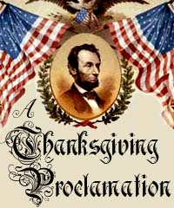
I do therefore invite my fellow classified staff from every part of Ventura College to set apart and observe
Wednesday, November 13 at 12 Noon
For a
Thanksgiving Potluck Celebration
Guthrie Hall
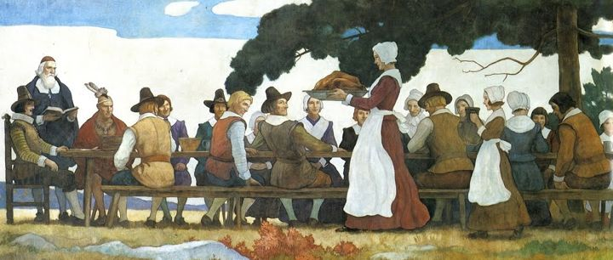
Turkey and Ham will be provided by the Classified Senate.
Staff whose last name begins with A-P please bring a side dish and Q-Z bring a dessert.
Bring your own drink.
RSVP to Eileen Crump at eileen_crump@vcccd.edu by November 8, 2013

