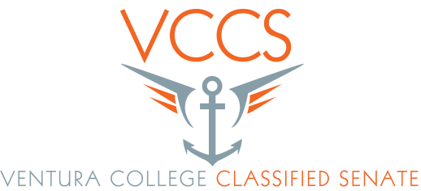
AGENDA

Date: 4 / 7 / 16
Time: 3 to 5p.
Room: CCCR

- Call to Order
- Adoption of the Agenda
- Public Comment
- Minutes approval (March minutes) Eileen – Action needed
- Accreditation Report (second reading) – Action https://docs.google.com/document/d/1AQ2bldFe493IwCyVdGNvav
- Integrated plan draft – second reading – Action
- Campus re-org – Action item
- Resolution “Do we want to join in to write a resolution to management to tell them Classified need help and we cannot keep up the pace we have been working at for the past 5 years”
- BY-Law change to stager officer elections of officers in the future – reason “do we always want to have half the e-board elected to office every other year. This way half the e-board has always been in on what has gone the past two years” - Discussion
- Information items
a. Campus Clean-up – Barbara Cogert
b. Orientation for new Classified – Peder & Eileen
c. Elections - Peder
d. Appreciation Lunch - Peder
e. Graduation - Rick
e. Santa Paula – What’s up – Sabrina
f. SEIU update – Olivia/Felicia

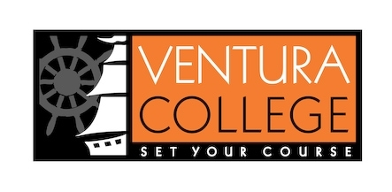
Our College Mission
At Ventura College, we transform students’ lives, develop human potential, create an informed citizenry, and serve as the educational and cultural heart of our community. Placing students at the center of their learning experience, we serve a highly diverse student body by providing innovative instruction and student support, focusing on associate degree and certificate completion, transfer, workforce preparation, and basic skills. We are committed to the sustainable continuous improvement of our college and its services.

9 + 1

1. Standards or policies regarding student support and success
2. College governance structures, as related to classified roles
3. Classified roles and involvement in accreditation processes
4. Policies for classified professional development activities
5. Processes for program review
6. Processes for Institutional planning and budget development
7. Curriculum systems integrations and implementation
8. Degree and certificate requirements
9. Educational program development
- Any other district and college policy, procedure, or related matters that will have a significant effect on Classified Staff

