The Council agreed upon “Group Norms” to
- Stay focused on issues that will improve student learning.
- Remain positive, professional, and respectful of each other.
- Listen to, respect, and strive to understand all points of view.
- Respect the time of the council by starting and ending the meeting on time.
- Work together to build consensus.

Ventura College
Department Chairs and Coordinators’ Council
4/2/2019
(Note this an out-of-cycle meeting due to Spring Break)
MCW – 312 | 3:00 – 4:30 PM

- Welcome & Announcements on Back of Agenda
- Approval of Meeting Notes from 2/26 (3:00-3:05 pm)
- General Council Announcements (3:05 -3:10 pm)
- Work and Economic Development Discussion (Chancellor Gillespie- 3:10-3:40 pm)
- Discussion of Organization Structure for 2019-20 (3:40 -4 pm)
- VP Presidents Reports (4 -4:15 pm)
  - VPAA
  - VPS
- Discussion without Administration time permitting
- Adjournment

Next Meeting Date: 4/23/2019

Our Mission
At Ventura College, we transform students’ lives, develop human potential, create an informed citizenry, and serve as the educational and cultural heart of our community. Placing students at the center of their learning experience, we serve a highly diverse student body by providing innovative instruction and student support, focusing on associate degree and certificate completion, transfer, workforce preparation, and basic skills. We are committed to the sustainable continuous improvement of our college and its services.
Our Vision
Ventura College will be a beacon of learning—a source of inspiration and guidance—for our students and community.
Our Guiding Principles
At Ventura College we believe that students come first and all else follows. We strive to create a campus environment that fosters collaboration, communication, and mutual respect. We are committed to these Guiding Principles in all that we do:
- Embrace the strength of diversity
- Listen with intensity and compassion
- Communicate with integrity and patience
- Design student-centered solutions
- Spark self-confidence and a sense of discovery
- Pursue our vision and goals with passion
Council Charge
The Department Chair and Coordinator Council provides a forum for the discussion of academic, operational and institutional issues. This is a faculty-driven body that makes recommendations to the Administrative Council.
Announcements
- Draft Catalog available online
- Diversity in Culture Festival- April 10 & 11
- Registration Calendar:
  - Special Populations to begin registering in April
- California Community College’s Update-
  - Curriculum- the Chancellor’s Office sent out a memo telling the field that COCI (Chancellor’s Office Curriculum Inventory) is “nearing the end of its shelf-life.” COCI is the central repository for all approved courses and programs statewide. This system was put in place roughly 3 years ago and has been problematic since it started. Interestingly enough from a user standpoint, I feel we are actually in a good place. However, the state is soliciting proposal for a replacement.
  - Student Centered Funding Formula (SCFF)- As you know, the Chancellor’s Office has developed a complex incentive-based funding formula for college apportionment allocations. Unfortunately, the Chancellor’s Office is reporting an approximate $320,000,000 underfunding for this system. At present, they have reported enough funds to allocate the 2017-18 hold harmless apportionment plus COLA apportionment to colleges only. In order for colleges to be funded for additional incentive metrics achieved, more money would have to be found.
  - Student Services Equity Plans- College Equity Plans are due June 30. The Chancellor’s Office has been struggling with populating data information. One of the problems is related to the 55 colleges that have a minority group as a majority population. Ventura College with a Latino population of 61%, we are one of these colleges. The problem is that the state has us comparing all metrics against our majority population. As such, a disproportionate impact and equity gaps will not be found with our Latino population. Yet, we now that our Latino students are not completing multiple success metrics at the same rate as their college peers. When I asked the Chancellor’s Office about this problem at a meeting on Wednesday, they commented that they have realized this problem and plan to issue a memo to the field and new data metrics soon.
  - Legislation-
    - Assembly Bill (AB) 2 (Santiago) would extend the California College Promise program to two years for qualified full-time students and would eliminate the requirement for qualified students to be considered “first time”
    - SB 586 (Roth)- requires for any College and Career Access Pathways (CCAP) partnerships to consult with local workforce development boards to align pathways with current and future employment needs.
    - AB 1729 (Smith)- Existing law limits the number of pupils a principal is authorized to recommend for community college summer session pursuant to those provisions to 5% of the total number of pupils in any grade level, as specified. This bill would additionally exempt from the 5% limitation pupils who are enrolled in certain community college courses, and would explicitly provide that the 5% limitation applies to pupils enrolled in physical education courses at the community college.
    - AB 897 Medina- Under existing law, a person employed to teach adult or community college classes for not more than 67% of the hours per week of a full-time employee having comparable duties, excluding substitute service, is classified as a temporary employee and not a contract employee. This bill would change the maximum time a part-time, temporary employee may teach, without becoming a contract employee, to 85% of the hours per week of a full-time employee having comparable duties.
    - AB 1727 Weber– Career Development and College Preparation (CDCP) noncredit courses have an attendance accounting method of positive attendance. This bill would require the board to adopt regulations requiring the accounting, for purposes of state funding of community colleges, to be conducted by positive attendance count or on a census date basis in accord with certain computational requirements.
    - SB 777 Rubio- Existing law requires that community college districts with less than 75% of their hours of credit instruction taught by full-time instructors apply a portion of their program improvement allocation, as provided, to reaching the 75% standard. This bill would require a district that has less than 75% of its hours of credit instruction taught by full-time instructors to make, at a minimum, an annual 10% reduction in the district’s deficit, defined as the gap between 75% of the total district credit hours taught and the total of those taught by full-time faculty
  - Workforce and Economic Development-
    - New Vice Chancellor- Sheneui Weber
    - Strong Workforce Program (SWP) K-12 application have been submitted. Requests exceed funding amount allocated with a large amount of requests from Northern CA.
    - K-12 college liaison for SWP is on hold. Originally, SWP was to pay for a liaison for each college/district.
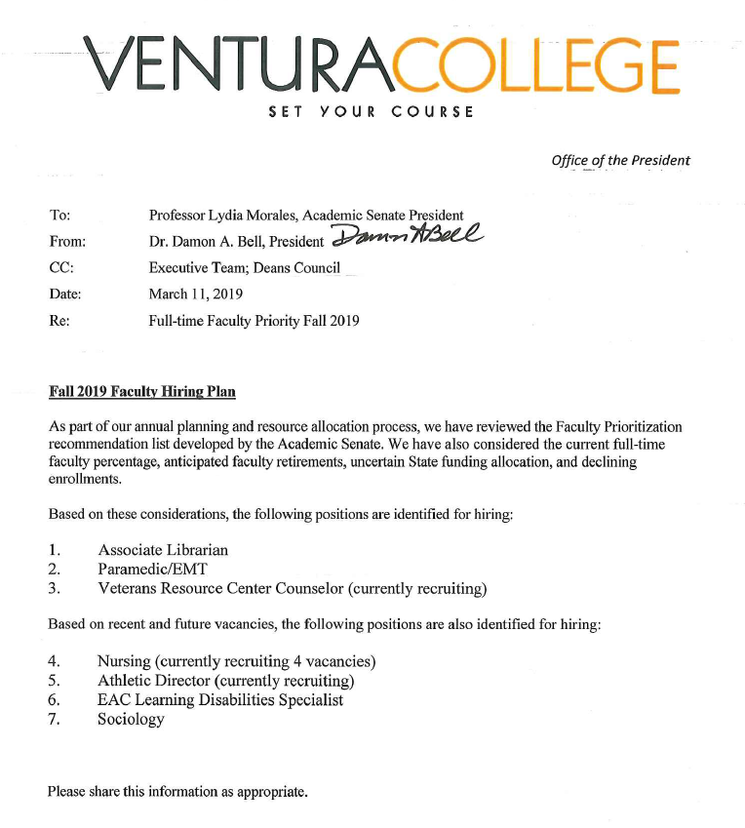
*Note that nursing actually has 5 open positions

