ASVC Board
March 31, 2020, 3:30 PM
Zoom Conference
Board Members

Constituency
Constituency | Representative |  | Constituency | Representative
President | Daisy Castillo |  | Director of Equity and Inclusion | Vacant
Vice President | Vacant |  | Director of East Campus | Enrique Rodriguez
Director of External Affairs | Vacant |  | Public  Relations Officer | Vacant
Director of Administration | Leanne Mancira |  | Community Relations  Officer | Vacant
Director of Finance | Carlo Plascencia |  | Event and Activities Officer | Vacant
Director of Student Organizations | Jasmin Martin |  | Athletic Liaison Officer | Athena Lazos

Agenda Item | Discussion Notes | Action?
- Call to Order
- Roll Call
- Public Forum
- Approval of Minutes
- Advisor Report
- New Business
- General Assembly Resolutions
- Coronavirus Update
- Committee Communications
- Adjournment
*Indicates action may be taken
Agenda approved by
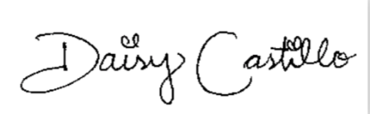 _____________________________
Daisy Castillo, President

