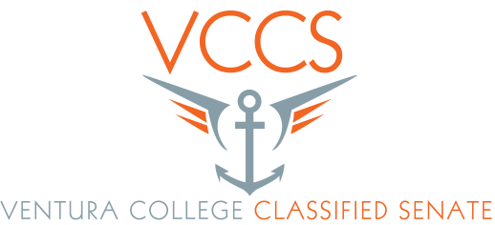
AGENDA

Date: 10/9/2015
Time: 10 a.m. to 11:30a
Room: CCCR

- Call to Order
- Adoption of the Agenda
- Guest introductions
- Public Comments
- Approval of Minutes
- Treasures report - Rachel
- Action items
a. Making Decisions Document – Rick & Peder
b. Thanksgiving Potluck for our November meeting (Yes or No)
- Program Review (Do we want to submit for dollars to cover things like New Classified orientation, CLI, Thanksgiving, and spring retreat)
- Fundraising for senate scholarship
- Equity Report (Due to state in November)
- 3SP report (Due to state in November)

- Information Items
- State Classified Senate meeting to be held here at Ventura College March 2016. Hosted by the three VCCCD Classified Senates. We will need to start planning and ramping up for this very special opportunity to host this meeting.
- Campus wide Committee and work group reports. (If you serve on a committee or work please fill us in on what is going on, Very short)
- SEIU update
- For the Good of the Order
- Adjournment
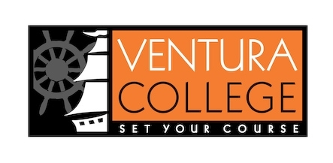
Our College Mission
At Ventura College, we transform students’ lives, develop human potential, create an informed citizenry, and serve as the educational and cultural heart of our community. Placing students at the center of their learning experience, we serve a highly diverse student body by providing innovative instruction and student support, focusing on associate degree and certificate completion, transfer, workforce preparation, and basic skills. We are committed to the sustainable continuous improvement of our college and its services.

9 + 1

1. Standards or policies regarding student support and success
2. College governance structures, as related to classified roles
3. Classified roles and involvement in accreditation processes
4. Policies for classified professional development activities
5. Processes for program review
6. Processes for Institutional planning and budget development
7. Curriculum systems integrations and implementation
8. Degree and certificate requirements
9. Educational program development
- Any other district and college policy, procedure, or related matters that will have a significant effect on Classified Staff

